UNITED STATES

SECURITIES AND EXCHANGE COMMISSION
Washington, D.C. 20549

 | SCHEDULE 14A INFORMATION
 | Proxy Statement Pursuant to Section 14(a) of the
 | Securities Exchange Act of 1934
 | (Amendment No. )
Filed by the Registrant | ☒
Filed by a Party other than the Registrant | ☐

Check the appropriate box:

- Preliminary Proxy Statement

- Confidential, for Use of the Commission Only (as permitted by Rule 14a-6(e)(2))

- Definitive Proxy Statement

- Definitive Additional Materials

- Soliciting Material Pursuant to § 240.14a-12


ENOVIX CORPORATION

(Name of Registrant as Specified In Its Charter)

Payment of Filing Fee (Check all boxes that apply):

- No fee required

  - Fee paid previously with preliminary materials

  - Fee computed on table in exhibit required by Item 25(b) per Exchange Act Rules 14a-6(i)(1) and 0-11

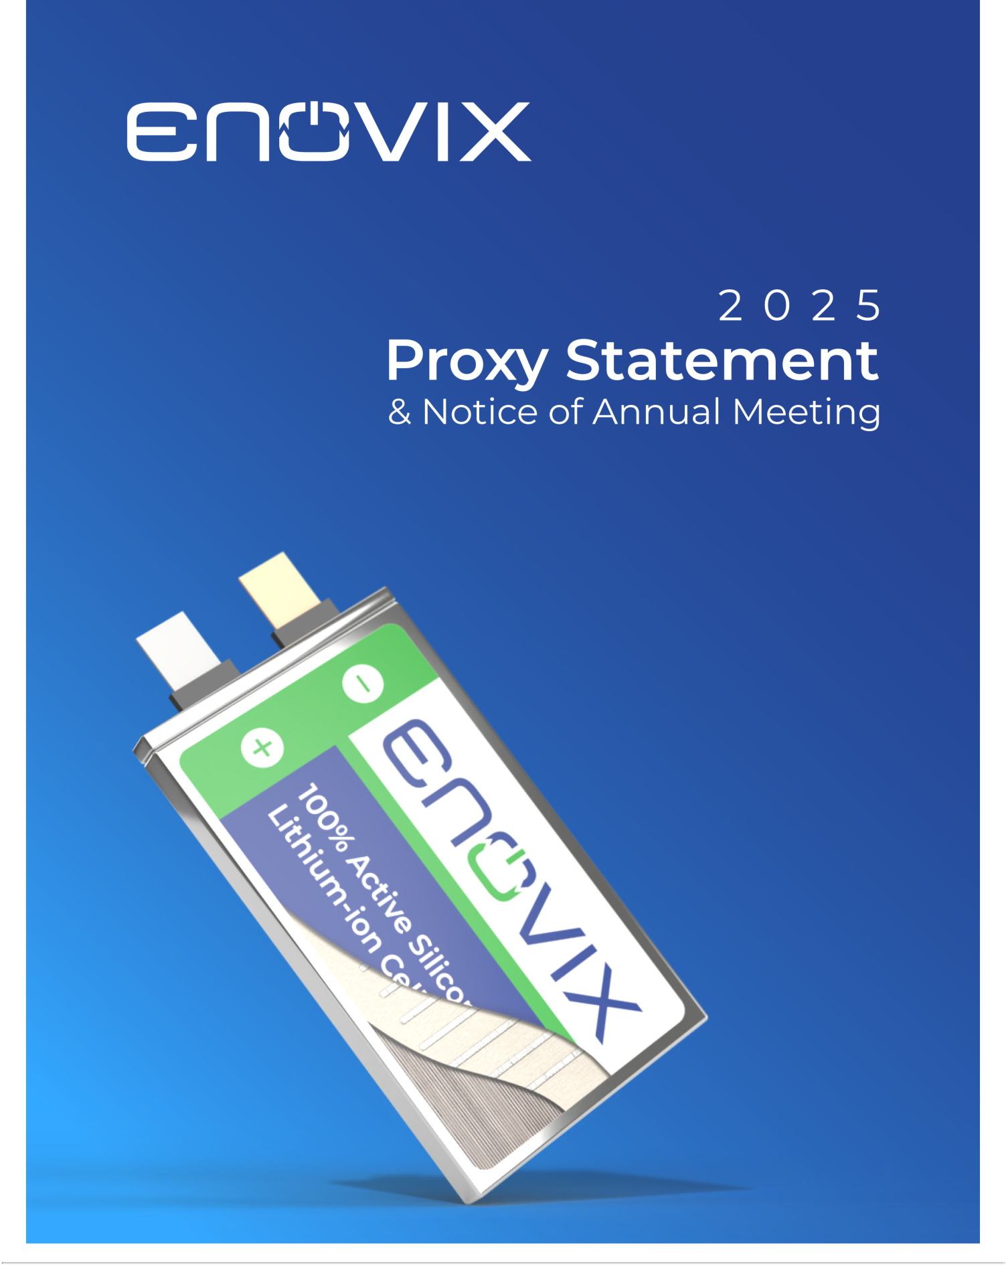

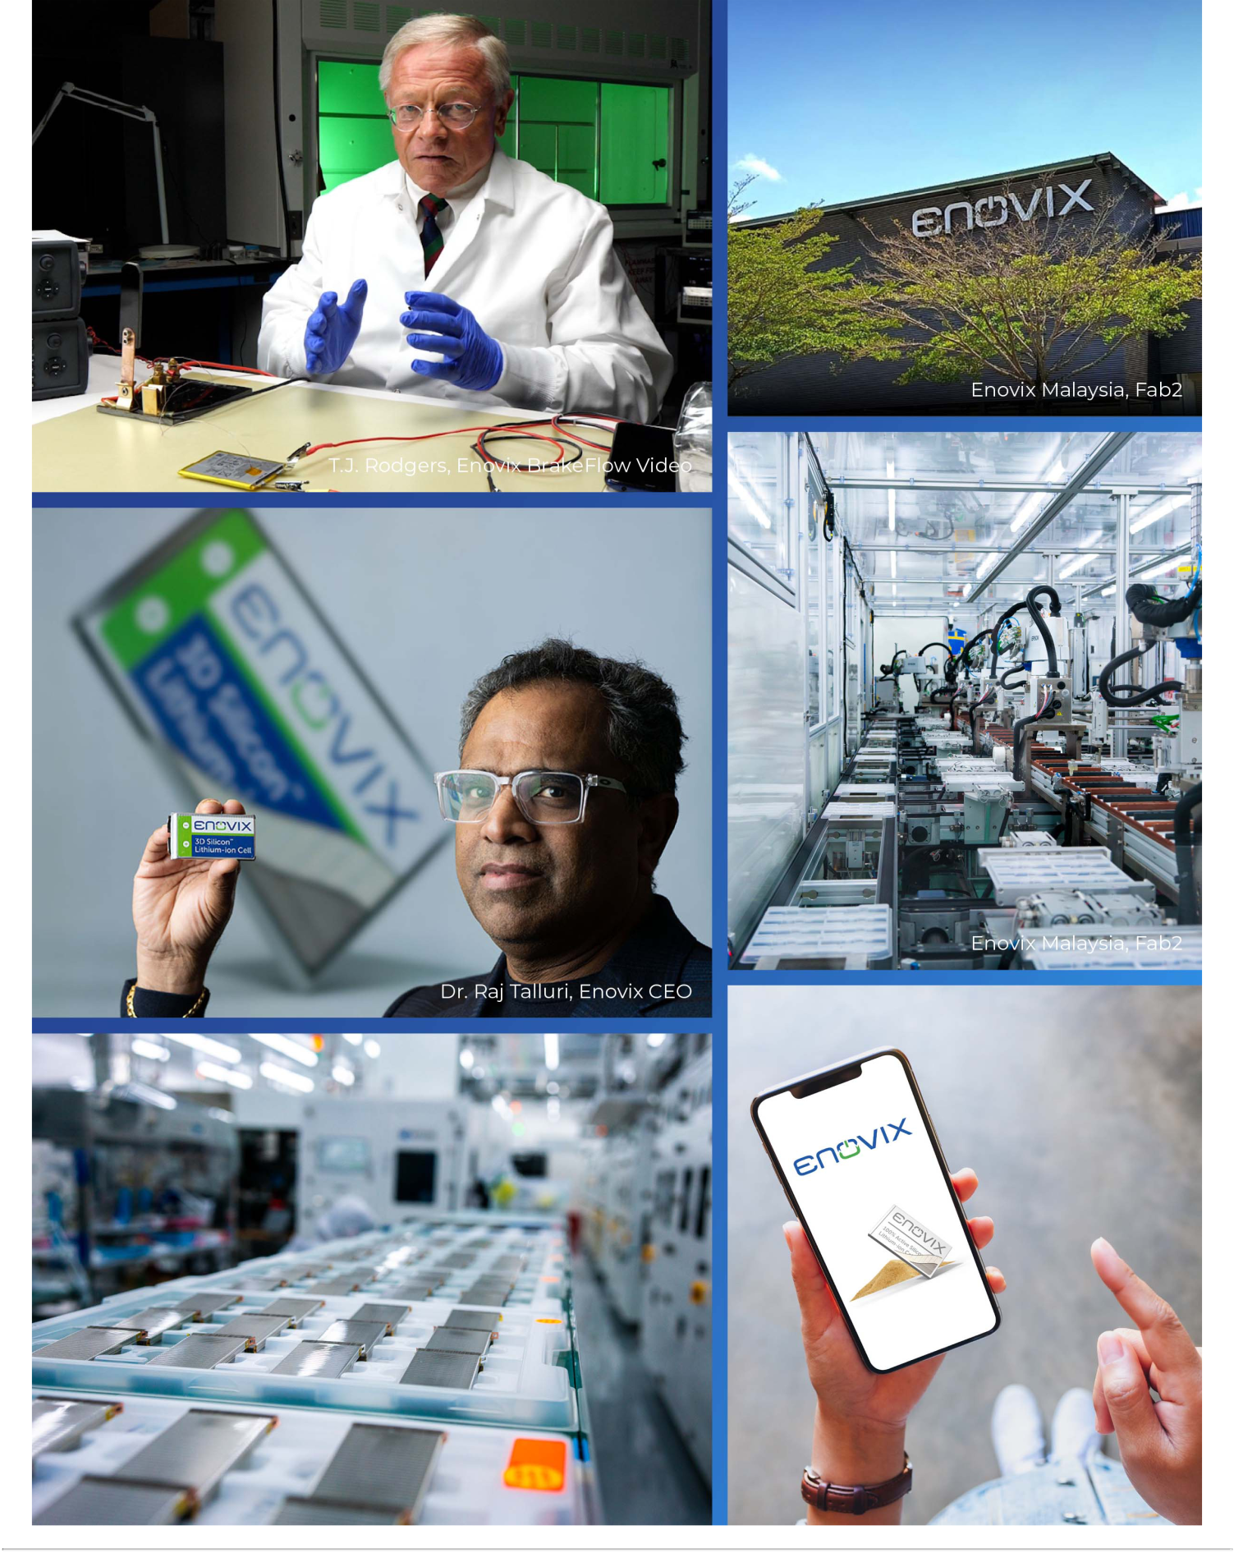


Dear Fellow Shareholders,


In 2024, we achieved key milestones in manufacturing, technology and sales, setting the stage for a breakout year in in 2025. We are focused on launching our first smartphone battery and converting our IoT pipeline into contracted backlog. Customers across multiple industries are acknowledging the readiness of our manufacturing capabilities, which are coming online at the perfect time to meet strong demand for our high energy-density solutions and diversified supply chain.

In manufacturing, Fab2 in Malaysia completed Site Acceptance Testing (SAT) for the High-Volume Manufacturing (HVM) line, a key milestone in our journey to scale production. Additionally, we were honored to host several customers at our factory in Malaysia, conducting detailed line tours. And multiple OEMs initiated formal factory audits to support their qualification processes.

In products, we successfully completed safety testing of EX-1M and performance results indicate that we are on track to meet targets for energy density, cycle life, and fast charging. And the first EX-2M samples from Fab2 were shipped to customers on schedule. Our battery technology continues to advance across multiple generations, with significant progress in safety and performance validation, customer sampling, and next-generation design. We are now refining our electrochemistry to further enhance performance metrics. Looking ahead, we have officially kicked off the design phase for EX-3M.

Regarding commercialization, we are focused on smartphone mass production as the primary commercialization goal. In October of 2024, we signed a strategic partnership that outlined key milestones leading up to our entry into the smartphone market by late 2025. In addition to focusing on the smartphone industry, we are also targeting the emerging AI-enabled smart eyewear market and are in the process of developing custom cells for customers.

In smartphones, we are seeing strong tailwinds that we expect to continue in 2025. OEMs are increasingly requesting batteries with higher capacity to support the growing power demands of next-generation AI applications. Additionally, with smartphone penetration already at saturation levels, market leaders are intensifying their focus on product differentiation – particularly in regions outside the US, where competition is fierce. We believe that our EX-2M and upcoming EX-3M battery solutions align with evolving demands, reinforcing our role as a strategic partner to leading OEMs.

In the EV space, we continue advancing development agreements with two of the world’s largest automotive OEMs. Consistent with our capital-efficient strategy, we remain focused on targeted collaborations that allow us to scale in this vertical while optimizing investment.

A new industry trend that has recently emerged is supply chain-driven demand, particularly in the defense sector. Soon after the US elections in November, we observed an increase in inbound interest from drone manufacturers and defense suppliers seeking battery solutions that comply with allied country supply chain requirements. As a reminder, a significant portion of our 2024 revenue came from sales of conventional graphite battery products to defense customers. While these developments are still evolving, we are optimistic about the potential upside.

2025 is off to a fast start, fueled by accelerating AI innovation and a shifting landscape that is driving OEMs to diversify their supply chains. As a leader in high-energy-density battery technology with manufacturing facilities in Korea and Malaysia, Enovix is well positioned to capitalize on these industry trends.

Thank you for your continued support and investment in Enovix Corporation.

Sincerely,
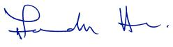

Raj Talluri

Chief Executive Officer

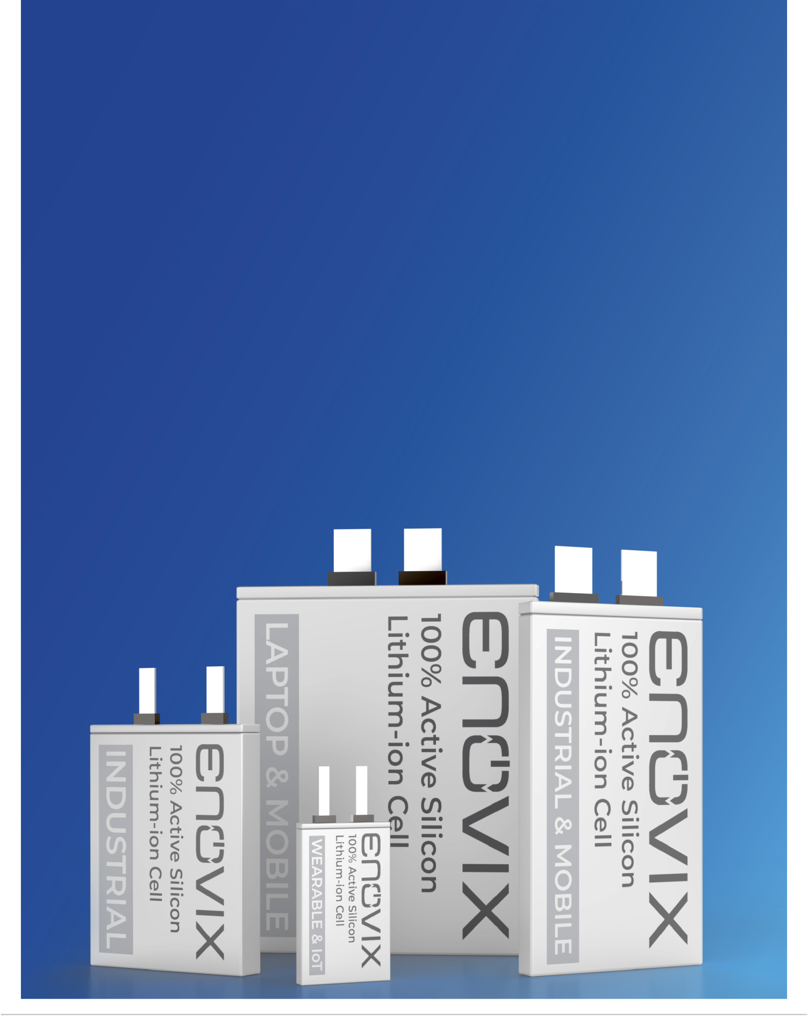

Notice of 2025 Annual Meeting of Stockholders


DATE & TIME

Thursday, June 12, 2025

1:30 p.m. Pacific Daylight Time

WHERE

Virtual Meeting via webcast at www.virtualshareholdermeeting.com/ENVX2025

RECORD DATE

The close of business on April 15, 2025

PROXY MATERIALS Our proxy statement and annual report are available at
www.proxyvote.com

Dear Stockholder of Enovix Corporation:

The 2025 Annual Meeting of Stockholders (“Annual Meeting”) of Enovix Corporation (the “Company”) will be held on Thursday, June 12, 2025 at 1:30 p.m. Pacific Daylight Time.

The Annual Meeting will be held for the following purposes:

- To elect seven director nominees to serve until the 2026 Annual Meeting of Stockholders;

- To approve, on an advisory basis, the compensation of our named executive officers;

To ratify the appointment of Deloitte & Touche LLP as our independent registered public

- accounting firm for the fiscal year ending December 28, 2025; and

- To transact such other business as may properly come before the Annual Meeting or any adjournment or postponement thereof.

These items of business are more fully described in the Proxy Statement accompanying this notice of Annual Meeting. The record date for the Annual Meeting is April 15, 2025. Only stockholders of record at the close of business on that date may vote at the Annual Meeting or any adjournment thereof.

AVAILABILITY OF PROXY MATERIALS

On or about April 24, 2025, we expect to mail the Notice of Internet Availability (“Notice”) to stockholders, with instructions on how to access our proxy materials at proxyvote.com. Our proxy materials include the attached Proxy Statement, our Annual Report, and form of voting instruction card.

PARTICIPATING IN THE ANNUAL MEETING

To participate in the Annual Meeting, visit www.virtualshareholdermeeting.com/ENVX2025, and log in using the 16-digit control number printed in the box marked by an arrow on your Notice, proxy card or voter instruction form.

PLEASE VOTE AS SOON AS POSSIBLE

Your vote is important. Whether or not you are able to attend the virtual Annual Meeting, it is important that your shares be represented. Please follow the voting instructions in the Notice to vote online, or complete, date, sign and return the proxy card by mail. On behalf of our Board of Directors, thank you for your participation in this important annual process.

By Order of the Board of Directors,

Arthi Chakravarthy

Chief Legal Officer and Corporate Secretary

April 24, 2025

Table of Contents

Information Regarding the Board of Directors and Corporate Governance | 1
Director Nominees | 1
Director Independence | 6
Committees of the Board of Directors | 7
Meetings of the Board and Committees | 9
Corporate Governance Guidelines | 9
Board Leadership | 10
Board Role in Risk Oversight | 10
Code of Ethics | 10
Insider Trading Policy | 10
Sustainability | 11
Communications with the Board | 11
Director Compensation | 12
Company Profile | 16
Enovix Mission | 16
Our People | 16
Executive Officers | 17
Compensation Discussion and Analysis | 20
Executive Compensation Program | 20
How We Designed Incentives for 2024 | 21
2024 Compensation Design and Decisions | 23
Other Aspects of Executive Compensation | 27
Compensation Committee Report | 30
Executive Compensation Tables | 32
2024 Summary Compensation Table | 32
2024 Grants of Plan-Based Awards Table | 34
Outstanding Equity Awards as of December 29, 2024 | 36
Option Exercises and Stock Vested | 37
Potential Payments Upon Termination or Change of Control | 37

Pay Ratio Disclosure | 39
Pay Versus Performance | 40
Items to Be Voted On | 45
Proposal No. 1 - Election of Directors | 45
Proposal No. 2 - Advisory Vote to Approve the Compensation of Named Executive Officers | 46
Proposal No. 3 - Ratification of the Appointment of Independent Registered Public Accounting Firm | 47
Security Ownership | 50
Report of the Audit Committee | 52
Certain Relationships and Related Party Transactions | 53
General Information - Annual Meeting and Voting | 56
Other Information | 63
Equity Compensation Plan Information | 63
Delinquent Section 16(a) Reports | 63
2024 Annual Report | 64
Other Matters | 64

This Proxy Statement may contain “forward-looking statements” within the meaning of the Private Securities Litigation Reform Act of 1995. All statements other than statements of historical or current facts, are forward-looking statements. Examples of forward-looking statements include statements regarding our business strategy, governance strategy, executive compensation program objectives and philosophy, sustainability strategies and goals, and plans and objectives of management for future operations. Forward-looking statements are based on current expectations, beliefs and assumptions that are difficult to predict and are subject to risks and uncertainties, which could cause actual results or performance to be different from those expressed or implied by these forward-looking statements. These risks and uncertainties include, but are not limited to, those factors described under the caption “Risk Factors” in our Annual Report, subsequent quarterly reports and other documents filed with the Securities and Exchange Commission from time to time. We undertake no obligation to revise or update any forward-looking statements.

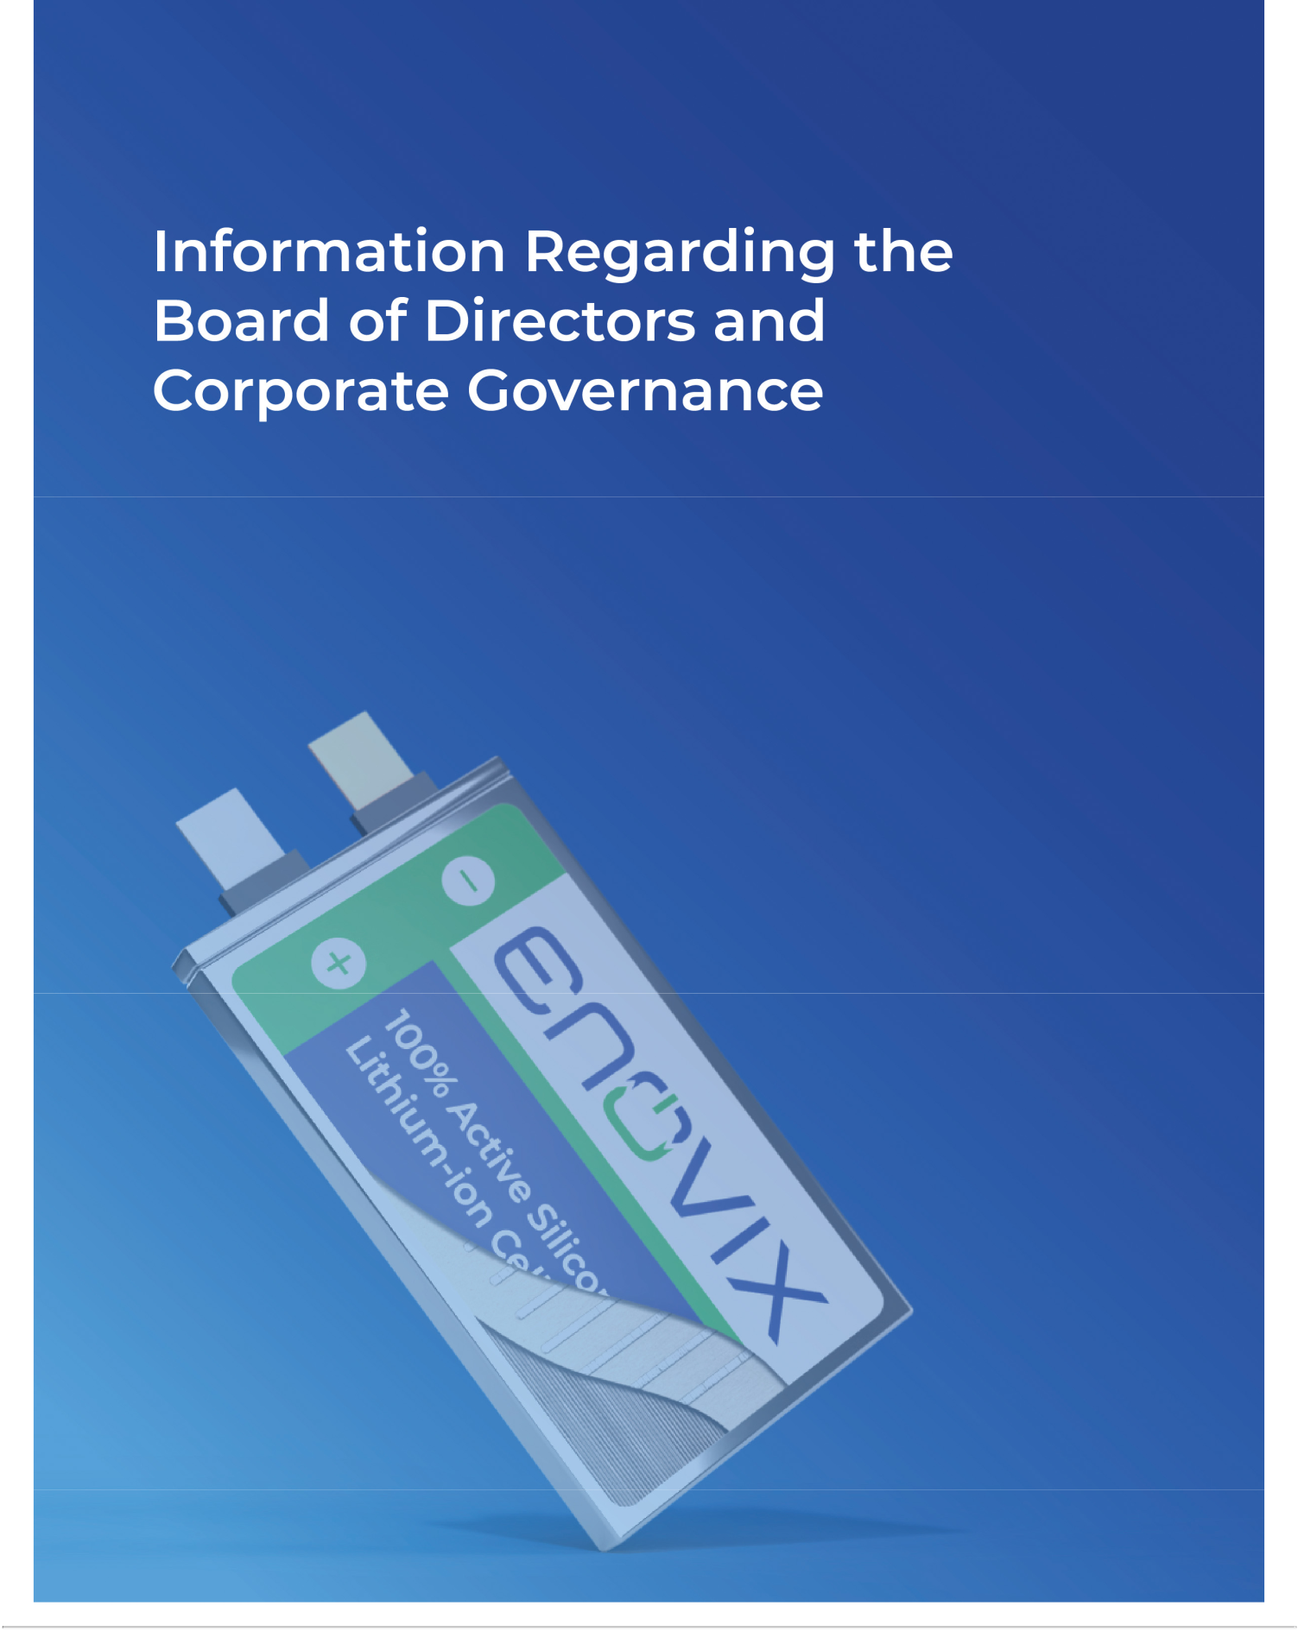

Table of Contents

Information Regarding the Board of Directors and Corporate Governance

Director Nominees

This table and the biographies below provide information regarding our seven director nominees. Each nominee is up for re-election for a one-year term expiring at the 2026 Annual Meeting of Stockholders. The Board of Directors has concluded that each of these seven incumbent directors should be nominated for re-election based on their extensive senior leadership experiences, competencies and other key qualifications summarized in the director biographies below. We believe the directors’ combined strengths are vital to the Board’s ability to provide independent oversight, effective risk management and guidance toward long-term sustainable stockholder value.

Name | Position |  | Age | Independent (Y/N) | Director Since
Thurman John Rodgers | Chairman |  | 77 | N | 2020
Betsy Atkins | Director |  | 71 | Y | 2021
Pegah Ebrahimi | Director |  | 45 | Y | 2021
Bernard Gutmann | Director |  | 65 | Y | 2023
Joseph Malchow | Director |  | 39 | Y | 2023
Gregory Reichow | Director |  | 55 | Y | 2021
Dr. Raj Talluri | President, CEO and Director |  | 62 | N | 2023
 | Enovix Corporation | 1 | 2025 Proxy Statement

Table of Contents

Director Biographies

Biographical and other information for our directors is provided below.


Thurman John Rodgers

Chairman

Age: 77

Director Since: 2020

THURMAN JOHN RODGERS has served as Chairman of our Board of Directors since July 2021 and previously served as Chief Executive Officer and Chairman of the Board of Rodgers Silicon Valley Acquisition Corp. (RSVAC), our predecessor entity, from September 2020 to July 2021, as Chairman of Legacy Enovix’s Board from July 2021 to January 2023, and as a member of Legacy Enovix’s Board of Directors from February 2012 to July 2021 (with Legacy Enovix referring to Enovix Operations, Inc. as of July 2021, and Enovix Corporation prior to that).

Mr. Rodgers founded Cypress Semiconductor Corporation in 1982 and served as the President, Chief Executive Officer and as a member of its Board of Directors until April 2017. Mr. Rodgers currently serves as the Chief Executive Officer of Complete Solaria, Inc., since April 2024, and on the Board of Directors of Enphase Energy, Inc., since January 2017. From January 2017 until January 2023, Mr. Rodgers served as Chairman of the Board of Directors of FTC Solar, Inc., a solar technology company. Since June 2023, Mr. Rodgers has served as Executive Chairman of Complete Solaria, a solar technology company, and as a member of its Board of Directors since November 2022. From May 2002 to May 2011, Mr. Rodgers served as a member of the Board of Directors of SunPower Corporation, an energy company. Mr. Rodgers is presently a member of the Board of Directors of several privately-held companies.

From June 2004 through December 2012, Mr. Rodgers was a member of the board of trustees of Dartmouth College. He holds a B.S. in Physics and Chemistry from Dartmouth and a M.S. and Ph.D. in Electrical Engineering from Stanford University. At Stanford, Mr. Rodgers invented, developed and patented VMOS technology.

Mr. Rodgers brings 35 years of public company CEO experience to the Board, as well as his skills in strategic leadership and management, and as a director of both private and public companies.

Enovix Corporation 2 2025 Proxy Statement

Table of Contents


Betsy Atkins

Director

Age: 71

Director Since: 2021


BETSY ATKINS has served as a member of our Board of Directors since July 2021 and previously served as a member of Legacy Enovix’s Board of Directors from January 2021 to January 2023 (with Legacy Enovix referring to Enovix Operations, Inc. as of July 2021, and Enovix Corporation prior to that). Since 1994, Ms. Atkins has served as the Chief Executive Officer of Baja Corp, an independent venture capital firm focused on technology, renewable energy and life sciences. Ms. Atkins is a highly acclaimed public company director and author and currently serves on the public company boards of Rackspace Technology, a technology solutions company, SolarEdge, a clean energy solutions company and Wynn Resorts Ltd., a hospitality company, as well as other private companies.

Ms. Atkins previously served on the boards of SL Green Realty Corp., a real estate investment trust, from 2015 to 2024, Cognizant Technology Solutions, an information technology services company, from 2017 to 2018, Schneider Electric, an energy company, from 2011 to 2019, Covetrus, Inc. and its predecessor, Vets First Choice, a pharmaceutical company, from 2016 to 2019, HD Supply, Inc., an industrial distributor, from 2013 to 2018, and SunPower Corporation, a publicly-traded energy company, from 2005 to 2012.

Ms. Atkins received a B.A. from the University of Massachusetts.

Ms. Atkins brings decades of public company CEO experience to the Board, as well as her skills as a director of public and private companies, and corporate governance expertise.

Pegah Ebrahimi

Director

Age: 45

Director Since: 2021

PEGAH EBRAHIMI has served as a member of our Board of Directors since November 2021 and previously served as a member of Legacy Enovix’s Board of Directors from November 2021 to January 2023. Since February 2022, Ms. Ebrahimi has served as Co-Founder and Managing Partner of FPV Ventures, an investment fund focused on investing in mission driven founders. From October 2019 to January 2021, Ms. Ebrahimi served as a board advisor of Gainsight Inc., a technology company, focused on software optimizing the customer experience and improving product analytics. From January 2019 to October 2020, she served as the Chief Operating Officer of Cisco Collaboration at Cisco Systems Inc., a publicly-traded, multinational company, focused on designing and developing networking equipment and technology.

From November 2013 to January 2019, she served as chief operating officer of Global Technology Banking at Morgan Stanley & Co. LLC, a multinational investment bank and financial services company, where she previously served as chief information officer of global investment banking from December 2009 to November 2013 and vice president investment banking from July 2008 to November 2009. From 2015 to May 2018, she served as an advisory board member of Accompany, Inc., a technology company, focused on designing and developing a relationship intelligence platform.

Ms. Ebrahimi received a B.S. in Economics and Mathematics from the Massachusetts Institute of Technology.

Ms. Ebrahimi brings financial and capital markets expertise, as well as strategic executive leadership experience to the Board.

Enovix Corporation 3 2025 Proxy Statement

Table of Contents


Bernard

Gutmann

Director

Age: 65

Director Since: 2023


BERNARD GUTMANN has served as a member of our Board of Directors since June 2023. Mr. Gutmann brings close to forty years of experience in the semiconductor space. Most recently he served as the Executive Vice President and Chief Financial Officer & Treasurer of ON Semiconductor, a semiconductor manufacturing company, a position he held from September 2012 to February 2021. Prior to that, from 2006 to 2012, he served in the role of Vice President, Corporate Analysis & Strategy of SCI LLC, a wholly owned subsidiary of ON Semiconductor. From 1999 to 2002, he held the position of Director, Financial Planning & Analysis of SCI LLC.

In these roles, his responsibilities have included finance integration, financial reporting, restructuring, tax, treasury and financial planning and analysis. Prior to joining ON Semiconductor, Mr. Gutmann served in various financial positions with Motorola, a consumer electronics company, from 1982 to 1999, including controller of various divisions and an off-shore wafer and backend factory, finance and accounting manager, financial planning manager and financial analyst.

Mr. Gutmann holds a Bachelor of Science in Management Engineering from Worcester Polytechnic Institute in Massachusetts.

Mr. Gutmann brings financial expertise, as well as both executive and leadership experience to the Board.

Joseph Malchow

Director

Age: 39

Director Since: 2023

JOSEPH MALCHOW has served as a member of our Board of Directors since June 2023. Since 2013, Mr. Malchow has served as the Founding Partner at HNVR Technology Investment Management, a venture capital firm based in Portola Valley, California. Mr. Malchow also serves on the Board of Enphase Energy, Inc., a global energy technology company, where he has helped to architect a digital transformation to advance software-defined distributed clean energy systems. From January 2021 to January 2023, Mr. Malchow served on the Board of Archaea Energy Inc., a leading producer of renewable energy, until its acquisition by BP. From December 2020 through July 2021, he served on the Board of RSVAC.

Mr. Malchow also serves as a member of the Board of the National Civic Arts Society in Washington, D.C. and has a wide range of technical expertise, including scaled infrastructure, software-driven businesses, data and computer security and artificial intelligence.

Mr. Malchow holds an A.B. from Dartmouth College and a J.D. from Stanford University.

Mr. Malchow brings entrepreneurial, investment and leadership experience to the Board, as well as his technical and financial expertise.

Enovix Corporation 4 2025 Proxy Statement

Table of Contents


Gregory Reichow

Director

Age: 55

Director Since: 2021


GREGORY REICHOW has served as a member of our Board of Directors since July 2021 and as a member of Legacy Enovix’s Board of Directors from November 2020 to January 2023 (with Legacy Enovix referring to Enovix Operations, Inc. as of July 2021, and Enovix Corporation prior to that). Since July 2016, he has served as a Partner at Eclipse Ventures, LLC, a venture capital firm. From June 2013 to July 2016, Mr. Reichow served as Vice President, Production (manufacturing, supply chain and automation engineering), at Tesla, Inc., an electric automobile manufacturer. From April 2011 to June 2013, he served as Vice President of Operations, powertrain, at Tesla.

From November 2003 to April 2011, Mr. Reichow served as Senior Vice President of Operations of SunPower Corporation, an energy company. From 1993 to 2003, he served various manufacturing and quality roles at Cypress Semiconductor Corporation, a semiconductor company.

Mr. Reichow received a B.S. in Mechanical & Industrial Engineering from the University of Minnesota.

Mr. Reichow brings manufacturing expertise, as well as executive and leadership experience to the Board.

Dr. Raj Talluri

President and Chief Executive Officer

Age: 62

Director Since: 2023

DR. RAJ TALLURI has served as our President and Chief Executive Officer and as a member of our Board of Directors since January 2023. Prior to joining Enovix, Dr. Talluri was Senior Vice President and General Manager of the Mobile Business Unit at Micron Technology Inc., a publicly-traded global company, focused on creating data memory and storage solutions, from March 2018 through December 2022. Prior to Micron, from 2009 through March 2018, Dr. Talluri was at Qualcomm Inc., a publicly-traded multinational company, focused on designing and manufacturing semiconductors and wireless telecommunications products, where he served as Senior Vice President and General Manager of the Internet of Things business unit from 2015 through March 2018.

Dr. Talluri began his career at Texas Instruments, a publicly-traded global company, focused on designing, manufacturing and embedding semiconductor chips, from 1993 through January 2009, first as a member of the technical staff and then successively leading product groups and business units over a 16-year tenure culminating with becoming General Manager of the OMAP wireless terminals business unit.

Dr. Talluri holds a Ph.D. in Electrical Engineering from the University of Texas at Austin, a Master of Engineering degree from Anna University in Madras, India, and a Bachelor of Engineering from Andhra University in Waltair, India.

Dr. Talluri brings executive and leadership experience to the Board, as well as his technical expertise.

Enovix Corporation 5 2025 Proxy Statement

Table of Contents

Board of Directors - Skills and Experience

The table below highlights some of the key skills and experiences that our directors have developed through education, direct experience and oversight responsibilities. The skills matrix below does not encompass all types of experience or skills of our Board of Directors.

 | Thurman John |  | Pegah | Bernard | Joseph | Gregory
Expertise Area | Rodgers | Betsy Atkins | Ebrahimi | Gutmann | Malchow | Reichow | Dr. Raj Talluri
Engineering and Technical | l |  | l |  | l | l | l
Manufacturing / Supply Chain | l |  |  |  |  | l | l
Semiconductor or Battery Design | l |  |  | l |  | l | l
Intellectual Property and Patent | l |  |  |  |  |  | l
International Business - Asia Pacific | l |  |  | l |  | l | l
CEO / Executive Management | l | l |  | l | l |  | l
Financial Management and Accounting | l |  | l | l | l | l
Sales and Business Development | l |  | l |  | l |  | l
Public Board / Governance | l | l |  |  | l
Entrepreneurship | l | l | l |  | l | l
Human Capital Management | l | l |  |  | l | l
IT / Cybersecurity |  | l | l | l | l

Director Independence

Our common stock is listed on the Nasdaq Global Select Market. As required under Nasdaq listing standards, a majority of the members of our Board of Directors must qualify as independent. All directors who served in 2024 are considered independent under Nasdaq’s listing standards, except our President and Chief Executive Officer, and Mr. Rodgers.

In addition, the Board has determined that Bernard Gutmann, Pegah Ebrahimi and Joseph Malchow met the heightened independence requirements for Audit Committee membership as set forth in Rule 10A-3 under the Securities Exchange Act of 1934, as amended (the “Exchange Act”), and the applicable listing standards of Nasdaq, and that Gregory Reichow, Betsy Atkins and Joseph Malchow met the heightened independence requirements for Compensation Committee members set forth in Rule 10C-1 under the Exchange Act and the applicable Nasdaq listing standards.

In making these determinations, the Board considered the current and prior relationships that each non-employee director has with Enovix and all other facts and circumstances the Board of Directors deems relevant, including the beneficial ownership of our common stock by each non-employee director and the transactions described in the section titled “Certain Relationships and Related Party Transactions.” There are no family relationships among any of our directors or executive officers.

Enovix Corporation 6 2025 Proxy Statement

Table of Contents

Committees of the Board of Directors

The Board of Directors has established standing committees in connection with the discharge of its responsibilities. These committees include an Audit Committee, a Compensation Committee and a Nominating and Corporate Governance Committee. Pursuant to our Bylaws, the Board of Directors may establish such other committees as may be permitted by law. The following table provides current membership information for each of these Board of Directors committees.

 |  |  | Nominating and Corporate
Name | Audit Committee | Compensation Committee | Governance Committee
Thurman John Rodgers
Betsy Atkins |  | l | C
Pegah Ebrahimi | l |  | l
Bernard Gutmann | C
Joseph Malchow | l | l | l
Gregory Reichow |  | C | l
Dr. Raj Talluri
C - Chair

Below is a description of the Audit Committee, Compensation Committee and Nominating and Corporate Governance Committee of the Board of Directors.

Each of the committees operates pursuant to a written charter and each committee reviews and assesses the adequacy of its charter on an annual basis.

The committee charters can be found in the Governance section of our website at https://ir.enovix.com/.

Audit Committee

The primary purpose of the Audit Committee is to oversee our corporate accounting and financial reporting processes, systems of internal control, and financial statement audits. The Audit Committee also reviews and assesses the adequacy of its charter and the committee’s performance on an annual basis. As a result of such annual assessment, the Audit Committee Charter was amended in February 2025.

The Board of Directors has determined that Mr. Gutmann, chair of the Audit Committee, qualifies as an audit committee financial expert, as defined by SEC rules, based on a qualitative assessment of his knowledge, education and experience.

Key responsibilities of the Audit Committee include:

- helping the Board of Directors oversee corporate accounting and financial reporting processes;

- managing the selection, engagement, qualifications, independence and performance of a qualified firm to serve as the independent registered public accounting firm to audit the financial statements;

- discussing the scope and results of the audit with the independent registered public accounting firm, and reviewing, with management and the independent accountants, the interim and year-end operating results;

- developing procedures for employees to submit concerns anonymously about questionable accounting or audit matters;

- reviewing related person transactions;

- obtaining and reviewing a report by the independent registered public accounting firm at least annually that describes internal quality control procedures, any material issues with such procedures and any steps taken to deal with such issues when required by applicable law; and

- approving or, as permitted, pre-approving, audit and permissible non-audit services to be performed by the independent registered public accounting firm.

Enovix Corporation 7 2025 Proxy Statement

Table of Contents

Compensation Committee

The primary purpose of the Compensation Committee is to oversee the Company’s compensation policies, plans and programs, and to review and determine, in coordination with outside consultants as applicable, the compensation to be paid to executive officers, directors and other senior management.

Key responsibilities of the Compensation Committee include:

- reviewing and approving the compensation of the chief executive officer, other executive officers and senior management;

- administering the equity incentive plans and other benefit programs;

- reviewing, adopting, amending and terminating incentive compensation and equity plans, employment agreements, severance agreements, profit sharing plans, bonus plans, change-of-control protections and any other compensatory arrangements for the executive officers and other senior management; and

- reviewing and establishing general policies relating to compensation and benefits of the employees, including the overall compensation philosophy.

COMPENSATION COMMITTEE INTERLOCKS AND INSIDER PARTICIPATION.

None of Ms. Atkins and Messrs. Malchow and Reichow are an officer or employee of the Company. None of our executive officers currently serves, or in the past fiscal year has served, as a member of the board of directors or compensation committee of any entity that has one or more executive officers serving on our Board of Directors or Compensation Committee.

COMPENSATION COMMITTEE PROCESSES AND PROCEDURES

The Compensation Committee typically meets quarterly, and also meets regularly in executive session. The Compensation Committee charter grants the committee full access to all the Company’s books, records, facilities and personnel.

The Compensation Committee may select, or receive advice from, a compensation consultant, legal counsel or other adviser, other than in-house legal counsel and certain other types of advisers, only after assessing the independence of such individual in accordance with SEC and Nasdaq requirements. The Compensation Committee’s process comprises two elements: determining compensation levels and establishing performance objectives. For executives other than the Chief Executive Officer, our Compensation Committee solicits and considers evaluations and recommendations submitted to the Compensation Committee by the CEO. In the case of the CEO, the evaluation of his performance is conducted by the Compensation Committee, which determines any adjustments to his compensation as well as awards to be granted. The CEO may not participate in deliberations or determinations regarding their compensation or individual performance objectives. The Compensation Committee does not delegate authority to approve executive officer compensation.

We have designed our executive compensation program to attract, motivate and retain a team of highly qualified executives who will drive innovation and business success.

Nominating and Corporate Governance Committee

The Nominating and Corporate Governance Committee consists of Ms. Atkins, Ms. Ebrahimi, Mr. Malchow and Mr. Reichow. Specific responsibilities of the

Nominating and Corporate Governance Committee include:

- identifying and evaluating candidates, including the nomination of incumbent directors for reelection and nominees recommended by stockholders, to serve on the Board of Directors;

- considering and making recommendations to the Board regarding the composition and chairperson designation of the Board committees;

- reviewing and recommending to the Board the compensation paid to the directors;

- instituting plans or programs for the continuing education of the Board and orientation of new directors;

- reviewing, evaluating and recommending to the Board of Directors succession plans for executive officers;

Enovix Corporation 8 2025 Proxy Statement

Table of Contents

- overseeing and managing our cybersecurity risk assessment and management processes;

- overseeing our sustainability activities;

- developing and making recommendations to the Board of Directors regarding corporate governance guidelines and matters, including in relation to corporate social responsibility; and

- overseeing periodic evaluations of the performance of the Board of Directors, including our individual directors and committees.

The Nominating and Corporate Governance Committee believes that a director nominee should demonstrate, through significant accomplishments in their field or otherwise, an ability to make a meaningful contribution to the Board’s oversight of the business and operations of the Company, and a reputation for the highest personal integrity and ethics in both their professional and personal endeavors. The Nominating and Corporate Governance Committee will also consider such factors as relevant expertise, sufficient bandwidth to devote to our affairs, and potential to rigorously represent the long-term interests of our stockholders. The Nominating and Corporate Governance Committee will review director candidates in the broader context, including the current composition of the Board, our current strategic focus and the long-term interests of stockholders.

The Nominating and Corporate Governance Committee also takes into account the results of the Board of Directors’ self-evaluation, conducted annually on a group and individual basis. In addition, every three years, this evaluation is conducted with an outside consultant. The Nominating and Corporate Governance Committee uses its network of contacts to compile a list of potential candidates, and, if it deems appropriate, a professional search firm. The Committee conducts any appropriate and necessary inquiries into the backgrounds and qualifications of possible candidates after considering the function and needs of the Board of Directors, and selects nominees to recommend to the Board by a majority vote.

The Nominating and Corporate Governance Committee will consider director candidates recommended by stockholders, if in compliance with our Amended and Restated Certificate of Incorporation and Bylaws and all applicable laws, rules and regulations. The Nominating and Corporate Governance Committee does not intend to alter the manner in which it evaluates candidates, including the minimum criteria set forth above, based on whether or not the candidate was recommended by a stockholder. Stockholders who wish to recommend individuals for consideration by the Nominating and Corporate Governance Committee to become nominees for election to the Board of Directors may do so by providing timely notice in writing to our Secretary at c/o Enovix Corporation, 3501 W. Warren Avenue, Fremont, California 94538. To be timely for our 2026 Annual Meeting of Stockholders, our Secretary must receive the notice not earlier than the close of business on February 12, 2026 and not later than the close of business on March 14, 2026. Submissions must include the specific information required in Section 5 of our Bylaws. For additional information about our director nomination requirements, please see our Bylaws.

Meetings of the Board and Committees

The Board of Directors held five meetings, the Audit Committee held five meetings, and the Compensation Committee and Nominating and Corporate Governance Committee each held four meetings during fiscal year 2024. Each director attended at least 75% of the Board meetings, and of the committees on which they served, held during fiscal year 2024. Four of our seven Board members attended our 2024 annual meeting. Directors are encouraged to attend the annual meeting of stockholders and are expected to regularly attend the Board meetings and meetings of the committees on which they serve.

Corporate Governance Guidelines

The Board of Directors has adopted Corporate Governance Guidelines to ensure that it will have the necessary authority and practices in place to review and evaluate our business operations as needed and to make decisions that are independent of our management. The guidelines are also intended to align the interests of directors and management with those of our stockholders. Our Corporate Governance Guidelines set forth the practices of the Board of Directors with respect to, among other things, board composition and selection, director compensation, board meetings, executive sessions with management, board committee composition, Chief Executive Officer performance evaluation, succession planning, and board assessments. The Corporate Governance Guidelines are available in the investors section of our website at https://ir.enovix.com/.

Enovix Corporation 9 2025 Proxy Statement

Table of Contents

Board Leadership

The positions of Chairman of the Board of Directors and Chief Executive Officer are presently separated, with Mr. Rodgers serving as our Chairman and Dr. Talluri serving as our Chief Executive Officer. We believe this arrangement, at this time, allows our Chief Executive Officer to focus on our day-to-day business, while allowing the Chairman to lead the Board of Directors in its fundamental role of providing advice to and independent oversight of management. Our Bylaws and Corporate Governance Guidelines, which do not require that our Chairman of the Board of Directors and Chief Executive Officer positions be separate, allow our Board of Directors to determine the leadership structure that is appropriate for us at any given point in time, taking into account the dynamic demands of our business and other factors.

Board Role in Risk Oversight

One of the key functions of the Board of Directors is the informed oversight of our risk management process. The Board administers this oversight function directly through the Board of Directors as a whole, as well as through each of the three standing committees of the Board of Directors that address risks inherent to their respective areas of oversight. In particular, the Board is responsible for monitoring and assessing strategic risk exposure. The Audit Committee is responsible for considering and discussing our major financial risk exposures, including steps management can take to monitor and control such exposures, such as guidelines and policies governing the risk assessment and management process. The Audit Committee also monitors compliance with legal and regulatory requirements. The Compensation Committee of the Board is responsible for assessing and monitoring our compensation plans, policies and programs for compliance with applicable legal and regulatory requirements, including from time to time in consultation with outside counsel and Compensia, our independent compensation consultant.

Code of Ethics

We have adopted a Code of Business Conduct and Ethics, applicable to all of our employees, executive officers and directors. Our Code of Business Conduct and Ethics is available at the investors section of our website at https://ir.enovix.com/. We are committed to maintaining high standards of financial integrity, open communication and a workplace environment free of harassment, discrimination or retaliation of any kind. We maintain a formal whistleblower policy under the oversight of our Chief Compliance Officer as well an ethics reporting hotline through a third party vendor. Reports of suspected violations of our Code of Conduct can be made directly to Human Resources, the Chief Compliance Officer or by phone, internet or mobile application through our ethics reporting hotline, which also allows for anonymous reporting. Retaliation is strictly prohibited under both our Code of Business Conduct and Ethics and whistleblower policy. Any amendments to the Code of Conduct, or any waivers of its requirements, will be disclosed on our website to the extent required by applicable law including the rules of Nasdaq and SEC regulations.

Insider Trading Policy

Our Board of Directors has adopted an insider trading policy governing the purchase, sale and/or other disposition of Company securities by our employees, directors and consultants. We believe this policy and the procedures that the Company follows are reasonably designed to promote compliance with the insider trading laws, rules and regulations, as well as Nasdaq listing standards. A copy of the Insider Trading Policy is filed as an exhibit to our Annual Report on Form 10-K for the fiscal year ended December 29, 2024.

As part of our insider trading policy, all employees, directors and consultants are prohibited from engaging in short sales, transactions in put or call options, hedging transactions, pledges or other inherently speculative transactions with respect to our securities or derivative securities. The insider trading policy also prohibits pledging our securities as collateral for loans or holding our securities in margin accounts, unless a waiver to such restriction is approved by the Board of Directors or Audit Committee. Consistent with this policy, Mr. Rodgers received permission to use our securities, registered in his name and that of his living trusts, as security collateral for his investment account.

Enovix Corporation 10 2025 Proxy Statement

Table of Contents

Sustainability

Enovix published its fourth Sustainability Report on April 22, 2025, which provides an overview of our sustainability initiatives in fiscal year 2024 and a roadmap of our sustainability program going forward. The following are a few highlights:

- We received multiple safety certifications at our global subsidiaries, including for wearable Li-ion battery cells, ISO 9001:2015 quality management certification for the manufacturing facility and cell characterization and safety lab at Fab2, and multiple safety certifications at Enovix Korea, reflecting a continued commitment to excellence in occupational health and safety practices.

- We tracked both energy and water use data at each of our operational locations in Fremont, India, Korea and Malaysia, and prepared our second climate disclosure project (CDP) Climate Change Report to disclose fiscal year 2024 energy use data metrics and greenhouse gas (GHG) emissions, which data was verified by a third-party.

- We updated and published to the Governance section of our website the Enovix Supplier Code of Conduct, which requires Enovix suppliers to adhere to rigorous ethical, health, safety and environmental standards, including compliance with all laws relating to human rights and conflict minerals management.

- Enovix published an updated Task Force on Climate-related Financial Disclosures (TCFD) Index, which covers governance, strategy, risk management, and metrics and targets topics, and appears in Appendix A of our 2024 Sustainability Report, as well as our first Global Reporting Initiative (GRI) Index, which appears in Appendix B.

- We adopted and published company-wide policies on Conflict Minerals, Environmental Health and Safety, and Human Rights, each of which is available on the Governance section of our website.

Communications with the Board

Stockholders wishing to communicate with the Board of Directors or an individual director may send a written communication to Enovix Corporation, 3501 W. Warren Avenue, Fremont, California 94538, Attention: Secretary. The Secretary will review each communication and forward such communication to the Board of Directors or to any individual director to whom the communication is addressed unless the communication contains advertisements or solicitations or is unduly hostile, threatening or similarly inappropriate, in which case the Secretary will discard the communication or inform the proper authorities, as may be appropriate. We value our investors’ perspectives and stakeholder feedback. Please refer to the section titled “Stockholder Engagement” later in this Proxy Statement.

Enovix Corporation 11 2025 Proxy Statement

Table of Contents

Director Compensation

Director Compensation Policy

Each non-employee director is eligible to receive compensation for their service consisting of annual cash retainers and equity awards pursuant to our non-employee director compensation policy.

Under our Director Compensation Policy, amended in August 2023, each non-employee director receives an annual cash retainer of $50,000, The chairperson and lead independent director receive an additional $47,000 and $25,000, respectively, for serving in such roles on our Board of Directors.

The chairpersons and members of the three committees of the Board of Directors are also entitled to the following additional annual cash retainers under our

Director Compensation Policy:

 | Chairperson Fee |  | Member Fee
Board of Directors Committee | ($) |  | ($)
Audit Committee |  | 22,000 | 10,000
Compensation Committee |  | 15,000 | 7,500
Nominating and Corporate Governance Committee |  | 10,000 | 5,000

All annual cash compensation amounts are payable in equal quarterly installments in arrears, on the last day of each fiscal quarter for which the service occurred, prorated based on the days served in the applicable fiscal quarter.

Initial Equity Awards

Each non-employee director upon appointment to our Board of Directors will automatically receive an initial equity award in the form of restricted stock units (“RSUs”) with a grant-date value equal to $275,000, which is calculated based on the Fair Market Value (as defined in our 2021 Plan) of the underlying common stock on the date of grant (the “Initial RSU awards”). The Initial RSU awards vest quarterly over three years, subject to continuous service through the applicable vesting date.

Annual Equity Awards

On the date of the 2024 annual meeting of stockholders, each continuing non-employee director received an annual equity award in the form of RSUs with a grant-date value equal to $195,000, which is calculated based on the Fair Market Value (as defined in our 2021 Plan) of the underlying common stock on the date of grant (the “Annual RSU awards”).

The Annual RSU awards vest on the earlier of (i) the date of the following annual meeting of stockholders (or the date immediately prior to the next annual meeting of stockholders if the non-employee director’s service as a director ends at such meeting due to the director’s failure to be re-elected or the director not standing for re-election) or (ii) the one-year anniversary of the date of grant, subject to continuous service through the applicable vesting date.

Vesting Acceleration

In the event of a Change of Control (as defined in our 2021 Plan), any unvested portion of an outstanding equity award granted under the Initial Director Compensation Policy or Amended Director Compensation Policy will fully vest immediately prior to the closing of such Change of Control, subject to the non-employee director’s continuous service with us on the effective date of the Change of Control.

Expenses

We reimburse our non-employee directors for ordinary, necessary and reasonable out-of-pocket travel expenses to cover in-person attendance at and participation in meetings of the Board of Directors and its committees. We also reimburse our non-employee directors for other reasonable expenses related to Board of Directors service, such as director education.

Enovix Corporation 12 2025 Proxy Statement

Table of Contents

Director Compensation Table

The following table sets forth information regarding the compensation earned by or paid to non-employee directors during fiscal year 2024. As an executive officer and director, Dr. Talluri (our President and CEO) did not receive any additional compensation for his service as a member of our Board of Directors and therefore have not been included in this table. The compensation of Dr. Talluri is set forth above under “Executive Compensation Tables - 2024 Summary Compensation Table.”

 | Fees Earned or Paid in Cash | Stock Awards |  | Total
Name | ($)⁽¹⁾ | ($)⁽²⁾ |  | ($)
Thurman John Rodgers | 97,000 |  | 195,000 | 292,000
Betsy Atkins | 67,500 |  | 195,000 | 262,500
Pegah Ebrahimi | 65,000 |  | 195,000 | 260,000
Bernard Gutmann | 72,000 |  | 195,000 | 267,000
Joseph Malchow | 72,500 |  | 195,000 | 267,500
Gregory Reichow | 70,000 |  | 195,000 | 265,000

- The amounts reported in this column represent the annual cash retainer fees paid during fiscal year 2024 in accordance with our Director Compensation Policy.

- The reported amounts reflect the aggregate grant-date fair value of equity awards granted to each non-employee director during fiscal year 2024, computed in accordance with the ASC Topic 718, Stock-based Compensation. For fiscal year 2024, the assumptions used in calculating the grant-date fair value of the equity awards reported in this column are set forth in Note 2 to our audited consolidated financial statements in our Annual Report on Form 10-K for the fiscal year ended December 29, 2024. As required by SEC rules, the amounts shown exclude the impact of estimated forfeitures related to service-based vesting conditions. On June 13, 2024, each non-employee director serving was granted an Annual RSU award of 15,128 RSUs in accordance with our Director Compensation Policy.

The following table indicates the number of outstanding stock options and unvested RSU awards held by each non-employee director as of December 29, 2024:

 | RSUs⁽¹⁾ | Number of Shares
Name | RSUs⁽¹⁾ | Underlying Stock Options
Thurman John Rodgers | 7,564 | —
Betsy Atkins | 7,564 | 51,691
Pegah Ebrahimi | 7,564 | —
Bernard Gutmann | 17,535 | —
Joseph Malchow | 17,535 | —
Gregory Reichow | 7,564 | —

- Each unit granted pursuant to an RSU award represents a contingent right to receive one share of our common stock for each unit that vests.

Enovix Corporation 13 2025 Proxy Statement

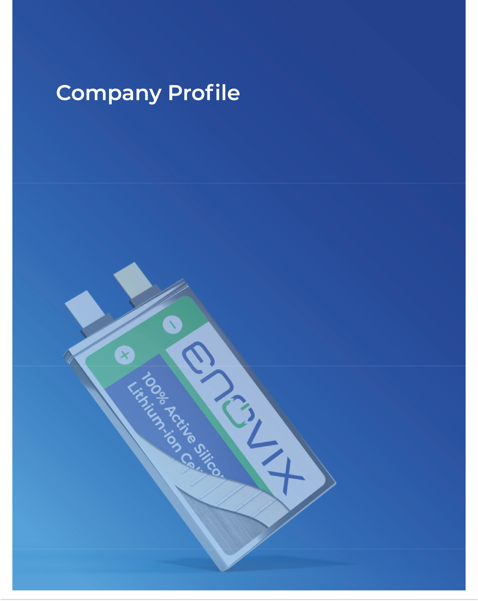

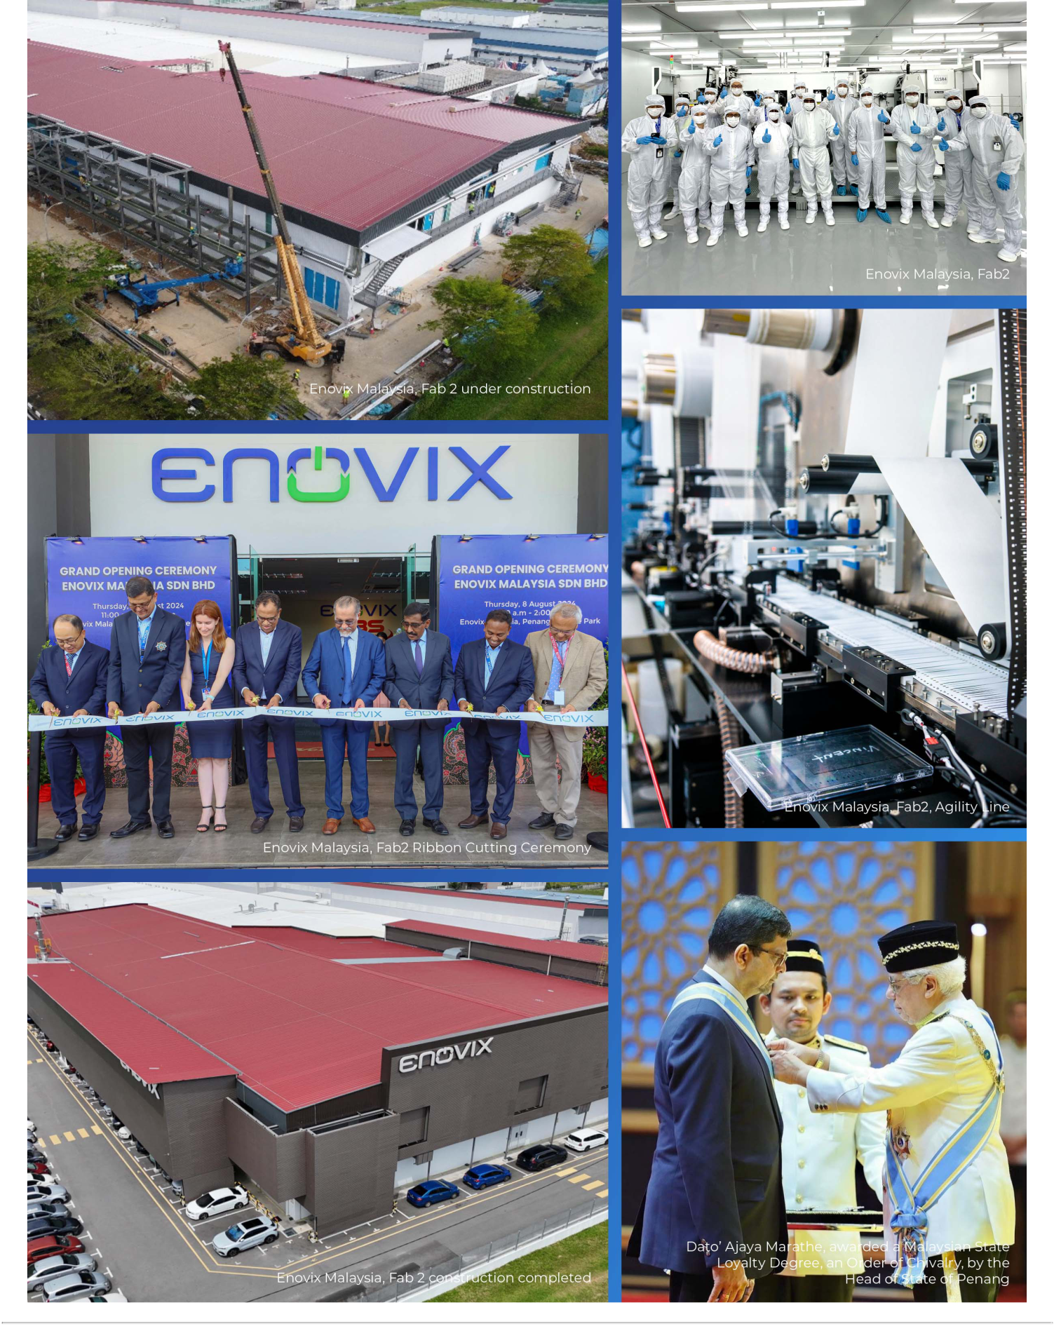

Table of Contents

Company Profile

Enovix Mission

Enovix is on a mission to deliver high-performance batteries that unlock the full potential of technology products. We do this by designing, developing, manufacturing, and commercializing next generation Lithium-ion, or Li-ion, battery cells that significantly increase the amount of energy density and storage capacity relative to conventional battery cells. Our battery’s mechanical design, or “architecture,” allows us to use high performance chemistries while enabling safety and charge time advantages.

Enhanced batteries for the mobile, IoT and defense sectors enable the development of devices that can accommodate user preferences for more advanced features and a slimmer design. Electric Vehicles (“EVs”) that use advanced batteries charge faster with lower system costs, allowing consumers to drive longer without having to stop to charge.

Enovix was established in 2006 based on the fundamental premise that improving battery performance would require a reinvention of the battery’s architecture. Our architecture allows us to use 100% active silicon and no graphite in the battery’s anode, which is the negative electrode that stores lithium ions when a battery is charged. The advantage of silicon over graphite is that a battery can theoretically store more than twice as much lithium as graphite, which increases a battery’s energy density and overall capacity. The battery industry has historically struggled to incorporate more than a small amount of silicon in the anode because silicon can swell and crack in conventional architectures, impacting safety and performance. By contrast, our architecture is designed to accommodate silicon’s swelling and apply stack pressure that alleviates the cracking problem.

Our corporate functions, and certain sales, operations and engineering activities, are located at our U.S. headquarters, while our manufacturing and research and development activities are conducted primarily in Malaysia, Korea and India.

Our People

Our people are our greatest asset. We employ approximately 570 full-time employees. Of that number, approximately 18% are located in the United States, and 82% in Asia Pacific, which includes South Korea, Malaysia, India and China.

Our team at Enovix is comprised of a diverse group of dedicated technicians, engineers, scientists, and business professionals who are all driven to create a better, low-carbon world through innovation in energy storage.

We could not be where we are today without the dedication of our workforce. We prioritize pathways for career development, employee feedback, and competitive compensation and benefits packages. Our benefits program includes an employee stock purchase plan, paid time off, team building events and talent development opportunities. The program is designed to ensure we continue to motivate, strengthen and empower our workforce.

Building a company where everyone feels that they belong is a priority at Enovix. We strive to live up to our Core Values every day: integrity, respect, innovation, resilience, excellence and customer focus. Employees carry these Core Values with them on their access badge. Our Core Values are reinforced in new hire training, employee engagement activities and everyday interactions.

Enovix Corporation 16 2025 Proxy Statement

Table of Contents

Executive Officers

Our executive officers as of April 24, 2025 are as follows:

Name | Age | Position
Dr. Raj Talluri | 62 | President and Chief Executive Officer
Ryan Benton ⁽¹⁾ | 54 | Chief Financial Officer
Ajay Marathe | 63 | Chief Operating Officer
Arthi Chakravarthy | 46 | Chief Legal Officer and Head of Corporate Development

- Mr. Benton’s employment with the Company commenced on April 14, 2025.

Biographical information for Dr. Talluri is included above under the section titled “Director Nominees.”


Ryan Benton

Chief Financial Officer

Age: 54

Executive Officer Since: 2025

RYAN BENTON has served as our Chief Financial Officer since April 14, 2025.

Previous Experience

- Prior to Enovix, Mr. Benton served as Chief Financial Officer of Silvaco, Inc., a provider of software solutions for semiconductor and photonics design, from August 2023 to April 2025.

- From July 2020 to August 2023, he served as Chief Financial Officer and a member of the board of directors of Tempo Automation, an electronics manufacturer.

- From September 2018 to July 2020, Mr. Benton served as Chief Financial Officer of Revasum, a semiconductor capital equipment company.

- From December 2012 to May 2017, he held multiple positions at Exar Corporation, a fabless semiconductor chip manufacturer.

Mr. Benton received a Bachelor of Arts of Business Administration in Accounting from the University of Texas at Austin and passed the State of Texas Certified Public Accountancy exam. He has served on several public company boards, including as independent director and audit committee chair.

Enovix Corporation 17 2025 Proxy Statement

Table of Contents


AJAY MARATHE has served as our Chief Operating Officer since November 2022.

Previous Experience

- From October 2021 to August 2022, he served as Senior Vice President, Operations, at Western Digital, a digital storage solutions company.

- From November 2011 to October 2021, he served as Chief Operating Officer at Lumileds, a global lighting company.

- From October 2009 to November 2011, he served as Senior Vice President, Operations at Solaria Corporation, a solar module manufacturer.

- From April 1984 to 2007, he held various roles at AMD, a multinational semiconductor company.

Ajay Marathe

Chief Operating Officer

Age: 63

Executive Officer Since: 2022


Mr. Marathe received a Bachelor of Engineering in production engineering from Veermata Jijabai Technological Institute, University of Bombay, India and an M.S. in industrial engineering/operations research from Texas Tech University.

Arthi

Chakravarthy

Chief Legal Officer

Age: 46

Executive Officer Since: 2023

ARTHI CHAKRAVARTHY has served as our Chief Legal Officer since April 2023. Since 2009, she has served as a Board Member of Hospital for Hope India, a non-profit hospital in rural India she co-founded.

Previous Experience

- Prior to Enovix, Ms. Chakravarthy was the General Counsel of Lighting eMotors, a zero emissions commercial vehicle manufacturing company.

- From March 2019 to July 2021, she served as Deputy General Counsel of Micron Technology, Inc., a semiconductor company.

- Before Micron, she was Vice President, Commercial Legal Affairs at TiVo, Inc., a consumer hardware company.

- Ms. Chakravarthy began her career at law firms including Wilson Sonsini Goodrich & Rosati and Morrison

  - Foerster LLP.

Ms. Chakravarthy received a J.D. from Stanford Law School where she served as Editor of the Stanford Law Review. She has her B.A. in Human Biology with Honors from Stanford University.

Enovix Corporation 18 2025 Proxy Statement

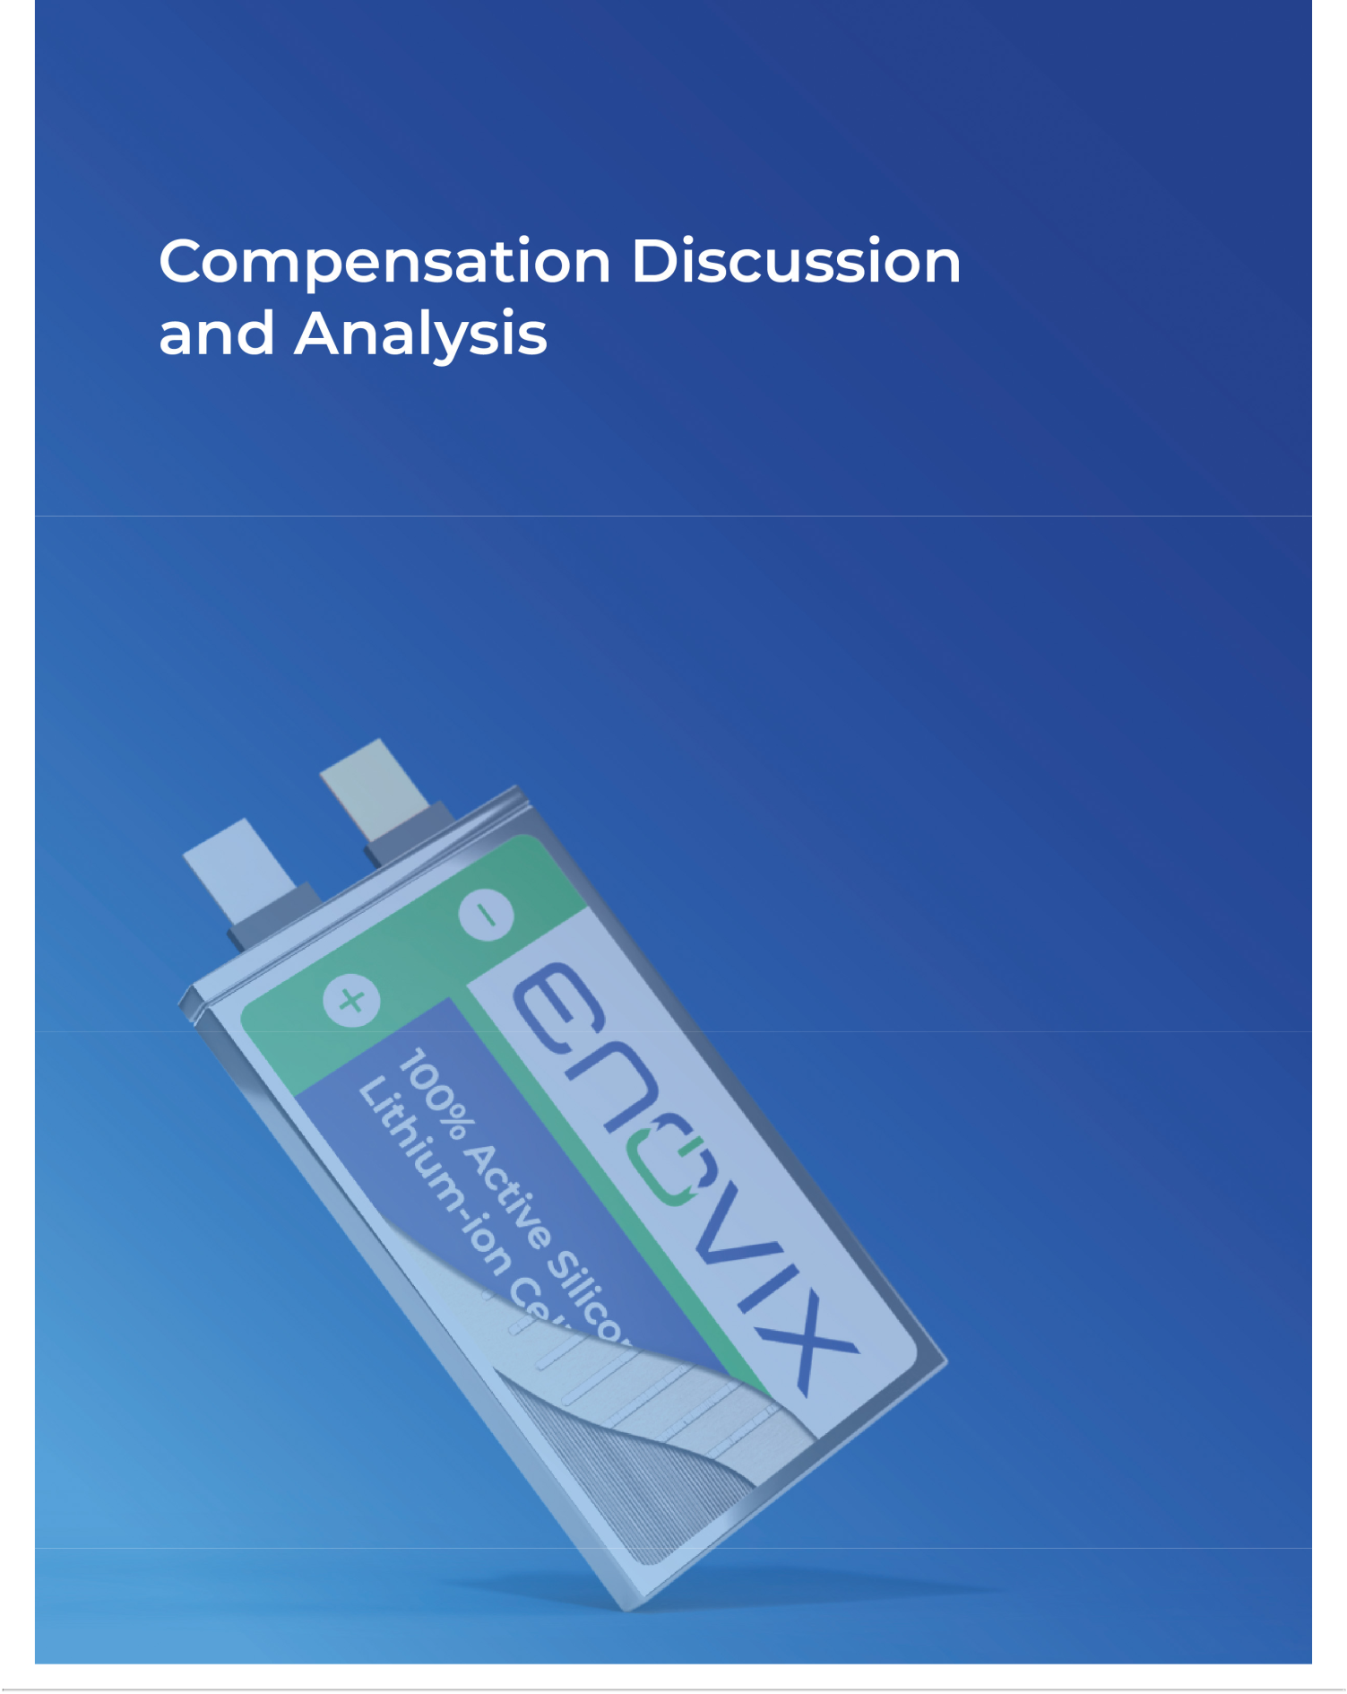

Table of Contents

Compensation Discussion and Analysis

Executive Compensation Program

For fiscal year 2024, our named executive officers (NEOs) were:

Name | Title
Dr. Raj Talluri | President and Chief Executive Officer
Farhan Ahmad | Former Chief Financial Officer ⁽¹⁾
Ajay Marathe | Chief Operating Officer
Arthi Chakravarthy | Chief Legal Officer and Head of Corporate Development

- Mr. Ahmad’s last day of employment as an executive officer was December 16, 2024.

Executive Compensation Principles

We are on a mission to deliver high-performance batteries that unlock the full potential of technology products, such as mobile phones, IoT, and defense. We are headquartered in Fremont, California with strategic operational locations in South Korea, Malaysia, India and China. Our current executive compensation program is intended to align executive compensation with our business objectives and to enable us to attract, retain and reward executive officers who contribute to our long-term success.

The foundational pillar to our executive compensation program is to promote accountability for performance and formulate incentives that will create long-term stockholder value. Our strategy has been to design our compensation programs to drive alignment of all employees, including our named executive officers, with our stockholders.

We believe focusing on long-term stockholder value creates collective motivation and responsibility across our Company, consistent with our one team approach. Accordingly, we have a pay for performance emphasis and the majority of our named executive officers’ 2024 pay is contingent on achievement of long-term goals to meaningfully advance the Company.

In 2024, a majority of our NEOs’ target compensation was primarily performance-based compensation under our annual and long-term incentive programs, consistent with our pay for performance culture. We have designed our executive compensation program to attract, reward, and retain executive officers who create continual near- and long-term stockholder value by achieving the Company’s strategic goals and Corporate Success Factors (CSFs). There were over 130 quarterly and annual corporate CSFs in 2024. We also aim to ensure that our executive compensation program is market competitive, as finding, retaining and motivating exceptional talent is essential to our stability and ability to successfully execute our financial, operational and strategic objectives.

ANNUAL PERFORMANCE: Our short-term annual equity incentive program focuses on key metrics that are critical drivers for the Company’s short-term and long-term strategic objectives. These metrics are a constellation of Company strategic goals and more detailed CSFs that we encourage the Company to focus on.

LONG-TERM PERFORMANCE: The majority of our executives’ total compensation is tied to achieving key goals over multiple years that move the company towards long-term stockholder value and growth. In addition to long-term multi-year goals, we have equity grants that vest over multiple years, which encourages named executive officers to consider longer-term goals.

Enovix Corporation 20 2025 Proxy Statement

Table of Contents

Stockholder Engagement

The feedback we receive from shareholders plays a key role in Board and committee discussions and helps guide the decisions made by the Board. Each year, our executive management team proactively engages with our largest stockholders to understand their views and gather input on key issues. In 2024, the Company engaged with stockholders representing approximately 60% of our outstanding common stock and held substantive discussions with stockholders that expressed an interest. These conversations cover a range of corporate governance topics, including—but not limited to—Board composition, governance practices, and the continued alignment of executive compensation with Company performance. The stockholder feedback was shared with our Board and Compensation Committee, which informed our decision-making regarding compensation practices.

For our 2024 Annual Meeting of Stockholders, approximately 79% of votes cast supported our advisory “say-on-pay” proposal regarding executive compensation. While the Compensation Committee appreciated that a substantial majority of our stockholders supported our compensation practices, it carefully considered the say-on-pay voting results in the following context:

- 50% of our CEO’s 2024 long-term incentives were granted in the form of performance-based equity: In fiscal year 2023, we hired several new executives, including the CEO. Dr. Talluri’s 2023 equity compensation was granted in RSUs to induce him to join Enovix and compensate him for a portion of the awards he forfeited in departing from his prior employer. Initial equity packages for our CEO and other NEOs are structured as a long-term investment in both leadership and company performance. For 2024, 50% of Dr. Talluri and the other NEOs’ equity awards were granted in PRSUs, which require achievement of certain aspirational metrics tied to Company performance and significant efforts to achieve such goals, and 50% were granted in RSUs that vest gradually over multiple years.

- Meaningful year-over-year reduction in CEO pay: For the CEO’s 2024 equity awards, the value of $10.4 million represents an approximate 35% reduction compared to his 2023 equity awards. For the CEO’s 2025 equity awards, the value of $7.0 million granted to Dr. Talluri represents an approximate 33% reduction compared to his 2024 equity awards.

The Compensation Committee will continue to monitor and evaluate our executive compensation program decisions going forward in light of stockholder engagement and investor feedback, including as expressed through the outcome of future say-on-pay votes.

How We Designed Incentives for 2024

In 2024, a majority of our NEO’s target compensation was performance-based compensation under both our annual and long-term incentive programs, consistent with our pay for performance and long-term value creation objectives. In designing incentives for NEOs, the Compensation Committee:

- Set over 100 quarterly and 30 annual rigorous and detailed near-term performance goals across the four quarterly and aggregate annual measurement periods that comprise our short-term incentives. These goals tied to financial, operations, research and development, sales, quality related metrics such as improving our sales outlook, cutting our manufacturing expenses, and milestones around units sold and product launch;

- Paid 100% of quarterly and annual incentive executive compensation in equity to further align executive and stockholder interests; and

- Awarded long-term equity incentives in an equal mix of time-based and performance-based equity that vests over multiple years and, in the case of performance-based awards, upon the achievement of key operations, revenue and research and development targets that are aligned with long-term stockholder value creation.

The charts below highlight the focus on equity and the portion of at-risk mix of the total compensation for our CEO and NEOs based on 2024 compensation. At-risk compensation refers to the portion of an executive’s or employee’s total pay package that is not guaranteed and depends on achievement of performance goals or other conditions being met, and its value varies relative to our stock price performance.

Enovix Corporation 21 2025 Proxy Statement

Table of Contents
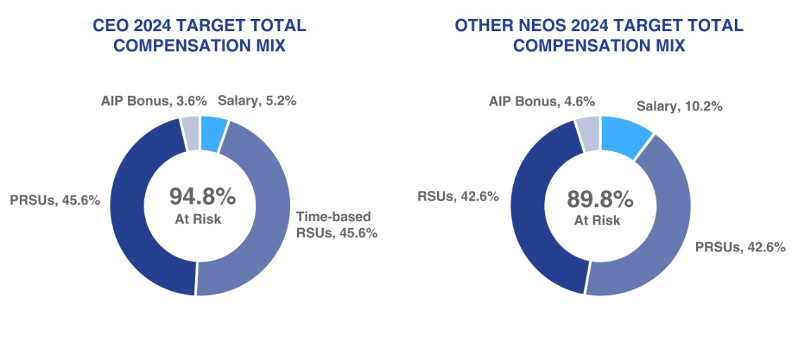

Executive Compensation Components

 |  |  | % of Total Annual
 |  | % of Total Annual | Compensation for
 | Element | Compensation for CEO | Other NEOs | At Risk | Key Features | Long-term Return
 |  |  |  |  | Attract and retain employees;
 | Base Salary | 5.2% | 10.2% |  | recognize performance, job scope | Not applicable
 |  |  |  |  | and experience
 | Quarterly and Annual |  |  | ü | Based on over 100 rigorous
 | Quarterly and Annual | 3.6% | 4.6% | ü | financial, operational, research and | Not applicable
 | Incentives
 | Incentives |  |  | ü | sales goals
 | Long-Term Incentives- | 45.6% | 42.6% | ü | Multi-year vesting; aligned with the | Aligns with long-term
 | Performance Based | 45.6% | 42.6% | ü | Company’s key strategic goals | returns
 | Long-Term Incentives- Time |  |  | ü | Encourages focus on long-term | Aligns with long-term
 | Long-Term Incentives- Time | 45.6% | 42.6% | ü | stockholder value creation, fosters | Aligns with long-term
 | Based |  |  |  |  | returns
 | Based |  |  | ü | retention | returns

2024 Performance Highlights

Our strategic priorities in 2024 were to build out Fab2, achieve site acceptance testing for our manufacturing lines and deliver battery samples to smartphone customers. These and other highlights from fiscal year 2024 include that the Company:

MANUFACTURING:

- Celebrated the grand opening of our Fab2 manufacturing facility in Penang, Malaysia, welcomed customers for tours of the new facility, and had multiple OEMs initiate formal factor audits in support of their qualification processes;

- Completed Site Acceptance Testing (SAT) for its High-Volume Manufacturing (HVM) and Agility lines at Fab2.

PRODUCTS:

- Successfully completed safety testing of EX-1M, with performance results indicating we are on track to meet targets for energy density, cycle life and fast charging;

- Successfully sampled EX-2M to key smartphone customers;

- Began development on our next product category of EX-3M batteries.

Enovix Corporation 22 2025 Proxy Statement

Table of Contents

CUSTOMERS:

- Expanded active customer engagements to seven of the top eight smartphone OEMs;

- Remain on track for commercial smartphone battery launches in 2025, pending successful completion of customer qualifications;

- Advanced relationships with customers in the augmented reality / virtual reality (AR/VR) and smart eyewear markets;

- Entered into a development agreement with a leading automaker and non-binding MOU with a global automotive OEM.

CAPITALIZATION:

- Substantially completed our 2024 Restructuring Plan, including a reduction in force and continued operating expense discipline, providing optionality for funding additional HVM lines in 2025 and beyond.

2024 Compensation Design and Decisions

Base Salary

Base salaries are set at levels that the Compensation Committee, after review of the Peer Group and analysis of the overall market, deems to be necessary to attract and retain highly talented executive officers. Base salaries of our named executive officers are also set with the goal of rewarding executive officers on a day-to-day basis for their time and services and based on their job responsibilities and other applicable considerations. For 2024, the Compensation Committee determined to increase the base salaries of our named executive officers generally consistent with rates of inflation, with the exception of our CEO, which base salary increase reflected his performance.

 |  | 2024 Annualized | Percent Increase
 | Name | Base Salary | Over 2023
 | Name | ($) | (%)
 | Dr. Raj Talluri | 595,000 | 9%
 | Farhan Ahmad | 385,481 | 1%
 | Ajay Marathe | 463,500 | 3%
 | Arthi Chakravarthy | 357,269 | 2%

Annual Incentive Program

Our management team is eligible for short-term incentive compensation through our bonus plan, the Annual Incentive Program (the “AIP”). The AIP is intended to help attract and retain our management team members, reward them based on actual business results and help create a “pay for performance” culture.

Every year the Compensation Committee undertakes a rigorous review and analysis to establish annual corporate performance goals under the AIP, and oversees the process by which our management team members establish individual performance goals under the AIP. We refer to these corporate and individual performance goals as critical success factors (CSFs). Incentive compensation under the AIP in 2024 was split into five eligibility periods: four quarterly and one annual.

There were over 130 quarterly and annual corporate CSFs in 2024 that related to measures of performance, covering financial, manufacturing, research and development, products, sales, operational and other metrics, budgetary and operational goals and objectives relating to manufacturing progress, product development, sales, safety, quality, compliance and human capital management, revenue targets, operational efficiency such as spend reduction, customer growth, technology roadmap execution and the shipment of samples to customers. No single corporate or individual CSF carries more than 15% of the overall performance weighting. Individual CSFs are specifically tailored to the individual’s area of responsibility and oversight. While we do not disclose the specifics of our actual goals due to competitive reasons, the goals were designed, for example, to enable the achievement of our public goals discussed in our quarterly shareholder letters for 2024.

Enovix Corporation 23 2025 Proxy Statement

Table of Contents

The corporate CSF achievement level is based on the Company’s CSF score with a minimum threshold level of achievement of 0% to a maximum of 120%. Similarly, the individual CSF achievement level is based on the individual’s CSF score, with a minimum threshold level of 0% to a maximum of 120%. The Compensation Committee assessed performance based on our achievements of the corporate CSFs and each individual’s achievement of their individual CSFs, as applicable, on a quarterly and annual basis. The average corporate CSF achievement across the bonus payments was 83.3% with the lowest achievement in a given quarter at 54.6%. The corporate CSFs and individual CSFs for the named executive officers for each quarter and the annual period in 2024 are set forth below:

Performance Goals | Corporate CSFs Outcome (%) | Individual CSFs Outcome (%)
Q1 2024 | 80 | 63 - 100
Q2 2024 | 99 | 79 - 100
Q3 2024 | 55 | 55 - 100
Q4 2024 | 100 | 100
Annual 2024 | 83 | 83 - 120

Considering all of these factors, the Compensation Committee determined the individual payouts to the NEOs under the AIP based on the achievement level percentages set forth in the table below. The final payout determination under the AIP can be in the form of cash or equity at the Compensation Committee’s discretion. For 2024, the Compensation Committee elected to use only equity, in the form of fully vested RSUs.

In February 2025, based on Company performance against the 2024 CSFs over the four quarterly and annual performance periods, the Compensation Committee approved the following aggregate 2024 annual incentive award payouts:

 |  |  |  |  | 2024 AIP Payout
 |  | 2024 AIP Maximum | Cash |  | RSUs (1) | Total
Name | 2024 AIP Target ($) | ($) | ($) |  | ($) | ($)
Dr. Raj Talluri | $585,000 | 842,400 |  | — | 422,518 | 422,518
Farhan Ahmad (2) | $138,115 | 198,886 |  | — | 93,588 | 93,588
Ajay Marathe | $368,640 | 530,842 |  | — | 266,890 | 266,890
Arthi Chakravarthy | $213,489 | 307,424 |  | — | 184,974 | 184,974

- The amounts set forth in this column reflect the aggregate grant date fair value of stock awards granted.

- Mr. Ahmad’s last day of employment as an executive officer was December 16, 2024 and his AIP payout was prorated accordingly.

Long-Term Equity Incentive Program (“LTIP”)

We use long-term incentive stock awards consistent with our compensation philosophy to reward and retain our executive officers, align their incentives with the long-term corporate performance of the Company and help drive long-term stockholder value.

Our long-term incentive program is comprised of 50% performance stock units (“PRSUs”) and 50% time-based RSUs. Options, stock appreciation rights and other option-like awards are not part of our core compensation, and we did not grant new awards of these equity instruments in 2024.

Our practice is to approve annual equity awards for executives at the regularly scheduled meetings of our Compensation Committee and Board in February. Executives’ annual equity awards are granted in specified dollar amounts, with the number of shares for each PRSU grant, and time-based RSU grant, determined by the closing price of the Company’s common stock on the grant date, which is generally on or around April 1. We may occasionally grant off-cycle equity awards to executives in connection with a new hire or promotion, or for recognition, retention, or other purposes.

Enovix Corporation 24 2025 Proxy Statement

Table of Contents

The program is designed to align the interests of our executive officers and certain other employees with our mission and the interests of our stockholders. The 2024 equity grant amounts under the 2023 and 2024 LTI Plans were determined based on the Compensation Committee’s assessment of individual performance as well as the compensation data from peer companies and input from Compensia, and each award was comprised of 50% PRSUs and 50% RSUs.

2024 LONG-TERM INCENTIVE AWARDS

The annual equity awards granted to our named executive officers under the 2024 LTIP were determined by our Compensation Committee considering the factors noted above, including review of a competitive market analysis prepared by Compensia.

For the PRSU component of the 2024 LTIP grant, 50% is earned upon our achievement of milestones in fiscal year 2024, and the remaining 50% is earned based on our achievement of milestones in fiscal year 2025. There are two key performance goals in each of fiscal years 2024 and 2025, weighted at 50% each: manufacturing operations and research and development in 2024, and manufacturing operations and product revenue in 2025. The possible payout of PRSUs is based on our achievement of the performance goals and ranges from 0% to 200%. The payout of PRSUs for fiscal year 2024 was 0% due to the non-attainment of the 2024 performance goals.

The time-based RSU component of the 2024 LTIP grant vests in sixteen equal quarterly installments, subject to continued service. The target goal LTI payout is at 50% for the executive team. Under the 2024 LTIP, the Compensation Committee determined the following equity awards granted to each of our named executive officers:

 |  | 2024 LTIP Grant
 | PRSU Grant Shares Vested | PRSU Grant Shares | PRSU Grant Shares | RSU Grant Shares
 | Based on 2024 Performance | Awarded | Forfeited | Awarded
Name | (#)⁽¹⁾ | (#) | (#)⁽¹⁾ | (#)⁽²⁾
Dr. Raj Talluri | — | 412,719 | 206,359 | 412,719
Farhan Ahmad ⁽³⁾ | — | 169,147 | 169,147 | 169,147
Ajay Marathe | — | 135,317 | 67,658 | 135,317
Arthi Chakravarthy | — | 101,488 | 50,744 | 101,488

- Under the 2024 LTIP, 50% of the PRSUs were forfeited as the fiscal year 2024 performance goals for manufacturing operations and research and development were not met, based on an evaluation of the achievement of such goals on February 12, 2025. The achievement of the fiscal year 2025 performance goals for the 2024 LTIP will be reviewed and determined in 2026. 50% of the PRSUs earned in respect to the 2025 performance goals will vest, subject to attainment of the goals, on the third annual anniversary of the grant date and the remaining PRSUs earned in respect to the 2025 performance goals will vest, subject to the attainment of the goals, on the fourth anniversary of the grant date, subject to continued service.

- The time-based RSUs under the 2024 LTIP vest in 16 equal quarterly installments, commencing on April 8, 2024, subject to the officers’ continued service as of each applicable vesting date.

- Mr. Ahmad’s last day of employment as an executive officer was December 16, 2024, prior to the vesting date related to PRSUs tied to the achievement of 2024 performance criteria. As such, all PRSU grant shares were forfeited.

ACHIEVEMENT OF 2023 LONG-TERM INCENTIVE AWARDS

For the PRSU component of the 2023 LTIP grant, one-third (1/3) were earned based upon our achievement of milestones in fiscal year 2023 and the remaining two-thirds (2/3) were earned based on our achievement of milestones in fiscal year 2024. The milestones were annual product revenue goals (reported in accordance with U.S. GAAP in our Form 10-K for both fiscal year 2023 and 2024), weighted at 50% in each fiscal year, and units sold goals in 2023 and in 2024, weighted at 50% in each fiscal year. The possible payout of PRSUs ranges from 0% to 200% for the product revenue milestone and 0% to 150% for the units sold milestone. Overall achievement of fiscal year 2024 goals was 32.7%, of which the annual product revenue goal was achieved at 65.4% and the units sold goal was not met. The PRSUs are subject to delayed release in accordance with our focus on long-term value creation. Accordingly, 50% of the PRSUs will be settled in shares in March 2026, and the remaining 50% of the PRSUs will be settled in shares in the first quarter of 2027.

Enovix Corporation 25 2025 Proxy Statement

Table of Contents

The RSU component of the 2023 LTIP grant has a three-year vesting period with 1/36th vesting monthly, subject to continued service. Under the 2023 LTIP, the Compensation Committee determined the following equity awards granted to each of our named executive officers:

 |  | 2023 LTIP Grant ⁽¹⁾
 | PRSU Grant Shares Vested
 | Based on 2024 | PRSU Grant Shares | PRSU Grant Shares | RSU Grant Shares
 | Performance | Awarded | Forfeited | Awarded
Name | _{(#)}(2) | (#) | _{(#)}(3) | _{(#)}(4)
Dr. Raj Talluri | 95,551 | 292,343 | 196,792 | 292,343
Farhan Ahmad ⁽⁵⁾ | — | 101,488 | 101,488 | 101,488
Ajay Marathe | 33,170 | 101,488 | 68,318 | 101,488
Arthi Chakravarthy | 20,786 | 63,599 | 42,813 | 63,599

- 2023 LTIP Grants were issued in fiscal year 2024, which represented pro-rated awards as the named executive officers joined during 2023.

- Under the 2023 LTIP, (a) no PRSUs vested based on the achievement of the 2023 performance criteria, as the product revenue and units sold goals were not attained, and

(b) 32.68% of the target PRSUs vested on February 12, 2025, based on the overall achievement of the 2024 performance criteria, including partial achievement of the product revenue goal and non-attainment of the units sold goal. 50% of the earned shares will be released on March 2, 2026 and the remaining 50% will be released on March 1, 2027. No 2023 LTIP shares were released in fiscal year 2024.

- Based on an evaluation of the achievement of certain performance criteria on February 12, 2025, the remaining portion of each named executive officers’ PRSU grant shares under the 2023 LTIP were forfeited.

- The time-based RSUs under the 2023 LTIP vest in 36 equal monthly installments, commencing on April 8, 2024, subject to the officers’ continued service as of each applicable vesting date.

- Mr. Ahmad’s last day of employment as an executive officer was December 16, 2024, prior to the vesting date related to PRSUs tied to the achievement of 2024 performance criteria. As such, all awarded PRSU shares were forfeited.

Enovix Corporation 26 2025 Proxy Statement

Table of Contents

Other Aspects of Executive Compensation

Compensation Consultant

During fiscal year 2024, the Compensation Committee retained Compensia, Inc. as its independent compensation consultant. The Compensation Committee requested that Compensia:

- provide market information, analysis, and other advice relating to executive compensation on an ongoing basis;

- evaluate the efficacy of our existing compensation strategy and practices in supporting and reinforcing our long-term strategic goals; and

- assist in refining our compensation strategy and in developing and implementing an executive compensation program to execute that strategy.

Over the course of 2024, Compensia advised on appropriate compensation for attracting and retaining executives based on the peer group and discussions with the Compensation Committee and executives. The Compensation Committee considered Compensia’s input as part of its decision-making process.

The Compensation Committee has evaluated its relationship with Compensia to ensure that it believes that such firm is independent from management. This review process included a review of the services that Compensia provided, the quality of those services and other applicable factors. Based on this review, as well as consideration of the factors affecting independence set forth in Exchange Act Rule 10C-1(b)(4), Rule 5605(d)(3)(D) of the Nasdaq listing standards, and such other factors as were deemed relevant under the circumstances, the Compensation Committee has determined that no conflict of interest was raised as a result of the work performed by Compensia.

Peer Group

On an annual basis, the Compensation Committee compares the NEOs’ total compensation to a peer group of companies in the industry to ensure that it is providing market competitive pay opportunities. The peer group consists of publicly traded companies of a similar market capitalization and focused on manufacturing and research and development in related industries including electrical components, semiconductors, technology hardware, chemicals and other industries adjacent to the broader battery technology space that may compete with Enovix for executive talent. The Compensation Committee targets less than the 50th percentile for the Company’s senior executive officers’ cash compensation and the 50th percentile for the equity compensation relative to the peer group. Actual equity compensation grants determined by the Compensation Committee are dependent on consideration of retention, performance, experience and other factors, in addition to peer group percentile targets.

The Compensation Committee conducts an annual review of our peer group composition to make any necessary adjustments to remove companies that no longer share similar developmental, market and organizational characteristics, and refine the selection criteria to include companies more relevant to the battery industry. While the Compensation Committee generally aims for year-over-year consistency in the peer group, it determined a number of changes were necessary for the peer group used to assess 2024 compensation decisions to better align with our prioritization of companies within the battery industry and focused on manufacturing and research and development.

Accordingly, the Compensation Committee added the seven companies marked below with an asterisk (*) to the peer group, and removed nine companies in adjacent automotive and chemical markets, that were outside the market cap range or revenue range, or otherwise did not have a significant technology component to their research and development or manufacturing activities similar to the Company (Blink Charging, ChargePoint, Energy Recovery, Eos Energy Enterprises, EVgo, Fisker, FuelCell Energy, Luminar Technologies, Solid Power).

Enovix Corporation 27 2025 Proxy Statement

Table of Contents

For 2024, our peer group consists of the following publicly traded companies:

Ambarella | indie Semiconductor* | Rambus
Amprius Technologies | IonQ* | SES AI
Arcadium Lithium¹ | MaxLinear* | Shoals Technologies Group
Cohu* | Navitas Semiconductor | Semtech*
Credo Technology Group* | QuantumScape | SiTime
Impinj | Power Integrations* | Wolfspeed

- Included in our 2023 peer group as Livent, prior to its January 2024 merger with Alkem to form Arcadium Lithium.

Clawback Policy

The Compensation Committee has adopted an Incentive Compensation Recoupment Policy (“Clawback Policy”) that complies with Nasdaq Listing Rule 5608, Section 10D of the Exchange Act and the rules promulgated thereunder. The Clawback Policy requires that covered executives must reimburse us, or forfeit, any excess incentive-based compensation received by such covered executive during the three completed fiscal years immediately preceding the date on which we are required to prepare an accounting restatement of our financial statements due to material noncompliance with any financial reporting requirement under the securities laws. Executives covered by the Clawback Policy include our current and former executive officers, as determined by the Compensation Committee in accordance with Section 10D of the Exchange Act and Nasdaq listing standards, and such other senior executives or employees who may from time to time be deemed subject to the Clawback Policy by the Compensation Committee.

Incentive-based compensation subject to the Clawback Policy includes any compensation that is granted, earned or vested based wholly or in part on the attainment of a financial reporting measure. The amount subject to recovery is the excess of the incentive-based compensation received based on the erroneous data over the incentive-based compensation that would have been received had it been based on the restated results, and is computed without regard to any taxes paid. The Clawback Policy will only apply to incentive-based compensation received on or after October 2, 2023, the effective date of the Clawback Policy.

Equity Grant Practices

We do not grant equity awards in anticipation of the release of material nonpublic information or time the release of material nonpublic information for the purpose of affecting the value of executive compensation. During fiscal year 2024, we did not grant stock options, stock appreciation rights, or similar option-like instruments to our named executive officers.

Employment Arrangements With Named Executive Officers

We believe that a strong, experienced management team is essential to the best interests of the Company and our stockholders. The employment agreements with our named executive officers provide for at-will employment and set forth the material initial terms of employment. Our named executive officers are also eligible for certain severance and change of control benefits, as described below under “Potential Payments Upon Termination or Change of Control.” In addition, each of our named executive officers has executed our standard confidential information and invention assignment agreement. The key terms of these agreements are described below.

Dr. Raj Talluri

We entered into an employment agreement with Dr. Talluri in January 2023, which governs the current terms of Dr. Talluri’s employment with us. The agreement provides for an initial annual base salary of $545,000 and an initial grant of 2,000,000 RSUs with a five-year vesting period. In addition, Dr. Talluri is eligible to receive an annual discretionary bonus of up to 100% of his base salary based in part on individual and corporate performance metrics. He may be granted future additional equity awards at the discretion of the Board of Directors.

Enovix Corporation 28 2025 Proxy Statement

Table of Contents

Farhan Ahmad

We entered into an employment agreement with Mr. Ahmad in July 2023, which governed the terms of Mr. Ahmad’s employment with us until his last day of employment as an executive officer on December 16, 2024. The agreement provided for an initial annual base salary of $380,000 and an initial grant of 202,020 RSUs with a five-year vesting period, of which the unvested portion was cancelled upon the termination of his consulting arrangement with the Company in January 2025. In addition, Mr. Ahmad was eligible to receive an annual discretionary bonus of up to 60% of his base salary based in part on individual and corporate performance metrics.

Ajay Marathe

We entered into an employment agreement with Mr. Marathe in November 2022, which governs the current terms of Mr. Marathe’s employment with us. The agreement provides for an initial annual base salary of $450,000 and an initial grant of 833,000 RSUs with a 5-year vesting period. In addition, Mr. Marathe is eligible to receive an annual discretionary bonus of up to 80% of his base salary based in part on personal and corporate performance metrics. He may be granted future additional equity awards at the discretion of the Board of Directors.

Arthi Chakravarthy

We entered into an employment agreement with Ms. Chakravarthy in April 2023, which governs the terms of her employment with us. The agreement provides for an initial annual base salary of $350,000 and an initial grant of 251,601 RSUs with a five-year vesting period. In addition, Ms. Chakravarthy is eligible to receive an annual discretionary bonus of up to 60% of her base salary, based in part on individual and corporate performance metrics. She may be granted future additional equity awards at the discretion of the Board of Directors.

Consulting Arrangement

Our former Chief Financial Officer, Farhan Ahmad, entered into a consulting agreement with us on December 17, 2024, pursuant to which Mr. Ahmad provided consulting services to us through the end of the consulting period on January 10, 2025. During the consulting period, Mr. Ahmad received a pro rata amount of his base salary as an executive officer and his RSUs continued to vest through the termination of his consulting arrangement. Mr. Ahmad did not receive any severance payments or other benefits in connection with his departure.

NON-QUALIFIED DEFERRED COMPENSATION

Our named executive officers did not participate in, or earn any benefits under, any non-qualified deferred compensation plan. Our Board of Directors may elect to provide officers and other employees with non-qualified deferred compensation benefits in the future if it determines that doing so is in our best interests.

PENSION BENEFITS

Our named executive officers did not participate in, or otherwise receive any benefits under, any pension or retirement plan sponsored by Enovix during fiscal year 2024.

SEVERANCE AND CHANGE OF CONTROL BENEFITS

Each named executive officer’s employment agreement provides for certain severance benefits if the executive’s employment is involuntarily terminated by us without "cause” or the executive resigns for “good reason,” and also provides for enhanced equity acceleration benefits if the qualifying termination of employment occurs in connection with a change of control of the Company. All such severance benefits are subject to execution and effectiveness of a release of claims and compliance with the applicable named executive officer’s employment agreement, confidentiality agreements, and non-competition and non-solicitation agreements, as well as returning all Company property to us.

We believe that these severance benefits are an important element of our executive compensation and retention program, which has particular importance in the context of a corporate transaction because providing change of control related severance benefits also should eliminate, or at least reduce, the reluctance of our named executive officers to diligently consider and pursue potential transactions that may be in the best interests of our stockholders. We also believe that our severance benefit arrangements with our named executive officers are consistent with compensation arrangements provided

Enovix Corporation 29 2025 Proxy Statement

Table of Contents

in a competitive market for executive talent and the events triggering payment represent appropriate hurdles for the severance benefits. We further believe that the benefits of such severance arrangements, including generally requiring a release of claims against us as a condition to receiving the severance benefits, are in our best interests.

Upon a named executive officer’s termination of employment, on a case-by-case basis we will also enter into a separation agreement with the named executive officer providing for severance benefits in exchange for a release of claims against the Company.

A description of the terms and conditions of the foregoing severance benefits and separation agreements, as well as information about the estimated payments that our named executive officers would have been eligible to receive as of December 29, 2024 (or for our named executive officers who terminated employment in 2024, a summary of the payments they actually received), are set forth in “Potential Payments upon Termination or Change of Control” below.

NO TAX GROSS-UPS

In fiscal year 2024, we did not make gross-up payments to cover our NEOs’ personal income taxes that pertained to any of the compensation, perquisites or personal benefits paid or provided by us.

HEALTH AND WELFARE BENEFITS

We provide benefits to our NEOs on the same basis as provided to all of our employees, including health, dental and vision insurance; and life and disability insurance. We do not maintain any executive-specific benefit or perquisite programs (other than as described below under “Potential Payments Upon Termination or Change of Control”).

401(K) PLAN

We maintain a 401(k) plan that provides eligible U.S. employees with an opportunity to save for retirement on a tax-advantaged basis. Eligible employees are able to defer eligible compensation up to certain limits under the Internal Revenue Code of 1986, as amended (the “Code”). We have the ability to make matching and discretionary contributions to the 401(k) plan and previously contributed 3% of base salary to employees’ accounts, regardless of an employee’s contribution decision. As of June 15, 2024, only certain employees below a specific salary threshold are eligible to receive the discretionary 3% of base salary contribution, which is provided regardless of an employee’s contribution decision. The 401(k) plan is intended to be qualified under Section 401(a) of the Code, with the related trust intended to be tax exempt under Section 501(a) of the Code. As a tax-qualified retirement plan, contributions to the 401(k) plan are deductible by us when made, and contributions and earnings on those amounts are not generally taxable to employees until withdrawn or distributed from the 401(k) plan.

Compensation Committee Report

Our Compensation Committee has reviewed and discussed the section titled “Compensation Discussion and Analysis” with our management. Based upon this review and discussion, the Compensation Committee recommended to the Board of Directors that the section titled “Compensation Discussion and Analysis” be included in this Proxy Statement and our Annual Report on Form 10-K for the fiscal year ended December 29, 2024.

Respectfully submitted by the Compensation Committee of the Board of Directors.

Gregory Reichow (Chairperson)

Betsy Atkins

Joseph Malchow

This report of the Compensation Committee shall not be deemed to be “soliciting material” or to otherwise be considered “filed” with the SEC, nor shall such information be incorporated by reference into any future filing under the Securities Act of 1933, as amended, or the Securities Exchange Act of 1934, as amended, except to the extent that the Company specifically incorporates it by reference into such filing.

Enovix Corporation 30 2025 Proxy Statement

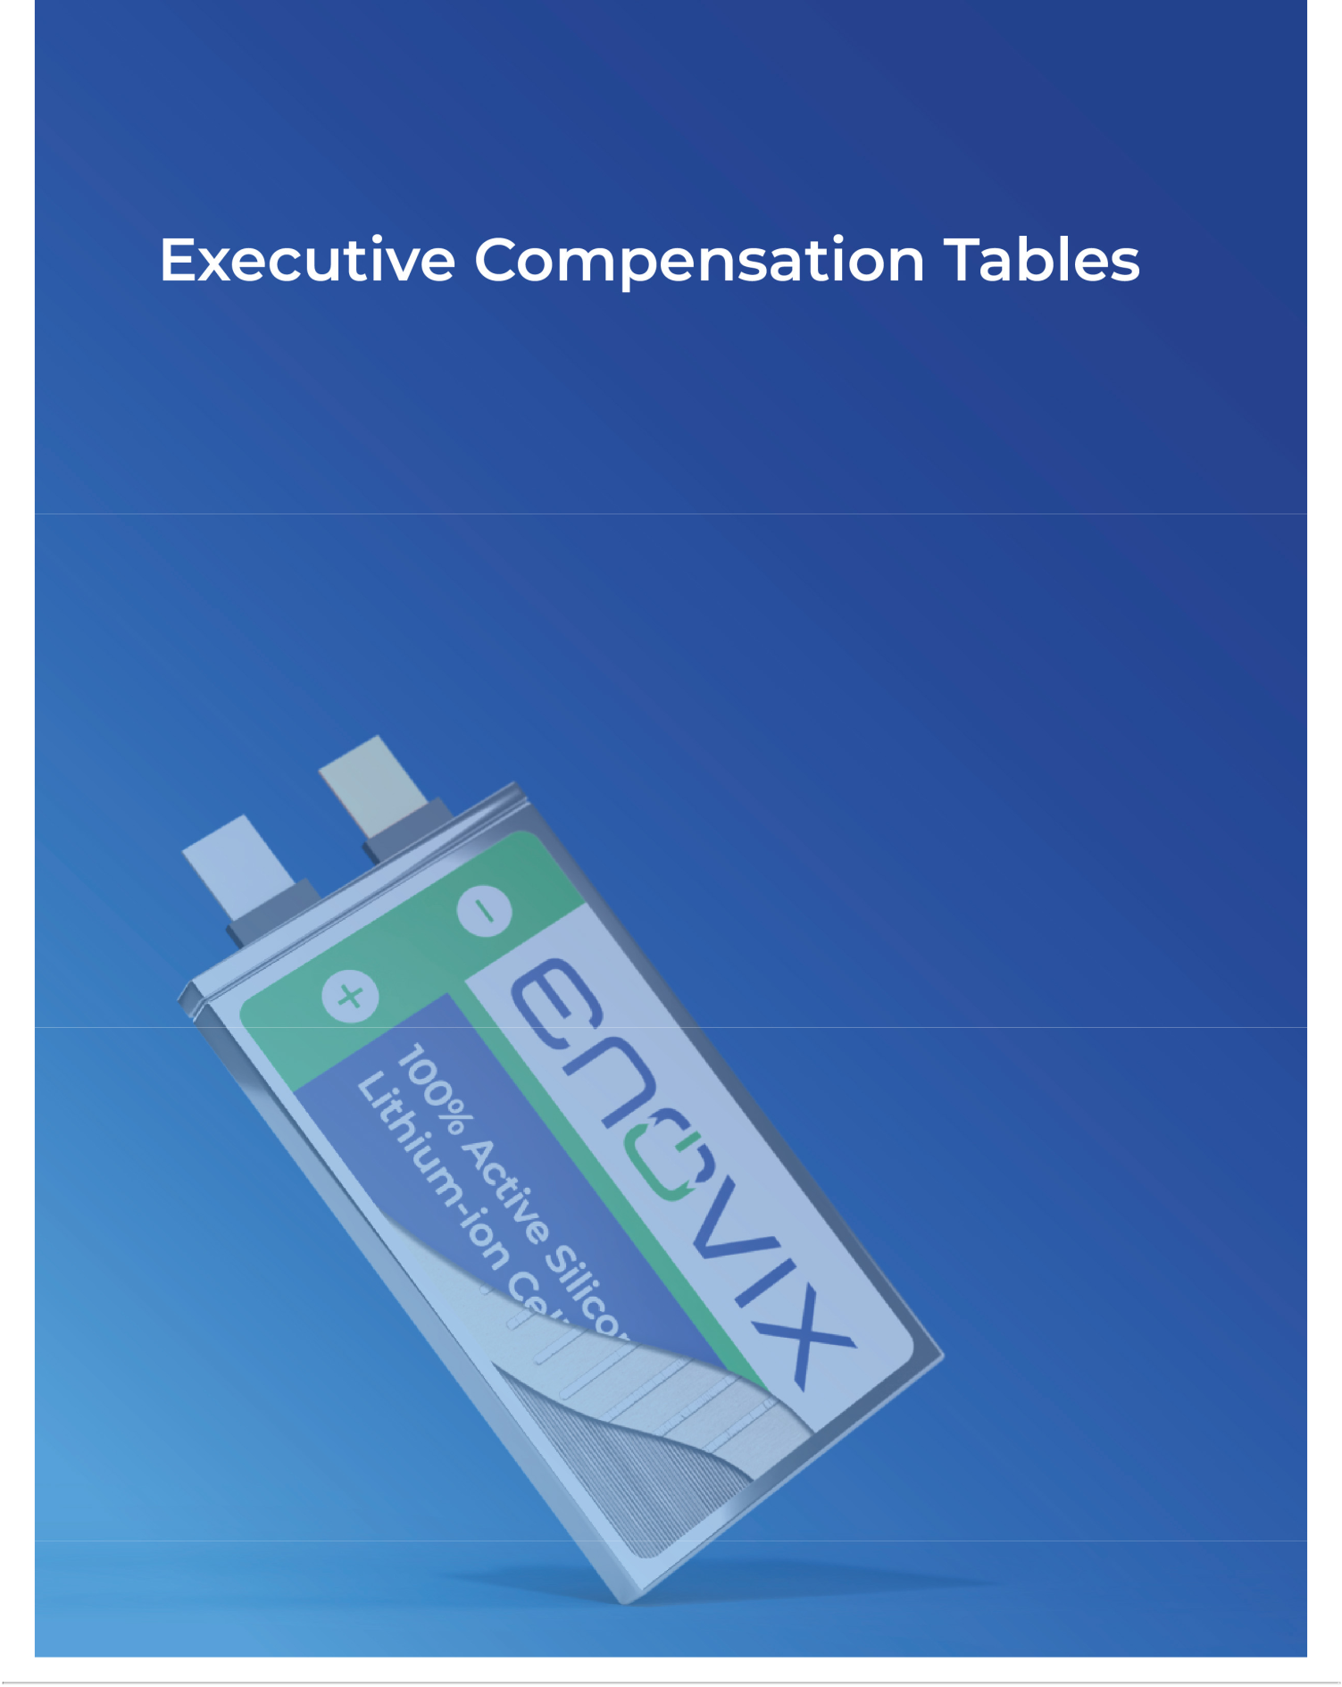

Table of Contents

Executive Compensation Tables

2024 Summary Compensation Table

The following table shows information regarding the compensation earned by or paid to our named executive officers during the fiscal years ended December 29, 2024, December 31, 2023, and January 1, 2023 (referred to as fiscal year 2024, 2023 and 2022, respectively).

 |  |  |  |  |  | Non-Equity
 |  |  |  |  | Stock | Incentive Plan | All Other
 |  |  | Salary | Bonus | Awards | Compensation | Compensation | Total
 | Name and Principal Position | Fiscal Year⁽¹⁾ | ($) | ($) | ($)⁽²⁾ | ($)⁽³⁾ | ($)⁽⁴⁾ | ($)
 | Dr. Raj Talluri | 2024 | 595,000 | — | 10,420,816 | 422,518 | 13,914 | 11,452,248
 | President and Chief Executive
 | Officer | 2023 | 519,846 | — | 16,140,000 | 328,719 | 13,992 | 17,002,557
 | Farhan Ahmad | 2024 | 372,137 | — | 3,999,985 | 93,588 | 21,702 | 4,487,412
 | Former Chief Financial Officer | 2023 | 182,692 | — | 3,999,996 | 60,544 | 5,886 | 4,249,118
 |  | 2024 | 463,500 | — | 3,499,978 | 266,890 | 10,392 | 4,240,760
 | Ajay Marathe
 | Ajay Marathe | 2023 | 450,000 | — | — | 121,259 | 13,949 | 585,208
 | Chief Operating Officer
 |  | 2022 | 60,577 | — | 11,628,680 | 38,880 | 1,650 | 11,729,787
 | Arthi Chakravarthy | 2024 | 357,269 | — | 2,439,986 | 184,974 | 7,963 | 2,990,192
 | Chief Legal Officer | 2023 | 242,308 | — | 2,749,999 | 84,291 | 7,830 | 3,084,428

- The Company’s fiscal year generally ends on the Sunday that is closest to December 31 and contains 52 weeks, except for the years with 53 weeks.

- The amounts reported in this column do not reflect dollar amounts actually received by the named executive officers. Instead, these amounts represent the grant-date fair value of RSUs and PRSUs granted in the applicable fiscal year and the incremental fair value of RSUs and PRSUs modified in the applicable fiscal year, in each case calculated in accordance with the Financial Accounting Standards Board’s (“FASB”) Accounting Standards Codification (“ASC”) Topic 718, Stock-based Compensation (“ASC 718”). For the PRSUs, the reported amounts presented above were calculated with the estimated probable outcome of the performance vesting condition in accordance with ASC 718 as of the grant date. See Note 2 to the Consolidated Financial Statements included in our Annual Report on Form 10-K for the fiscal year ended December 31, 2024 for a discussion of the relevant assumption used in calculating these amounts. The following table presents the target and maximum amounts of the aggregate grant date fair value of PRSUs granted under the 2023 and 2024 LTIP in fiscal year 2024.

 |  | Aggregate Grant Date Fair Value of PRSUs under 2023 and 2024
 |  | LTIP
Name | Grant Date | Target ($) | Maximum ($)
Dr. Raj Talluri | 4/8/2024 | 5,210,408 | 10,420,816
Farhan Ahmad^{(i)} | 4/8/2024 | 1,999,993 | 3,999,986
Ajay Marathe | 4/8/2024 | 1,749,989 | 3,499,978
Arthi Chakravarthy | 4/8/2024 | 1,219,993 | 2,439,986

- The PRSUs granted to Mr. Ahmad were forfeited in their entirety pursuant to the terms of the PRSU grant agreement, which provide that the grantee remain employed through the vesting date (as defined in the LTIP) in order to be eligible for the award.

Enovix Corporation 32 2025 Proxy Statement

Table of Contents

- The amounts reported in this column represent the amount earned under the AIP for each fiscal year, which included the actual payout in cash or fully vested RSUs in the following year. For the 2024 AIP payments in the form of fully vested RSUs, please refer to 2024 AIP payout table in the “2024 AIP Pay-for-Performance Alignment” section of this Proxy Statement.

- The following table summarizes the components of fiscal year 2024 total other compensation for our named executive officers, including 401(k) contributions, life insurance premiums and consulting service compensation.

 |  | 401(k) Employer | Group Term Life | Consulting | 2024 Total Other
 | Name | Contribution | Insurance | Service Compensation | Compensation
 | Name | ($) | ($) | ($) | ($)
 | Dr. Raj Talluri | 10,350 | 3,564 | — | 13,914
 | Farhan Ahmad^{(i)} | 7,548 | 810 | 13,344 | 21,702
 | Ajay Marathe | 6,828 | 3,564 | — | 10,392
 | Arthi Chakravarthy | 7,153 | 810 | — | 7,963

- Mr. Ahmad’s last day of employment as our Chief Financial Officer was December 16, 2024 and he entered into a consulting agreement with the Company on December 17, 2024, pursuant to which Mr. Ahmad provided consulting services to us through the end of the consulting period on January 10, 2025. During the consulting period, Mr. Ahmad received a pro rata amount of his base salary as an executive officer.

Enovix Corporation 33 2025 Proxy Statement

Table of Contents

2024 Grants of Plan-Based Awards Table

The following table provides information regarding the possible payouts to our named executive officers in fiscal year 2024 under the 2024 AIP, the LTIP and the equity awards received by our named executive officers in fiscal year 2024 under the Company’s 2021 Equity Incentive Plan (the “2021 Plan”).

 |  |  |  | Estimated Possible Payouts Under Non- |  |  |  | Estimated Possible Payouts Under Equity
 |  |  |  | Equity Incentive Plan Awards⁽¹⁾ |  |  |  | Incentive Plan Awards⁽²⁾
 |  |  |  |  |  |  |  |  |  |  |  | All Other
 |  |  |  |  |  |  |  |  |  |  | All Other | Option Awards:
 |  |  |  |  |  |  |  |  |  |  | Stock Awards: | Number of | Exercise Price | Grant Date Fair
 |  |  |  |  |  |  |  |  |  |  | Number of | Securities | or Base Price | Value of Stock
 |  |  |  |  |  |  |  |  |  |  | Shares or | Underlying | of Option | and Option
 |  |  |  |  |  |  |  |  |  |  | Units | Options | Awards | Awards
 | Name | Award Type | Grant Date | Threshold($) | Target ($) | Maximum ($) |  | Threshold (#) | Target (#) | Maximum (#) | _{(#)}(3) | (#) | ($) | _{($)}(4)
 | Dr. Raj Talluri | _{RSU}(5) | 4/08/2024 | — | — | — |  | — | — | — | 292,343 | — | — | 2,160,415
 |  | RSU⁽⁶⁾ | 4/08/2024 | — | — | — |  | — | — | — | 412,719 | — | — | 3,049,993
 |  | 2023 LTIP
 |  | PRSU⁽⁷⁾ | 4/08/2024 | — | — | — |  | — | 292,343 | 584,686 | 292,343 | — | — | 2,160,415
 |  | 2024 LTIP
 |  | PRSU⁽⁸⁾ | 4/08/2024 | — | — | — |  | — | 412,719 | 825,438 | 412,719 | — | — | 3,049,993
 |  | AIP - | — | — | 585,000 | 842,400 |  | — | — | — | — | — | — | —
 |  | Cash/RSU
 |  | _{RSU}(5)(9) | 4/08/2024 | — | — | — |  | — | — | — | 101,488 | — | — | 749,996
 | Farhan Ahmad
 | Farhan Ahmad | _{RSU}(6)(9) | 4/08/2024 | — | — | — |  | — | — | — | 169,147 | — | — | 1,249,996
 |  | 2023 LTIP
 |  | _{PRSU}(7)(9) | 4/8/2024 | — | — | — |  | — | 101,488 | 202,976 | 101,488 | — | — | 749,996
 |  | 2024 LTIP
 |  | _{PRSU}(8)(9) | 4/8/2024 | — | — | — |  | — | 169,147 | 338,294 | 169,147 | — | — | 1,249,996
 |  | AIP - | — | — | 138,115 | 198,886 |  | — | — | — | — | — | — | —
 |  | Cash/RSU
 | Ajay Marathe | _{RSU}(5) | 4/08/2024 | — | — | — |  | — | — | — | 101,488 | — | — | 749,996
 |  | RSU⁽⁶⁾ | 4/08/2024 | — | — | — |  | — | — | — | 135,317 | — | — | 999,993
 |  | 2023 LTIP
 |  | PRSU⁽⁷⁾ | 4/8/2024 | — | — | — |  | — | 101,488 | 202,976 | 101,488 | — | — | 749,996
 |  | 2024 LTIP
 |  | PRSU⁽⁸⁾ | 4/8/2024 | — | — | — |  | — | 135,317 | 270,634 | 135,317 | — | — | 999,993
 |  | AIP - | — | — | 368,640 | 530,842 |  | — | — | — | — | — | — | —
 |  | Cash/RSU
 |  | RSU⁽⁵⁾ | 4/08/2024 | — | — | — |  | — | — | — | 63,599 | — | — | 469,997
 | Arthi
 | Chakravarthy | RSU⁽⁶⁾ | 4/08/2024 | — | — | — |  | — | — | — | 101,488 | — | — | 749,996
 |  | 2023 LTIP
 |  | PRSU⁽⁷⁾ | 4/8/2024 | — | — | — |  | — | 63,599 | 127,198 | 63,599 | — | — | 469,997
 |  | 2024 LTIP
 |  | PRSU⁽⁸⁾ | 4/8/2024 | — | — | — |  | — | 101,488 | 202,976 | 101,488 | — | — | 749,996
 |  | AIP - | — | — | 213,489 | 307,424 |  | — | — | — | — | — | — | —
 |  | Cash/RSU

- Amounts reported in these columns represent the target and maximum amount of possible cash incentive opportunities, which are at the discretion of our Board of Directors or the Compensation Committee, be paid in the form of fully vested RSUs, provided to our named executive officers in fiscal year 2024 under the AIP, the terms of which are summarized under “Compensation Discussion and Analysis—Principal Elements of Compensation—Bonuses” and which do not represent actual compensation earned by our named executive officers for fiscal year 2024. There is no threshold amount disclosed in the table because earned amounts can go as low as zero. Target and maximum amounts were set as a percentage of each named executive officer’s base salary for fiscal year 2024 and adjusted for fiscal year 2024 in accordance with their employment tenure. For the actual amounts paid to each of the named executive officers, see the “Summary Compensation Table” above and the applicable footnotes.

Enovix Corporation 34 2025 Proxy Statement

Table of Contents

- Amounts reported in these columns represent PRSUs granted under the LTIP in fiscal year 2024 that will vest based on various goals with target (100%) and maximum (200%) payouts, as further described under “Compensation Discussion and Analysis—Executive Compensation Program—Executive Compensation Components—Long-Term Incentive Program.” There is no threshold amount disclosed in the table because earned amounts can go as low as zero.

- Represents RSUs granted.

- Amounts reported in this column do not reflect dollar amounts actually received by the named executive officers. Instead, these amounts represent the grant-date fair value of RSUs, PRSUs and stock options calculated in accordance with ASC 718. For the PRSUs, the reported amounts presented above were calculated with the estimated probable outcome of the performance vesting condition as of the grant date in accordance with ASC 718. See Note 2 to the Consolidated Financial Statements included in our Annual Report on Form 10-K for the fiscal year ended December 29, 2024 for a discussion of the relevant assumptions used in calculating these amounts.

- These RSUs vest in 36 equal monthly installments on each monthly anniversary of the vesting commencement date of April 8, 2024, subject to each individual’s continued service at each vesting date.

- These RSUs vest in 16 equal quarterly installments on each quarterly anniversary of the vesting commencement date of April 8, 2024, subject to each individual’s continued service at each vesting date.

- These 2023 LTIP PRSUs were granted in fiscal year 2024, of which 32.68% of the target PRSUs vested on February 12, 2025, upon the achievement of certain 2024 performance criteria and the remaining portion was forfeited. 50% of the vested shares will be released on March 2, 2026 and the remaining 50% will be released on March 1, 2027.

- These 2024 LTIP PRSUs were granted in fiscal year 2024, of which 50% of the target PRSUs were tied to performance criteria for fiscal year 2024 and 50% of the target PRSUs are tied to performance criteria for fiscal year 2025. The portion tied 2024 performance criteria was forfeited. With respect to the portion that is tied to 2025 performance criteria, subject to the achievement of the goals, 25%, 50% and 25%, respectively, will vest subject to continued service in the second quarter of fiscal year 2026, 2027 and 2028.

- Mr. Ahmad’s last day of employment as an executive officer was December 16, 2024, prior to the vesting date of the PRSUs, which tied to the achievement of 2024 performance criteria. As such, all awarded PRSU shares were forfeited.

Enovix Corporation 35 2025 Proxy Statement

Table of Contents

Outstanding Equity Awards as of December 29, 2024

The following table shows certain information regarding outstanding equity awards held by each of our named executive officers as of December 29, 2024.

 |  |  | Stock Awards
 |  |  |  |  | Equity Incentive Plan Awards:
 |  |  |  | Equity Incentive Plan Awards: | Market or Payout Value of
 |  |  |  | Number of Unearned Shares, | Unearned Shares, Units or
 |  | Number of Shares or Units of | Market Value of Shares or Units | Units or Other Rights That | Other Rights That Have Not
 |  | Stock That Have Not Vested | of Stock That Have Not Vested | Have Not Vested | Vested
Name | Grant Date | (#) | ($)⁽¹⁾ | (#) | ($)⁽¹⁾
Dr. Raj Talluri | 1/18/2023⁽²⁾ | 1,233,334 | 13,912,008 | — | —
 | 4/8/2024⁽³⁾ | 227,378 | 2,564,824 | — | —
 | 4/8/2024⁽⁴⁾ | 361,129 | 4,073,535 | — | —
 | 4/8/2024 ⁽⁵⁾ | — | — | 95,551 | 1,077,815
 | 4/8/2024 ⁽⁶⁾ | — | — | 206,360 | 2,327,741
Farhan Ahmad | 7/10/2023⁽²⁾ | 144,781 | 1,633,130 | — | —
 | 4/8/2024⁽³⁾⁽⁷⁾ | 78,936 | 890,398 | — | —
 | 4/8/2024⁽⁴⁾⁽⁷⁾ | 148,004 | 1,669,485 | — | —
Ajay Marathe | 11/14/2022⁽²⁾ | 485,917 | 5,481,144 | — | —
 | 4/8/2024⁽³⁾ | 78,936 | 890,398 | — | —
 | 4/8/2024⁽⁴⁾ | 118,402 | 1,335,575 | — | —
 | 4/8/2024 ⁽⁵⁾ | — | — | 33,170 | 374,158
 | 4/8/2024 ⁽⁶⁾ | — | — | 67,659 | 763,194
Arthi Chakravarthy | 5/1/2023⁽²⁾ | 167,734 | 1,892,040 | — | —
 | 4/8/2024⁽³⁾ | 49,466 | 557,976 | — | —
 | 4/8/2024⁽⁴⁾ | 88,802 | 1,001,687 | — | —
 | 4/8/2024 ⁽⁵⁾ | — | — | 20,786 | 234,466
 | 4/8/2024⁽⁶⁾ | — | — | 50,744 | 572,392

- The amount reported in this column represents the values of unvested RSUs as of December 29, 2024, which are based on the closing price of our common stock of $11.28 on December 27, 2024, the last trading day of fiscal year 2024.

- 1/5th of the shares of our common stock underling the RSUs shall vest on the one-year anniversary of the vesting commencement date, which is the grant date, and the remaining shares of our common stock underlying the RSUs shall vest in 48 equal monthly installments thereafter, subject to each individual’s continued service at each vesting date.

- These RSUs shall vest on in 36 equal monthly installments on each monthly anniversary of the vesting commencement date, which is the grant date, subject to each individual’s continued service at each vesting date.

- These RSUs shall vest on in 16 equal quarterly installments on each quarterly anniversary of the vesting commencement date, which is the grant date, subject to each individual’s continued service at each vesting date.

- These PRSUs represent the portion of the 2023 PRSUs (32.68%) that vested on February 12, 2025 based on the achievement of the 2024 performance criteria, of which 50% will be released on March 2, 2026 and the remaining 50% will be released on March 1, 2027. The remaining portion of the PRSUs were forfeited.

- These PRSUs represent the number of 2024 PRSUs that are outstanding (excluding the amount forfeited under the 2024 LTIP for the non-attainment of performance goals for fiscal year 2024) and eligible to vest subject to the achievement of the goals associated with the LTI plan for fiscal year 2025, of which 25%, 50% and 25%, respectively, will vest subject to continued service in the second quarter of fiscal year 2026, 2027 and 2028.

- Mr. Ahmad’s last day of employment as an executive officer was December 16, 2024, prior to the vesting date for the PRSUs that tied to achievement of 2024 performance criteria. As such, all awarded PRSU shares were forfeited.

Enovix Corporation 36 2025 Proxy Statement

Table of Contents

Option Exercises and Stock Vested

The following table provides information on stock option exercises, RSUs and PRSUs vested for our named executive officers during fiscal year 2024. There were no options exercised during the fiscal year 2024.

 | RSUs/PRSUs
 | Number of Shares Acquired on Vesting | Value Realized on Vesting
Name | (#)⁽¹⁾ | ($)⁽²⁾
Dr. Raj Talluri | 904,887 | 8,964,565
Farhan Ahmad | 110,220 | 1,418,502
Ajay Marathe | 219,739 | 2,267,951
Arthi Chakravarthy | 120,454 | 1,005,188

- The number of shares vested reported in this column excludes the 2024 AIP payout, which was granted as fully vested RSUs instead of cash.

- The values realized upon vesting for RSUs and PRSUs are based on the closing price of our common stock on the vesting dates. If the vesting date falls on a date the stock market is closed, the realized values are based on the latest available closing price of our common stock prior to the vesting date.

Potential Payments Upon Termination or Change of Control

Upon the termination of a named executive officer’s employment, the named executive officer is entitled to receive their base salary accrued through their last day of employment, as well as any unused vacation accrued through their last day of employment.

Change of Control and Severance Benefit Provisions

In each of our named executive officer’s employment agreements, the agreements contain a severance section that provides for severance benefits, including in connection with a Change of Control (all capitalized terms in this section, as defined in the employment agreements), subject to execution and effectiveness of a release of claims and compliance with their respective employment agreements, confidentiality agreements, and non-competition and non-solicitation agreements, as well as returning all company documents and other company property in their possession, custody or control, to us.

The severance section in our named executive officers’ employment agreements provides that, in the event of a qualifying termination, which is either an involuntary termination of the executive’s employment by us without Cause, not including death or disability, or the executive’s resignation for Good Reason, such executive will be eligible to receive the following: (i) cash severance in an amount equal to 12 months (for Dr. Talluri) or nine months (for each other executive) of the executive’s base salary in effect as of the separation date, payable in installments; (ii) Company-paid health care coverage in effect as of the separation date for a period of up to 12 months (for Dr. Talluri) or nine months (for each other executive); (iii) a prorated amount of the executive’s target annual bonus in effect for the year of termination, payable in a lump sum at the same time annual bonuses are paid to the Company’s other employees; and

- the Company shall accelerate the vesting of the number of then-unvested shares subject to the executive’s equity awards that would have vested had the executive’s employment continued for 24 months (for Dr. Talluri) or 18 months (for each other executive) following the executive’s separation date. Additionally, if the qualifying termination occurs within the period commencing three months prior to and ending 12 months following the closing of a Change of Control, the executive will also be eligible to receiving vesting acceleration for 100% (for Dr. Talluri) or 75% (for each other executive) of the then-unvested shares subject to the executive’s equity awards (after taking into account the accelerated vesting described in clause (iv) of the immediately preceding sentence).

Enovix Corporation 37 2025 Proxy Statement

Table of Contents

Severance Benefit Payment Tables

The following two tables quantify the severance and other benefits payable to each of our named executive officers (who continued employment with us as of December 29, 2024) on a qualifying termination of employment, and on a qualifying termination of employment following a change of control. The amounts presented in the following two tables could be different from the actual payments to our named executive officers when the actual events occur.

Potential Payments Upon a Qualifying Termination of Employment

 |  |  | Value of
 | Cash Severance | Bonus | Accelerated Equity | COBRA Severance | Total
 | Cash Severance | Bonus | Awards | COBRA Severance | Total
Name | _{($)}(1) | _{($)}(2) | ($)(3) | _{($)}(4) | ($)
Dr. Raj Talluri | 595,000 | 585,000 | 13,549,807 | 24,708 | 14,754,515
Farhan Ahmad⁽⁵⁾ | N/A | N/A | N/A | N/A | N/A
Ajay Marathe | 347,625 | 368,640 | 3,963,544 | 30,665 | 4,710,474
Arthi Chakravarthy | 267,952 | 213,489 | 1,639,210 | 18,531 | 2,139,182

- The amounts reported in this column represent an amount equal to the number of months of the base salary as of the last date of Mr. Ahmad’s employment as an executive officer of the Company.

- The amounts reported in this column represent an estimate of 2024 bonus target opportunities under the AIP for our named executive officers with an assumption of a full year of employment and the amounts reported in this column are before any tax withholding and standard payroll deductions.

- The amounts reported in this column represent the estimated fair value of the accelerated vesting of the unvested RSUs pursuant to the employment agreements of our named executive officers. All of the unvested PRSUs are assumed to be forfeited for the purpose of this disclosure.

These amounts were estimated as of December 29, 2024 based on the closing price of our common stock as of December 27, 2024 and the actual realized amount would be different from the estimate reported in this column.

- The amounts reported in this column represent the estimated cost of the health care coverage from the separation date pursuant to the employment agreements.

- Mr. Ahmad’s last day of employment as an executive officer of the Company was December 16, 2024.

Potential Payments Upon a Qualifying Termination of Employment Following a Change of Control

 |  |  | Value of
 |  |  | Accelerated Equity
 | Cash Severance | Bonus | Awards | COBRA Severance | Total
Name | ($)(1) | ($)(2) | ($)⁽³⁾ | ($)(4) | ($)
Dr. Raj Talluri | 595,000 | 585,000 | 22,878,107 | 24,708 | 24,082,815
Farhan Ahmad⁽⁵⁾ | N/A | N/A | N/A | N/A | N/A
Ajay Marathe | 347,625 | 368,640 | 6,543,517 | 30,665 | 7,290,447
Arthi Chakravarthy | 267,952 | 213,489 | 3,161,152 | 18,531 | 3,661,124

- The amounts reported in this column represent an amount equal to the number of months of the base salary as of the last date of Mr. Ahmad’s employment as an executive officer of the Company.

- The amounts reported in this column represent an estimate of 2024 bonus target opportunities under the AIP for our named executive officers with an assumption of a full year of employment and the amounts reported in this column are before any tax withholding and standard payroll deductions.

Enovix Corporation 38 2025 Proxy Statement

Table of Contents

- The amounts reported in this column represent the estimated fair value of the accelerated vesting of the unvested RSUs and PRSUs pursuant to the employment agreements of our named executive officers. For the unvested PRSUs, 50% of the 2024 LTIP grant tied to fiscal year 2025 performance goals are assumed to be achieved at 100% and included in the calculation for this disclosure.

These amounts were estimated as of December 29, 2024 based on the closing price of our common stock as of December 27, 2024 and the actual realized amount would be different from the estimate reported in this column.

- The amounts reported in this column represent the estimated cost of the health care coverage from the separation date pursuant to the employment agreements.

- Mr. Ahmad’s last date of employment as an executive officer of the Company was December 16, 2024.

Pay Ratio Disclosure

As required by SEC rules, we are providing disclosure about the relationship of the median annual total compensation of our employees to the annual total compensation of Dr. Talluri, our Chief Executive Officer and President during fiscal year 2024.

We identified the median employee for fiscal year 2024 by examining annual total compensation using our payroll records based on (i) base salary earned for 2024 and (ii) the grant date fair value of equity awards granted during fiscal year 2024. We annualized the total base salary for any permanent employee that works full-time but was hired after January 1, 2024. For the calculation of median annual total compensation, we included all full-time employees as of December 29, 2024, excluding our CEO and employees in India and China, as they represented less than 5% of our total headcount. This employee population consisted of 545 employees, with approximately 80% living outside the U.S. For any employee paid in currency other than U.S. Dollars (USD), we applied the applicable foreign currency exchange rate as of December 29, 2024 to convert such employee’s total compensation into USD. We elected to apply a cost-of-living adjustment to employees outside the U.S. using the most recent purchasing power parity conversion factor from the World Bank, which resulted in a cost-of-living factor (applied to USD converted pay) of 0.31 for employees in Malaysia and 0.64 for employees in Korea.

The following presents the ratio of the annual total compensation of Dr. Talluri, our CEO, to the median of the annual total compensation of all our employees, other than Dr. Talluri, our CEO, and certain excluded employees noted above. We determined that our median employee, represented by an equipment engineer based in Malaysia, earned approximately $45,878 in total annual compensation. After application of the cost-of-living adjustment described above, our median employee earned approximately $146,823 in total annual compensation. Dr. Talluri received $11,452,248 in total annual compensation, calculated as set forth in the Summary Compensation Table. With the cost-of-living adjustment, the estimated pay ratio is 78:1 between our CEO’s compensation and that of our median employee. Without the cost-of-living adjustment, the estimated pay ratio is 250:1 between our CEO’s compensation and that of our median employee.

The pay ratios reported above are a reasonable estimate calculated in a manner consistent with SEC rules based on our payroll records and the methodology described herein. SEC rules and guidance provide significant flexibility in how companies identify the median employee and calculate the pay ratio, which allows companies to use different methodologies, apply certain exclusions and make different assumptions particular to that company. As a result, the pay ratio reported by other companies may not be comparable to the pay ratio disclosed above, as other companies may have different employee populations and compensation practices and may utilize different methodologies, exclusions, estimates and assumptions in calculating their own pay ratios.

Enovix Corporation 39 2025 Proxy Statement

Table of Contents

Pay Versus Performance

Pay Versus Performance Table

As required by Section 953(a) of the Dodd-Frank Wall Street Reform and Consumer Protection Act and Item 402(v) of Regulation S-K, the table below includes information to demonstrate the relationship between NEO compensation and certain financial performance measures for fiscal years 2021, 2022, 2023 and 2024. For additional information about our performance-based pay philosophy and how we align executive compensation with our performance, refer to the “Compensation Discussion and Analysis” section beginning on page 20.

 |  |  |  |  |  |  | Value of Initial Fixed $100 Investment
 |  |  |  |  |  |  | Based on:
 |  |  |  |  |  | Average
 |  | Compensation | SCT Total for Mr. | Compensation | Average SCT | Compensation
 | SCT Total for Dr. | Actually Paid to Dr. | Rust -Former | Actually Paid to Mr. | Total for Non- | Actually Paid to | Total Shareholder | Peer Group Total
Fiscal | Talluri - PEO | Talluri | PEO | Rust | PEO NEOs | Non-PEO NEOs | Return | Shareholder Return | Net Loss ($ in | Revenue ($ in
Year | ($)(1) | ($)⁽²⁾ | ($)⁽¹⁾ | _{($)}(2)(9) | ($)⁽³⁾ | _{($)}(4)(9) | ($)(5) | ($)(6) | Thousands) ⁽⁷⁾ | Thousands) ⁽⁸⁾
2024 | 11,452,248 | 7,609,913 | — | — | 3,906,121 | 3,126,574 | 55 | 88 | (222,534) | 23,074
2023 | 17,002,557 | 25,902,557 | 12,065,920 | 6,141,312 | 3,590,308 | 1,541,128 | 61 | 74 | (214,132) | 7,644
2022 | — | — | 2,447,077 | (18,985,675) | 5,880,518 | 743,504 | 61 | 73 | (51,622) | 6,202
2021 | — | — | 6,093,656 | 42,373,070 | 2,081,139 | 16,282,851 | 134 | 113 | (125,874) | —

- The amounts reported in this column are the total compensation amounts reported for each individual who served as our CEO (our principal executive officer or “PEO”), for each fiscal year in the “Total” column of the Summary Compensation Table (“SCT”). Dr. Talluri served as our PEO during fiscal year 2024 and a part of fiscal year 2023. Mr. Rust served as our PEO during a part of fiscal year 2023 and all of fiscal year 2022. Please refer to Executive Compensation Tables - Summary Compensation Table.

- The amounts reported in this column represent the “compensation actually paid” (“CAP”) to Dr. Talluri and Mr. Rust for each fiscal year when they served as our PEO, as computed in accordance with Item 402(v) of Regulation S-K. The amounts do not reflect the actual amount of compensation earned by or paid to each PEO during such fiscal years and are based on valuation assumptions required by the SEC, which are unlikely to reflect actual amounts realized at vesting or exercise (as applicable). In accordance with the requirements of Item 402(v) of Regulation S-K, the following table shows the adjustments to the reported “Total” in the SCT to derive the “compensation actually paid” amount for the years presented below.

 |  |  |  | 2024
 | SCT Total for Dr. Talluri - PEO |  | $ | 11,452,248
 | Less: | Reported value in SCT “Stock Awards” column |  | (10,420,816)
 | Plus: | Fair value at fiscal year-end of outstanding and unvested of equity awards granted in the fiscal year |  | 8,520,785
 | Plus: | Change in fair value of outstanding and unvested equity awards granted in prior fiscal years |  | (1,529,334)
 | Plus: | Fair value at vesting of equity awards granted and vested in the fiscal year |  | 1,660,358
 | Plus: | Change in fair value as of the vesting date of equity awards granted in prior fiscal years that vested in the fiscal year |  | (2,073,328)
 | Total Adjustments |  |  | (3,842,335)
 | CAP to Dr. Talluri - PEO |  | $ | 7,609,913

- The amounts reported in this column are the average amounts reported for our NEOs as a group (excluding our PEO) in the “Total” column of the SCT for each fiscal year. For fiscal year 2024, our non-PEO NEOs included Mr. Ahmad, Mr. Marathe and Ms. Chakravarthy. For fiscal year 2023, our non-PEO NEOs included Mr. Ahmad, Mr. Marathe, Ms. Chakravarthy, Mr. Pietzke, Mr. Lahiri and Mr. Schmitt. For fiscal year 2022, our non-PEO NEOs included Mr. Pietzke, Mr. Marathe, Mr. Hejlek and Mr. Lahiri. For fiscal year 2021, our non-PEO NEOs included Mr. Pietzke and Mr. Lahiri.

Enovix Corporation 40 2025 Proxy Statement

Table of Contents

- The amounts reported in this column represent the average amount of the CAP to our non-PEO NEOs for fiscal years 2022, 2023 and 2024, as computed in accordance with Item 402(v) of Regulation S-K. The amounts do not reflect the actual average amount of compensation earned by or paid to our non-PEO NEOs during such fiscal
years and are based on valuation assumptions required by the SEC, which are unlikely to reflect actual amounts realized at vesting or exercise (as applicable). In accordance with the requirements of Item 402(v) of Regulation S-K, the following table shows the adjustments to the average reported “Total” in the SCT to derive the

average | amount | of | CAP | for | the | years | presented | below.
 |  |  |  |  |  |  | 2024
SCT Average Total for Non-PEO NEOs |  |  |  |  |  |  | $ | 3,906,121
Less: | Reported value in SCT “Stock Awards” column |  |  |  |  |  |  | (3,313,316)
Plus: | Fair value at fiscal year-end of outstanding and unvested of equity awards granted in the fiscal year |  |  |  |  |  |  | 2,473,025
Plus: | Change in fair value of outstanding and unvested equity awards granted in prior fiscal years |  |  |  |  |  |  | (330,018)
Plus: | Fair value at vesting of equity awards granted and vested in the fiscal year |  |  |  |  |  |  | 566,046
Plus: | Change in fair value as of the vesting date of equity awards granted in prior fiscal years that vested in the fiscal year |  |  |  |  |  |  | (175,284)
Total Adjustments |  |  |  |  |  |  |  | (779,547)
Average CAP to Non-PEO NEOs |  |  |  |  |  |  | $ | 3,126,574

- Our total shareholder return (“TSR”) represents the cumulative value of $100 as of end of each fiscal year presented if such amount were invested in our common stock at the market close on July 14, 2021 (the date of our common stock began trading on the Nasdaq Global Select Market under the symbol “ENVX”).

- The amounts reported in this column represent the weighted cumulative value of the peer group’s TSR for each period reported. The peer group used for this purpose is the same peer group used in the review of our executive compensation, as disclosed under Executive Compensation Discussion and Analysis. Please refer to “Compensation Discussion and Analysis—How We Make Executive Compensation Decisions” for the names of the peer companies. In our proxy statement last year, the peer group used was the peer group disclosed in our compensation discussion and analysis section of this proxy..

- The amounts reported in this column represent the net loss reported in our Annual Report on the Form 10-K for the applicable fiscal year.

- While we use a number of financial and non-financial performance measures for the purpose of evaluating performance for our compensation programs, we determined that revenue is the key financial performance measure used by us to link compensation actually paid to our NEOs to our performance. The amounts reported in this column represent the revenue reported in our Annual Report on the Form 10-K for the applicable fiscal year.

- The fair values of RSUs, PRSUs, and stock options included in the CAP to our PEOs and the average CAP to our Non-PEO NEOs are calculated at the required measurement dates, consistent with the approach used to value the awards at the grant date as described in our Annual Report on Form 10-K for the year ended December 29, 2024. Any changes to the RSU and PRSU fair values from the grant date (for current year grants) and from prior year-end (for prior year grants) are based on our updated stock price at the respective measurement dates and updated performance metric projections (for PRSUs). Changes to the stock option fair values are based on the updated stock price at the respective measurement dates, in addition to updated expected option term, implied volatility of our stock over the updated expected option term, and risk-free rate assumptions. For all years presented, the meaningful increases or decreases in the year-end stock option fair value from the fair value on the grant date were primarily driven by changes in the stock price.

Most Important Financial Performance Measures to Determine 2023 Compensation Actually Paid

The table below lists our most important financial performance measures used to link "Compensation Actually Paid" for our NEOs for fiscal year 2024 to our performance. These measures are used to determine the AIP payouts and the vesting criteria for PRSUs for the NEOs. The financial performance measures included in the following table are not ranked by relative importance.

Performance Matrix

Revenue

Operating expenses

Capital expenditures

Enovix Corporation 41 2025 Proxy Statement

Table of Contents

Pay Versus Performance Relationship

The graphs below reflect the relationship between the CAP to PEO and average CAP to non-PEO NEOs to our revenue, our net loss and our TSR for fiscal years 2021, 2022, 2023 and 2024.

CAP versus Revenue
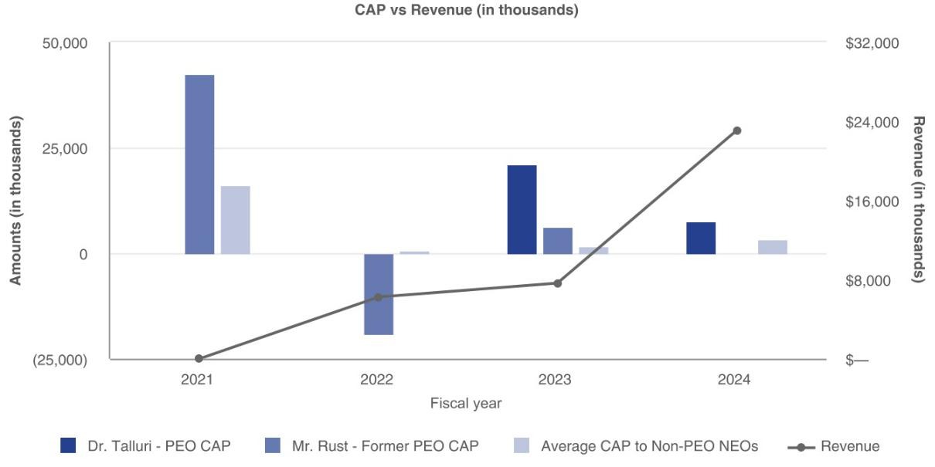

CAP versus Net Loss
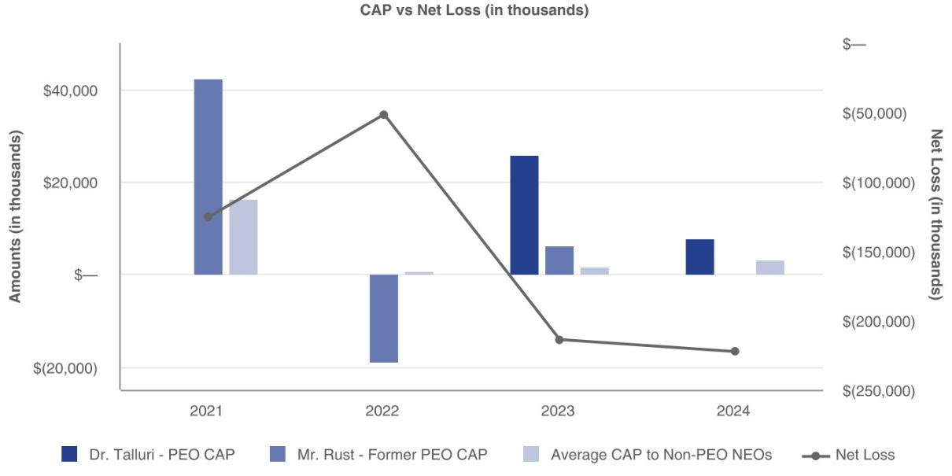

Enovix Corporation 42 2025 Proxy Statement

Table of Contents

CAP versus Cumulative Total Shareholder Return
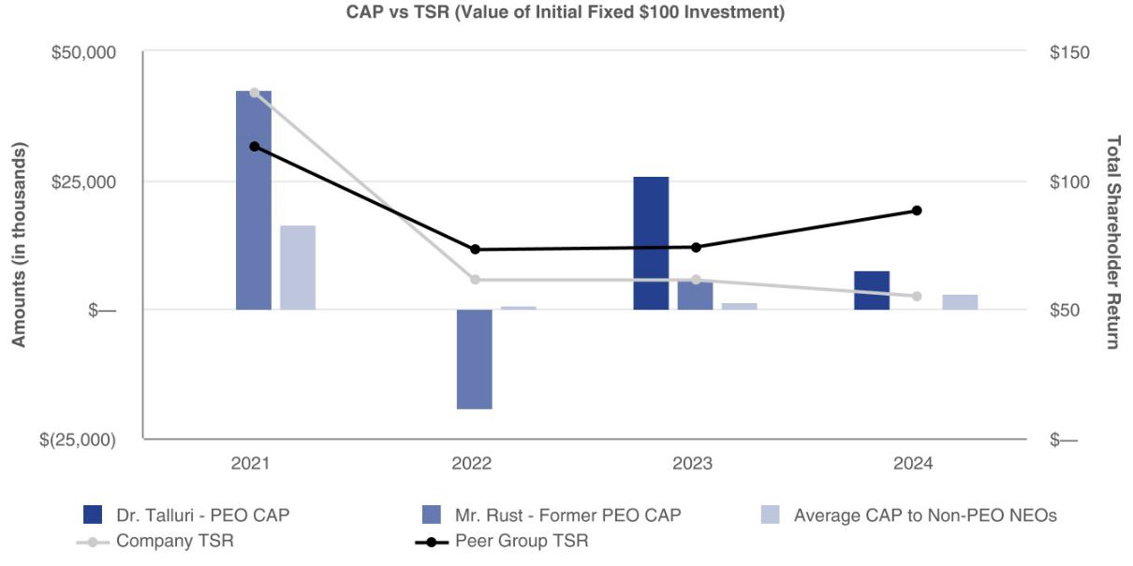

Enovix Corporation 43 2025 Proxy Statement

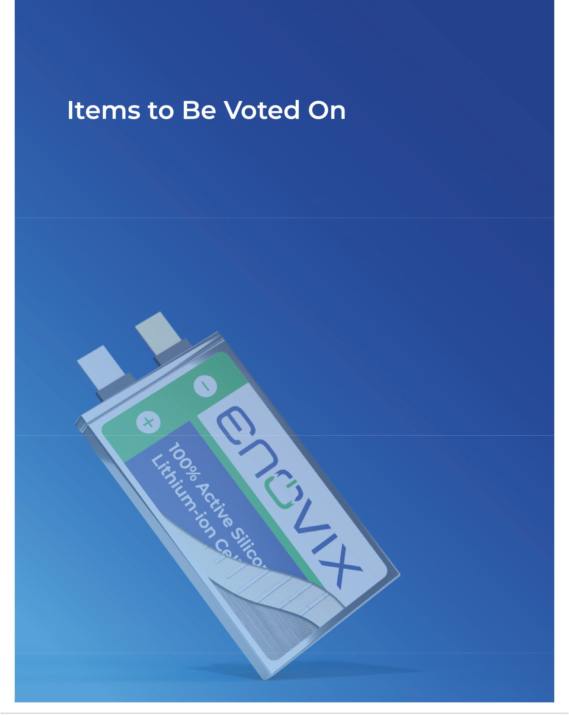

Table of Contents

Items to Be Voted On

PROPOSAL NO. 1

Election of Directors

Upon the recommendation of the Nominating and Corporate Governance Committee of our Board of Directors, our Board of Directors has nominated the seven director nominees listed below for election at the Annual Meeting:

Name | Position
Thurman John Rodgers | Chairman
Betsy Atkins | Director
Pegah Ebrahimi | Director
Bernard Gutmann | Director
Joseph Malchow | Director
Gregory Reichow | Director
Dr. Raj Talluri | President, CEO and Director

Each of the director nominees currently serves on the Board of Directors. If elected at the Annual Meeting, each nominee will serve a one-year term that will expire at the 2026 Annual Meeting of Stockholders when their successors are elected. Each nominee has consented to being named in this Proxy Statement and has agreed to serve if elected. We have no reason to believe that any nominee will be unable to serve if elected.

Please refer to the tables and narrative disclosure in the section titled “Information Regarding the Board of Directors and Corporate Governance” for information about each of our director nominees, including a brief biography, position, age, tenure and independence determination, as well as information regarding the specific experience, qualifications, attributes or skills that led the Nominating and Corporate Governance Committee and the Board of Directors to determine that the applicable nominee should serve as a member of the Board of Directors.

- The Board of Directors Unanimously Recommends a Vote “FOR” the Election of Each of the Nominees Listed Above.


Enovix Corporation 45 2025 Proxy Statement

Table of Contents

PROPOSAL NO. 2

Advisory Vote to Approve the Compensation of Named Executive Officers

Pursuant to Section 14A of the Exchange Act, our Board of Directors is providing stockholders with a vote to approve, on an advisory basis, the compensation of our named executive officers as disclosed in this Proxy Statement in accordance with SEC rules. This advisory vote, commonly known as a “say-on-pay” vote, is a non-binding vote on executive compensation paid to our named executive officers as disclosed in the “Executive Compensation Tables” section of this Proxy Statement, including the compensation tables and the corresponding narrative discussions. Consistent with the preference expressed by our stockholders at the last advisory vote on the frequency of our “say-on-pay” vote, we are conducting such votes annually. Accordingly, we expect to hold our next “say-on-pay” vote at our next annual meeting of stockholders in 2026. Because the vote is advisory, it will not be binding on the Board of Directors. However, the Board of Directors and the Compensation Committee will review the voting results and take them into consideration when making future decisions regarding executive compensation.

As described under the heading “Executive Compensation - Compensation Discussion and Analysis,” our current executive compensation program is intended to align executive compensation with our business objectives and to enable us to attract, retain and reward executive officers who contribute to our long-term success. We seek to accomplish this goal in a way that is aligned with the long-term interests of our stockholders. Our strategy has been to design our compensation programs to drive alignment of all employees, including our named executive officers. We believe that this approach recognizes that, as a Company, we are all one team with one mission. We believe our executive compensation program effectively aligns the interests of our named executive officers with our objective of creating sustainable long-term value for our stockholders.

For the reasons discussed above and in the Compensation Discussion and Analysis, our Board of Directors recommends that our stockholders vote “FOR” the “say-on-pay” vote as set forth in the following resolution:

RESOLVED, that the Company’s stockholders approve, on an advisory basis, the compensation of the named executive officers, as disclosed in this Proxy Statement pursuant to the compensation disclosure rules of the Securities and Exchange Commission.

- The Board of Directors Unanimously Recommends a Vote “FOR” the Approval of the Resolution Approving, on an Advisory Basis, the Compensation of Our Named Executive Officers.

Enovix Corporation 46 2025 Proxy Statement

Table of Contents

PROPOSAL NO. 3

Ratification of the Appointment of Independent Registered Public Accounting Firm

The Audit Committee of the Board of Directors has appointed Deloitte & Touche LLP as our independent registered public accounting firm for the fiscal year ending December 28, 2025. Deloitte & Touche LLP currently serves as our independent registered public accounting firm. The Board of Directors has directed that management submit the appointment of Deloitte & Touche LLP for ratification by our stockholders at the Annual Meeting. Representatives of Deloitte & Touche LLP are expected to be present at the Annual Meeting and will be given an opportunity to make a statement and respond to appropriate questions.

As a matter of good corporate governance the Audit Committee is submitting the appointment of Deloitte & Touche LLP as our independent registered public accounting firm to our stockholders for ratification, even though it is not required under our Bylaws nor other governing documents or applicable law. If our stockholders fail to ratify the appointment, the Audit Committee will reconsider whether to appoint new independent auditors. Even if the appointment is ratified, the Audit Committee, in its discretion, may direct the appointment of different independent auditors at any time during the fiscal year if they determine that such a change would be in the best interests of the Company and its stockholders.

Principal Accountant Fees and Services

The following table sets forth the aggregate fees billed for professional audit services and other services rendered by Deloitte & Touche LLP for fiscal years 2024 and 2023. All of the services described in the following fee table were approved by the Audit Committee.

Fiscal Years Ended

 | December 29, 2024 |  | December 31, 2023
 |  | ($ In thousands)
Audit Fees⁽¹⁾ |  | 2,417 | 2,470
Audit-Related Fees⁽²⁾ |  | 370 | 611
Tax Fees⁽³⁾ |  | 18 | 58
All Other Fees⁽⁴⁾ |  | 2 | 2
Total Fees |  | 2,807 | 3,141

- Audit Fees - This category includes the audit of our annual financial statements, the audit of our internal control over financial reporting, the review of our financial statements included in our Quarterly Reports on Form 10-Q, and services that are normally provided by the independent registered public accounting firm in connection with statutory audit and regulatory filings, business combinations and other matters for those fiscal years.

- Audit-Related Fees - This category generally consists of assurance and related services, such as equity and finance offerings and are not reported under “Audit Fees” above.

- Tax Fees - This category consists of services for tax compliance, tax advice, and tax planning.

- All Other Fees - This category consists of annual subscription for accounting literature.

Enovix Corporation 47 2025 Proxy Statement

Table of Contents

Pre-Approval Policies and Procedures

Our Audit Committee has procedures in place for the pre-approval of all audit services, audit-related services, tax services, and other services rendered by our independent registered public accounting firm, Deloitte & Touche LLP. Our Audit Committee generally pre-approves specified services in the defined categories of audit services, audit-related services and tax services up to specified amounts. Pre-approval may also be given as part of our Audit Committee’s approval of the scope of the engagement of the independent auditor or on an individual, explicit, case-by-case basis before the independent auditor is engaged to provide each service. The pre-approval of services may be delegated to one or more of the Audit Committee’s members, but the decision must be reported to the full Audit Committee at its next scheduled meeting. The Audit Committee has determined that the rendering of services other than audit services by Deloitte & Touche LLP is compatible with maintaining the principal accountant’s independence.


- of Deloitte and Touche LLP as Our Independent Registered Public Accounting Firm for the Fiscal _{Year Ending December 28, 2025.}TheBoardofDirectorsUnanimously Recommends a Vote “For” the Ratification of the Appointment

Enovix Corporation 48 2025 Proxy Statement

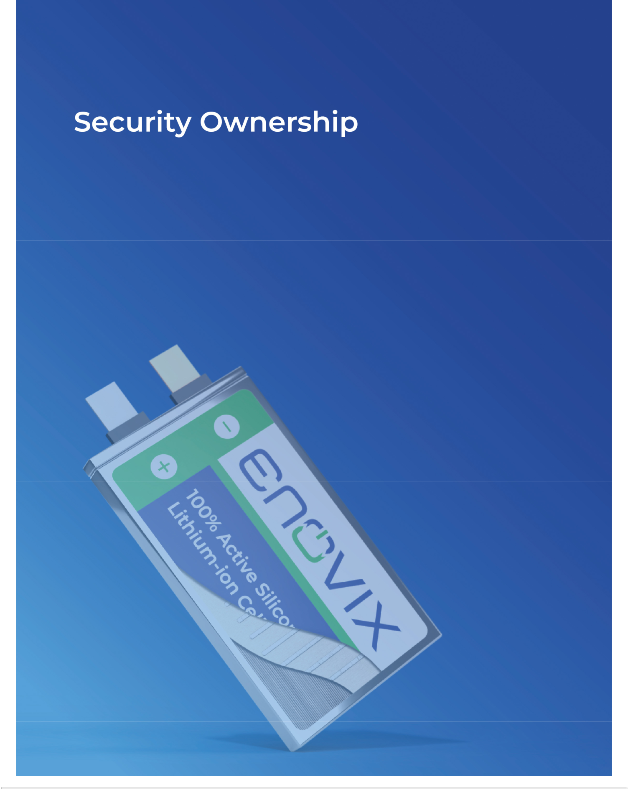

Table of Contents

Security Ownership

The following table sets forth information regarding the beneficial ownership of shares of our common stock as of March 30, 2025 by: (i) each person known by us to beneficially own more than 5% of our common stock; (ii) each of our directors and nominees for director; (iii) each of our named executive officers; and (iv) all current executive officers and directors as a group.

Applicable percentages are based on 191,715,117 shares of common stock outstanding on March 30, 2025, adjusted as required by SEC rules. We have determined beneficial ownership in accordance with the rules and regulations of the SEC. Each stockholder’s beneficial ownership and corresponding percentage include exercisable options, warrants, RSUs and PRSUs that become exercisable or may be settled within 60 days of March 30, 2025, at the discretion of the stockholder. These securities are deemed to be outstanding and beneficially owned by the person holding such options, warrants, RSUs or PRSUs for the purpose of computing the percentage ownership of that person, but they are not treated as outstanding for the purpose of computing the percentage ownership of any other person. Unless otherwise indicated, the persons or entities identified in this table have sole voting and investment power with respect to all shares shown as beneficially owned by them, and their business address is c/o Enovix Corporation, 3501 W. Warren Avenue, Fremont, California 94538.

 | Beneficial Ownership
 | of Common Stock
 | Number of | Percent of
Beneficial Owner | Shares | Total
Greater Than 5% Stockholder
The Vanguard Group⁽¹⁾ | 12,928,993 | 6.7 %
BlackRock, Inc.⁽²⁾ | 9,886,741 | 5.2 %
Named Executive Officers ⁽³⁾ and Directors
Thurman John Rodgers ⁽⁴⁾ | 25,797,483 | 13.2 %
Betsy Atkins ⁽⁵⁾ | 247,406 | *
Arthi Chakravarthy ⁽⁶⁾ | 84,383 | *
Pegah Ebrahimi ⁽⁷⁾ | 40,315 | *
Bernard Gutmann ⁽⁸⁾ | 30,229 | *
Joseph Malchow ⁽⁹⁾ | 659,329 | *
Ajay Marathe ⁽¹⁰⁾ | 331,509 | *
Gregory Reichow ⁽¹¹⁾ | 15,628 | *
Dr. Raj Talluri ⁽¹²⁾ | 471,446 | *
All current directors and executive officers as a group (12 individuals) ⁽¹³⁾ | 27,707,227 | 14.1 %

- Less than one percent

- The Vanguard Group, Inc. (Vanguard) reported beneficial ownership of these shares as of December 31, 2023, which consist of 12,928,993 shares held by Vanguard. The reporting entity has sole dispositive power with respect to 12,528,320 shares. The business address for The Vanguard Group is 100 Vanguard Boulevard, Malvern, Pennsylvania 19355. The information provided is based solely on the Schedule 13G/A filed by the reporting person with the SEC on February 13, 2024. The shares beneficially owned by Vanguard may have changed since the Schedule 13G/A filing.

Enovix Corporation 50 2025 Proxy Statement

Table of Contents

- BlackRock, Inc. reported beneficial ownership of these shares as of December 31, 2023, which consist of 9,886,741 shares held by BlackRock, Inc. The reporting entity is a parent holding company and has sole voting power with respect to 9,730,783 shares and sole dispositive power with respect to 9,886,741 shares, reporting on behalf of the holding company and its affiliated subsidiaries. The business address of BlackRock is 50 Hudson Yards, New York, New York 10001. The information provided is based solely on the Schedule 13G/A filed by the reporting person with the SEC on January 29, 2024. The shares beneficially owned by BlackRock may have changed since the Schedule 13G/A filing.

- As of March 30, 2025, our former Chief Financial Officer, Farhan Ahmad, and our current Chief Financial Officer, Ryan Benton, held no shares of our common stock. Further, Mr. Benton received an award of 748,752 RSUs on April 14, 2025, of which no shares are subject to vesting within 60 days of March 30, 2025.

- Consists of (i) 20,793,701 shares of common stock held by the Rodgers Massey Revocable Living Trust dtd 4/4/11, Thurman John Rodgers, Trustee, (ii) 900,000 shares of common stock held by the Rodgers Family Freedom and Free Markets Charitable Trust, (iii) 4,100,000 shares of common stock issuable to the Rodgers Massey Revocable Living Trust dtd 4/4/11, Thurman John Rodgers, Trustee pursuant to a warrant exercisable within 60 days of March 30, 2025, and (iv) 3,782 shares of common stock held by Mr. Rodgers.

- Consists of (i) 95,715 shares of common stock held directly by Ms. Atkins, (ii) 51,691 shares of common stock issuable to Ms. Atkins pursuant to options exercisable within 60 days of March 30, 2025, and (iii) 100,000 shares of common stock issuable to Ms. Atkins pursuant to a warrant exercisable within 60 days of March 30, 2025.

- Consists of (i) 66,121 shares of common stock held directly by Ms. Chakravarthy and (ii) 18,262 shares of common stock issuable to Ms. Chakravarthy upon the vesting of RSUs within 60 days of March 30, 2025.

- Consists of 40,315 shares of common stock held directly by Ms. Ebrahimi.

- Consists of 30,229 shares of common stock held directly by Mr. Gutmann.

- Consists of (i) 403,629 shares of common stock held directly by Mr. Malchow, (ii) 4,400 shares of common stock held by Mr. Malchow and his spouse, (iv) 1,300 shares held by his child. and (v) 250,000 shares of common stock issuable to Mr. Malchow pursuant to a warrant exercisable within 60 days of March 30, 2025.

- Consists of (i) 289,647 shares of common stock held directly by Mr. Marathe and (ii) 41,862 shares of common stock issuable to Mr. Marathe upon the vesting of RSUs within 60 days of March 30, 2025.

- Consists of 15,628 shares of common stock held directly by Mr. Reichow.

- Consists of (i) 362,743 shares of common stock held directly by Dr. Talluri and (ii) 108,703 shares of common stock issuable to Dr. Talluri upon the vesting of RSUs within 60 days of March 30, 2025.

- Consists of (i) 23,027,551 shares of common stock held by all of our current directors and executive officers as a group (ii) 51,691 shares of common stock issuable pursuant to options exercisable within 60 days of March 30, 2025, (iii) 177,985 shares of common stock issuable upon the vesting of restricted stock units within 60 days of March 30, 2025, and (iv) 4,450,000 shares of common stock issuable pursuant to warrants exercisable within 60 days of March 30, 2025.

Enovix Corporation 51 2025 Proxy Statement

Table of Contents

Report of the Audit Committee

The Audit Committee is a committee of the Board of Directors comprised solely of independent directors as required by the listing standards of the Nasdaq Stock Market LLC and the rules and regulations of the Securities and Exchange Commission. The composition of the Audit Committee, the attributes of its members and the responsibilities of the Audit Committee, as reflected in its charter, are intended to be in accordance with applicable requirements for corporate audit committees.

With respect to Enovix’s financial reporting process, its management is responsible for establishing and maintaining internal controls and preparing its financial statements. Enovix’s independent registered public accounting firm, Deloitte & Touche LLP, is responsible for performing an independent audit of Enovix’s financial statements. It is the responsibility of the Audit Committee to oversee these activities. It is not the responsibility of the Audit Committee to prepare financial statements. These are the fundamental responsibilities of management.

In the performance of its oversight function, the Audit Committee has reviewed and discussed the audited financial statements for the fiscal year ended December 29, 2024 with management and Deloitte & Touche LLP. The Audit Committee has discussed with Deloitte & Touche LLP the matters required to be discussed by the applicable requirements of the Public Company Accounting Oversight Board (“PCAOB”) and Securities and Exchange Commission. The Audit Committee has also received the written disclosures and the letter from Deloitte & Touche LLP required by the applicable requirements of the PCAOB regarding Deloitte & Touche LLP’s communications with the Audit Committee concerning independence and has discussed with Deloitte & Touche LLP its independence. Based on the foregoing, the Audit Committee has recommended to the Board of Directors that the audited financial statements be included in Enovix’s Annual Report on Form 10-K for the fiscal year ended December 29, 2024 for filing with the Securities and Exchange Commission.

Respectfully submitted by the members of the Audit Committee of the Board of Directors:

Bernard Gutmann (Chairperson)

Joseph Malchow

Pegah Ebrahimi

This report of the Audit Committee will not be deemed to be part of or incorporated by reference by any general statement incorporating by reference this Proxy Statement into any filing under the Securities Act of 1933, as amended, or under the Securities Exchange Act of 1934, as amended, except to the extent that we specifically incorporate this information by reference, and will not otherwise be deemed “soliciting material” or “filed” under either the Securities Act of 1933 or the Securities Exchange Act of 1934.

Enovix Corporation 52 2025 Proxy Statement

Table of Contents

Certain Relationships and Related Party Transactions

Other than compensation arrangements for our directors and executive officers, which are described in the section titled “Executive Compensation,” below is a description of transactions since January 1, 2024. A related person transaction includes transactions in which:

- we have been or are to be a participant;

- the amounts involved exceeded or will exceed $120,000; and

- any of our directors, executive officers or holders of more than 5% of any class of our capital stock, or any member of the immediate family of, or person sharing the household with, the foregoing persons, had or will have a direct or indirect material interest.

Convertible Senior Notes

On April 20, 2023, the Company issued $172.5 million aggregate principal amount of Convertible Senior Notes, pursuant to an indenture, dated as of April 20, 2023, between the Company and U.S. Bank Trust Company, National Association, as trustee. $10.0 million principal amount of the Convertible Senior Notes were issued to an entity affiliated with Thurman John Rodgers, Chairman of the Board of Directors, in a concurrent private placement. The Convertible Senior Notes are unsecured obligations of the Company and bear interest at a rate of 3.0% per year from April 20, 2023, and are payable semiannually in arrears on May 1 and November 1 of each year, beginning on November 1, 2023. The Convertible Senior Notes will mature on May 1, 2028 unless earlier converted, redeemed or repurchased.

Employment Relationships

The Company employs a family member of the Company’s current Chief Executive Officer and a member of our Board of Directors, Dr. Raj Talluri, Suraj Talluri. Mr. Talluri joined the Company in January 2024 and assists with sales in North America. His target annual compensation of $192,000, including base salary and target bonus, is based on reference to external market practices of similar positions or internal pay equity when compared to the compensation paid to employees in similar positions who were not related to our current Chief Executive Officer. Mr. Talluri is also eligible for equity awards on the same general terms and conditions as applicable to employees in similar positions who were not related to our current Chief Executive Officer.

Equity Awards to Directors and Executive Officers

We have granted equity awards to certain of our directors and executive officers pursuant to the applicable Employment Agreement and/or Separation Agreement with each such current and former executive officers and under our Initial and Amended Director Compensation Policies. For more information regarding the stock options and stock awards granted to our non-employee directors and Named Executive Officers, see the sections titled “Director Compensation” and “Executive Compensation.”

Indemnification Agreements

We have entered into indemnification agreements with each of our directors and executive officers. The indemnification agreements require us to indemnify our directors and executive officers to the fullest extent permitted by Delaware law.

Our Certificate of Incorporation contains provisions limiting the liability of directors, and our Bylaws provide that we will indemnify each of our directors and officers to the fullest extent permitted under Delaware law. Our Certificate of Incorporation and Bylaws also provide our Board of Directors with discretion to indemnify our employees and other agents when determined appropriate by our Board of Directors.

Enovix Corporation 53 2025 Proxy Statement

Table of Contents

Policies and Procedures for Related Person Transactions

Our Board of Directors has adopted a formal written related person transactions policy that sets forth our policies and procedures regarding the identification, review, consideration and oversight of related person transactions. The Audit Committee of our Board of Directors has the primary responsibility for reviewing and approving or ratifying transactions with related persons, which include our executive officers, directors, director nominees, beneficial owners of more than 5% of our common stock, and any immediate family member of the aforementioned persons. Under our policy, a “related person transaction” is a transaction, arrangement or relationship, or any series of similar transactions, arrangements or relationships, in which we or any of our subsidiaries are participants involving an amount that exceeds $120,000, including purchases of goods or services by or from the related person or entities in which the related person has a material interest, indebtedness and guarantees of indebtedness, subject to certain exceptions set forth in Item 404 of Regulation S-K under the Securities Act.

To identify related person transactions in advance, we will rely on information supplied by our executive officers, directors and certain significant stockholders. In considering a related person transaction, our Audit Committee will take into account the relevant available facts and circumstances, which may include, but are not limited to:

- the risks, costs, and benefits to us;

- the impact on a director’s independence in the event the related person is a director, immediate family member of a director or an entity with which a director is affiliated;

- the extent of the related person’s interest in the transaction;

- the purpose and terms of the transaction;

- management’s recommendation with respect to the proposed related person transaction;

- the availability of other sources for comparable services or products; and

- whether the transaction is on terms comparable to those that could be obtained in an arm’s length transaction.

Our Audit Committee will approve only those transactions that it determines are fair to us and in our best interests. Except as set forth above, there were no related person transactions in fiscal year 2024, and there are not currently any proposed related person transactions, that would require disclosure under SEC rules.

Enovix Corporation 54 2025 Proxy Statement

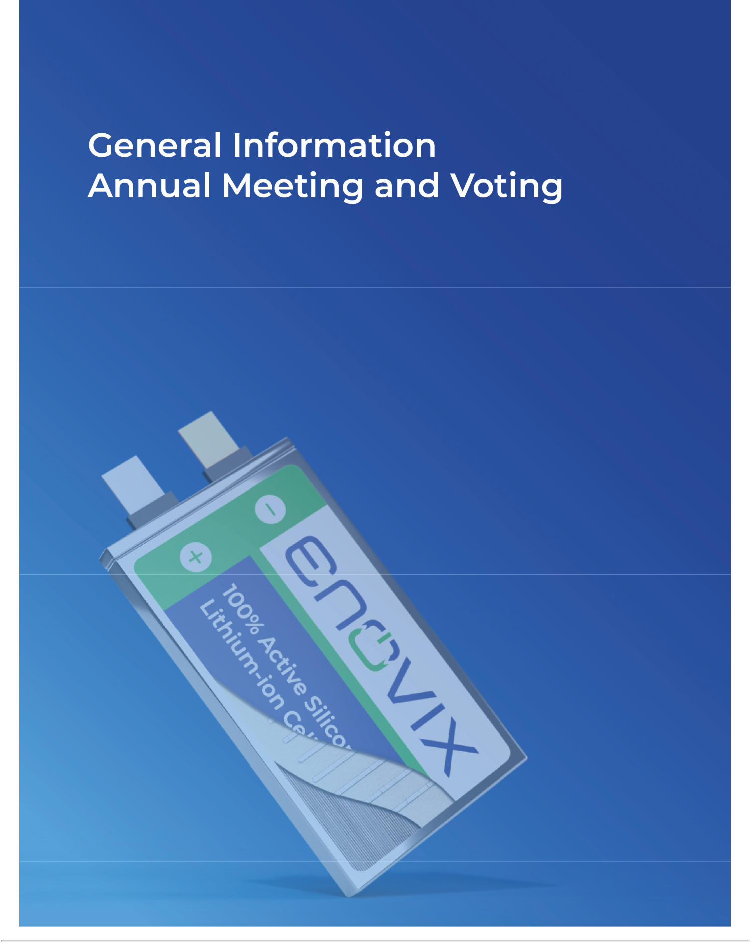

Table of Contents

General Information - Annual Meeting and Voting

2025 Annual Meeting of Stockholders

Our 2025 Annual Meeting of Stockholders will be held Thursday, June 12, 2025 at 1:30 p.m. Pacific Daylight Time. The Notice of Internet Availability of Proxy Materials, Notice of Annual Meeting, this Proxy Statement, and our Annual Report on Form 10-K for the fiscal year ended December 29, 2024 (collectively, the “proxy materials”) are first being furnished by and on behalf of the Board of Directors of Enovix Corporation on or about April 24, 2025.

Board of Directors Recommendation

Proposal |  | Board Recommendation
1 | Election of Directors | “FOR” each nominee
2 | Advisory Vote to Approve the Compensation of Our Named Executive Officers | “FOR”
3 | Vote to Ratify the Appointment of Independent Registered Public Accounting Firm | “FOR”

How You Can Vote

To vote online in advance of the Annual Meeting, go to www.proxyvote.com. You will be asked to provide the control number from the Notice or printed proxy card. Your internet vote must be received by 8:59 p.m. Pacific Daylight Time on Wednesday, June 11, 2025 to be counted. If you return a signed and dated proxy card or otherwise vote without marking voting selections, your shares will be voted as reflected in the table above.

Annual Meeting Proposals

There are three matters scheduled for a vote:

Proposal 1 To elect seven directors to hold office until the 2026 Annual Meeting of Stockholders

Proposal 2 To approve, on an advisory basis, the compensation of our named executive officers

To ratify the appointment of Deloitte & Touche LLP as our independent registered public accounting firm for the fiscal year ending Proposal 3 December 28, 2025

Stockholders of record at the close of business on April 15, 2025, the record date for the Annual Meeting, may vote at the Annual Meeting. Stockholders as of the record date are entitled to one vote for each share held on all matters properly brought before the Annual Meeting.

Notice of Annual Meeting

Pursuant to Securities and Exchange Commission (the “SEC”) rules, we have elected to provide access to our proxy materials over the internet. Accordingly, we have sent you the Notice because our Board of Directors is soliciting your proxy to vote at the Annual Meeting. All stockholders will have the ability to access the proxy materials on the website referred to in the Notice or request to receive a printed set of the proxy materials. Instructions on how to access the proxy materials over the internet or to request a printed copy may be found in the Notice. If you receive more than one Notice, your shares may be registered in more than one name or in different accounts. Please follow the voting instructions on each of the Notices.

On the record date, there were 191,970,506 shares of common stock, par value $0.0001 per share, outstanding and entitled to vote. We intend to mail the Notice on or about April 24, 2025 to all stockholders of record, who are entitled to vote at the Annual Meeting. The proxy materials will be made available to stockholders on the internet on the same date.

Enovix Corporation 56 2025 Proxy Statement

Table of Contents

The Notice will provide instructions as to how a stockholder of record may access and review the proxy materials on the website referred to in the Notice or, alternatively, how to request that a copy of the proxy materials, including a proxy card, be sent by mail or email to the stockholder of record. The Notice will also provide voting instructions. Please note that, while our proxy materials are available at the website referenced in the Notice, and our Notice of Annual Meeting, Proxy Statement and Annual Report on Form 10-K for the fiscal year ended December 29, 2024 (“fiscal year 2024”) are available on our website, no other information contained on either website is incorporated by reference in or considered to be a part of this document and these website addresses, where included in this Proxy Statement, are intended to provide inactive, textual references only.

Voting and Solicitation

Proposal No. 1 – Directors are elected by a plurality of the votes, meaning the seven nominees receiving the most “For” votes from the holders of shares present by remote communication or represented by proxy and entitled to vote on the election of directors will be elected. You may either vote “For” the nominees to the Board of Directors or you may “Withhold” your vote for any nominee you specify. A broker non-vote (as described below) will not have any effect on the voting outcome. If any nominee becomes unavailable for election, shares that would have been voted for that nominee will instead be voted for the election of a substitute nominee proposed by the Board of Directors.

Proposal No. 2 – The advisory vote on executive compensation (commonly referred to as “Say-on-Pay”) will be decided by the affirmative vote of the majority of the shares present by remote communication or represented by proxy and entitled to vote on the proposal. You may vote “For” or “Against” or abstain from voting on Proposal No. 2. An abstention will have the same effect as a vote “Against” and a broker non-vote will not have any effect on the voting results. This is an advisory vote and is not binding on our Board of Directors. However, our Board and Compensation Committee will take into account the outcome of the vote when considering future decisions regarding executive compensation.

Proposal No. 3 – For the proposal to ratify the appointment of Deloitte & Touche LLP, you may vote “For” or “Against” or abstain from voting. An abstention will have the same effect as a vote “Against” Proposal No. 3. The vote will be decided by the affirmative vote of a majority of shares present by remote communication or represented by proxy and entitled to vote on the proposal.

Votes will be counted by the inspector of election, who will separately count:

- Proposal No. 1 - votes “For,” “Withhold” and broker non-votes.

- Proposal No. 2 - votes “For” and “Against,” as well as abstentions.

- Proposal No. 3 - votes “For” and “Against,” as well as abstentions.

Voting Requirements by Proposal

The following table summarizes the voting requirements for each proposal:

Proposal Broker Discretionary Voting

Number Proposal Vote Required Allowed

Election of Directors

1 Plurality of votes cast for each nominee No

2 | Advisory Vote to Approve Compensation of Named | Majority of shares present or represented by proxy | No
2 | Executive Officers | and entitled to vote | No
3 | Ratification of the Appointment of Deloitte & Touche LLP | Majority of shares present or represented by proxy | Yes
3 | Ratification of the Appointment of Deloitte & Touche LLP | and entitled to vote | Yes

Broker Non-Votes

If a beneficial owner of shares does not give voting instructions to their broker on matters deemed to be “non-routine,” the broker cannot vote the shares. These unvoted shares are counted as “broker non-votes.” Since Proposal Nos. 1 and 2 are considered to be “non-routine,” we expect broker non-votes to exist in connection with Proposal Nos. 1 and 2. Proposal No. 3 is considered to be “routine,” and therefore we do not expect broker non-votes to exist in connection with Proposal No. 3.

Abstentions will be counted towards the vote total and will have the same effect as “Against” votes for Proposal Nos. 2, and 3.

Enovix Corporation 57 2025 Proxy Statement

Table of Contents

Stockholder Categories and Definitions

Beneficial Owner

If your shares are held in an account at a broker, bank or other agent, then you are the beneficial owner of shares held in “street name” and the broker or bank will send the Notice to you. As a beneficial owner, you have the right to direct your broker, bank or other agent regarding how to vote the shares in your account. You are also invited to attend the Annual Meeting. However, since you are not the stockholder of record, you may not vote your shares online at the Annual Meeting unless you request and obtain a valid legal proxy from your broker, bank or other agent. Check with your broker, bank, or other agent, and follow the instructions you receive during the registration process prior to the Annual Meeting.

Stockholder of Record

You are considered a stockholder of record if your shares were registered directly in your name with our transfer agent, Computershare Trust Company, N.A (as of the record date). As a stockholder of record, you may vote online during the Annual Meeting or by proxy in advance. Whether or not you plan to attend the Annual Meeting, we urge you to vote your shares by proxy in advance of the Annual Meeting to ensure your vote is counted.

Voting Procedures by Type of Stockholder

Beneficial Owner - Voting Process

If you are a beneficial owner, you should have received a Notice containing voting instructions from your broker or bank, rather than from us. Simply follow the voting instructions in the Notice to ensure that your vote is counted. If you are a beneficial owner, your broker may not vote your shares on Proposal Nos. 1 and 2 without your instructions, but may vote your shares on Proposal No. 3, even in the absence of your instruction. To ensure your shares are voted in the way you would prefer, you must provide voting instructions to your broker, bank or other agent by the deadline provided in the materials you receive. As a beneficial owner, if you prefer to vote online at the Annual Meeting, you must obtain a valid legal proxy from your broker, bank or other agent, which instructions should have been included with the proxy materials.

Stockholder of Record - Voting Process

If you are a stockholder of record, you may vote (1) in advance of the Annual Meeting by proxy through the internet, by telephone or by using a proxy card or

- online during the Annual Meeting.

  - To vote in advance of the Annual Meeting using a printed proxy card that may be delivered to you, simply complete, sign and date the proxy card and return it promptly in the envelope provided. If you return your signed proxy card to us before the Annual Meeting, we will vote your shares as you direct.

  - To vote in advance of the Annual Meeting by telephone, dial 1-800-690-6903 and follow the recorded instructions. You will be asked to provide the control number from the Notice or printed proxy card. Your telephone vote must be received by 8:59 p.m. Pacific Daylight Time on Wednesday, June 11, 2025 to be counted.

  - To vote online during the Annual Meeting, follow the provided instructions to join the Annual Meeting at www.virtualshareholdermeeting.com/ENVX2025, starting at 1:30 p.m. Pacific Daylight Time on Thursday, June 12, 2025. The webcast will open 15 minutes before the start of the Annual Meeting.

You may still attend the Annual Meeting and vote online even if you have already voted by proxy. If you are a stockholder of record and do not vote by completing your proxy card, through the internet, by telephone or online at the Annual Meeting, your shares will not be voted.

Attending the Virtual Annual Meeting

In order to enter the Annual Meeting, you will need the 16-digit control number, which is included with your voting instruction card received from your broker, bank or other agent if you are the beneficial owner and hold your shares in “street name” or included in the Notice or on your proxy card if you are the stockholder of record of shares of our common stock.

Enovix Corporation 58 2025 Proxy Statement

Table of Contents

Instructions on how to attend and participate in our Annual Meeting are also available at http://www.virtualshareholdermeeting.com/ENVX2025.

We recommend that you log in a few minutes before 1:30 p.m. Pacific Daylight Time to ensure you are logged in when the Annual Meeting starts. If you would like to submit a question during the Annual Meeting, you may log in to www.virtualshareholdermeeting.com/ENVX2025 using your control number, type your question into the “Ask a Question” field, and click “Submit.” The webcast will open at 1:15 p.m. Pacific Daylight Time, on June 12, 2025.

Annual Meeting Logistics

Beginning at 1:15 p.m. Pacific Daylight Time and during the virtual Annual Meeting, we will have a support team ready to assist stockholders with technical difficulties they may have with accessing or hearing the virtual meeting. If you encounter any difficulties accessing the Annual Meeting during the check-in or meeting time, please call the technical support number that will be posted at www.virtualshareholdermeeting.com/ENVX2025 or at www.proxyvote.com.

Any stockholder can attend the Annual Meeting as a guest, if they were not a stockholder as of the record date, or they misplaced their 16-digit control number, by registering as a “guest” online at www.virtualshareholdermeeting.com/ENVX2025 prior to the Annual Meeting. Please note that if you are registered as a guest to attend the virtual Annual Meeting, you will be unable to vote your shares.

To help ensure that we have a productive and efficient meeting, and in fairness to all stockholders in attendance, you will find posted our rules of conduct for the Annual Meeting when you log in prior to its start. During any question-and-answer session of the Annual Meeting, we will address questions pertinent to meeting matters, subject to time constraints. Questions that are substantially similar may be grouped and answered once to avoid repetition.

For the ten days prior to the Annual Meeting, a list of stockholders of record will be available upon request via ir@enovix.com for examination by any stockholder for any purpose germane to the Annual Meeting.

Householding

For stockholders who are beneficial owners, companies and intermediaries, such as brokers, are permitted to satisfy the delivery requirements for proxy materials with respect to two or more stockholders sharing the same address by delivering one set of proxy materials to those stockholders residing at the shared address. This process is referred to as “householding.” Upon written or oral request, we will promptly deliver a separate copy of our proxy materials to any stockholder at a shared address to which we delivered a single copy. A stockholder who wishes to receive a separate copy of proxy materials, now or in the future, should send a written request to: Enovix Corporation, 3501 W. Warren Avenue, Fremont, California 94538, Attention: Secretary, or by phone call or email to our Secretary, at (510) 844-2829 or gc@enovix.com.

Stockholders residing at a shared address who currently receive multiple copies of our proxy materials, and wish to request a single copy be mailed going forward, should contact their bank or broker.

Printed Proxy Materials

To request that a full set of the proxy materials be sent to your specified postal address, please go to www.proxyvote.com or call 1-800-579-1639. Please have your proxy card when you access the website or call and follow the instructions provided.

Revocability of Proxies

You can revoke your proxy at any time before the final vote at the Annual Meeting. Your most current proxy card or telephone or internet proxy is the one that is counted. If you are the stockholder of record of your shares, you may revoke your proxy in one of the following ways:

- You may submit another properly completed proxy card with a later date.

- You may grant a subsequent proxy by telephone or through the internet.

- You may send a timely written notice that you are revoking your proxy to our Secretary at Enovix Corporation, 3501 W. Warren Avenue, Fremont, California 94538.

Enovix Corporation 59 2025 Proxy Statement

Table of Contents

- You may attend the Annual Meeting and vote online. Simply attending the Annual Meeting will not, by itself, revoke your proxy.

If you are the beneficial owner, you may revoke your proxy in accordance with the instructions provided by your broker, bank or other agent to revoke your proxy.

Expenses of Proxy Solicitation

We will pay for the entire cost of soliciting proxies. In addition to these proxy materials, our directors and employees may also solicit proxies in person or by other means of communication. Directors and employees will not be paid any additional compensation for soliciting proxies. We have engaged Broadridge Financial Solutions, an independent tabulator, to receive and tabulate the proxies, to service as inspector of elections and to certify the results. We may also reimburse brokers, banks and other agents for the cost of forwarding proxy materials to beneficial owners.

Quorum Requirement

A quorum of stockholders is necessary to hold a valid meeting. A quorum will be present if stockholders holding at least a majority of the voting power of the outstanding shares entitled to vote are present at the Annual Meeting by remote communication or represented by proxy. On the record date, there were 191,970,506 shares outstanding and entitled to vote. Thus, the holders of 95,985,254 shares must be present at the Annual Meeting by remote communication or represented by proxy at the Annual Meeting to have a quorum. The inspector(s) of election appointed for the Annual Meeting will determine whether or not a quorum is present. Your shares will be counted towards the quorum only if you submit a valid proxy, or one is submitted on your behalf by your broker, bank or other agent, or if you vote online at the Annual Meeting. Abstentions and broker non-votes will be counted towards the quorum requirement. If there is no quorum, the Annual Meeting may be adjourned by the chairperson of the Annual Meeting or the vote of the holders of a majority of shares represented at the Annual Meeting and entitled to vote thereon.

Annual Meeting - Results of Voting

Preliminary voting results will be announced at the Annual Meeting. Final voting results will be disclosed in a Current Report on Form 8-K that we expect to file with the SEC within four business days after the Annual Meeting. If final voting results are not yet available, we intend to file a Current Report on Form 8-K to disclose preliminary results and, within four business days after the final results are known to us, file an amended Current Report on Form 8-K to disclose the final voting results.

Stockholder Proposals - 2026 Annual Meeting of Stockholders

Stockholders may present proper proposals for inclusion in our proxy statement and for consideration at next year’s annual meeting of stockholders by submitting their proposals in writing to our Secretary in a timely manner. For a stockholder proposal to be considered for inclusion in our proxy statement for the 2026 Annual Meeting of Stockholders, our Secretary must receive the written proposal at our principal executive offices not later than December 25, 2025. In addition, stockholder proposals must comply with the requirements of Rule 14a-8 under the Exchange Act , regarding the inclusion of stockholder proposals in company-sponsored proxy materials. Stockholder proposals should be addressed to:

Enovix Corporation

Attention: Secretary

3501 W. Warren Avenue

Fremont, California 94538

Our Amended and Restated Bylaws (the “Bylaws”) also establish an advance notice procedure for stockholders who wish to present a proposal before an annual meeting of stockholders but do not intend for the proposal to be included in our proxy statement. Our Bylaws provide that the only business that may be conducted at an annual meeting of stockholders is business that is (i) specified in the notice with respect to such annual meeting delivered to stockholders, (ii) brought specifically by or at the direction of our Board of Directors, or a duly authorized committee of our Board of Directors, or (iii) properly brought before the meeting in accordance with our Bylaws by a stockholder of record entitled to vote at the meeting. To be properly brought, notice of the proposal must contain the information required by our Bylaws and must be received by our Secretary at our principal executive offices not earlier than the close of business on February 12, 2026 and not later than the close of business on March 14, 2026.

Enovix Corporation 60 2025 Proxy Statement

Table of Contents

In the event that we hold the 2026 Annual Meeting of Stockholders more than 30 days before or after the one-year anniversary of the Annual Meeting, notice of a stockholder proposal that is not intended to be included in our proxy statement must be received no earlier than the close of business on the 120th day before the 2026 Annual Meeting of Stockholders and no later than the close of business on the later of the following two dates:

- the 90th day prior to the 2026 Annual Meeting of Stockholders; or

- the 10th day following the day on which public announcement of the date of our 2026 Annual Meeting of Stockholders is first made.

If a stockholder who has notified us of his, her or its intention to present a proposal at an annual meeting of stockholders does not appear to present his, her or its proposal at such annual meeting, we are not required to present the proposal for a vote at such annual meeting.

Director Nominations

Holders of our common stock may propose director candidates for consideration by the Nominating and Corporate Governance Committee of the Board of Directors (the “Nominating and Corporate Governance Committee”). Any such recommendations should include the nominee’s name and qualifications for membership on our Board of Directors and should be directed to our Secretary at the address set forth above. For additional information regarding stockholder recommendations for director candidates, see the section titled “Information Regarding the Board of Directors and Corporate Governance— Nominating and Corporate Governance Committee.”

Our Bylaws permit stockholders to nominate directors for election at an annual meeting of stockholders. To nominate a director candidate, the stockholder must provide the information required by our Bylaws. In addition, the stockholder must give timely notice to our Secretary in accordance with our Bylaws, which, in general, require that the notice be received by our Secretary within the time periods described above for stockholder proposals that are not intended to be included in a proxy statement.

In addition, stockholders who intend to solicit proxies in support of director nominees other than our nominees must provide in their notice any additional information required by Rule 14a-19 under the Exchange Act.

Enovix Corporation 61 2025 Proxy Statement

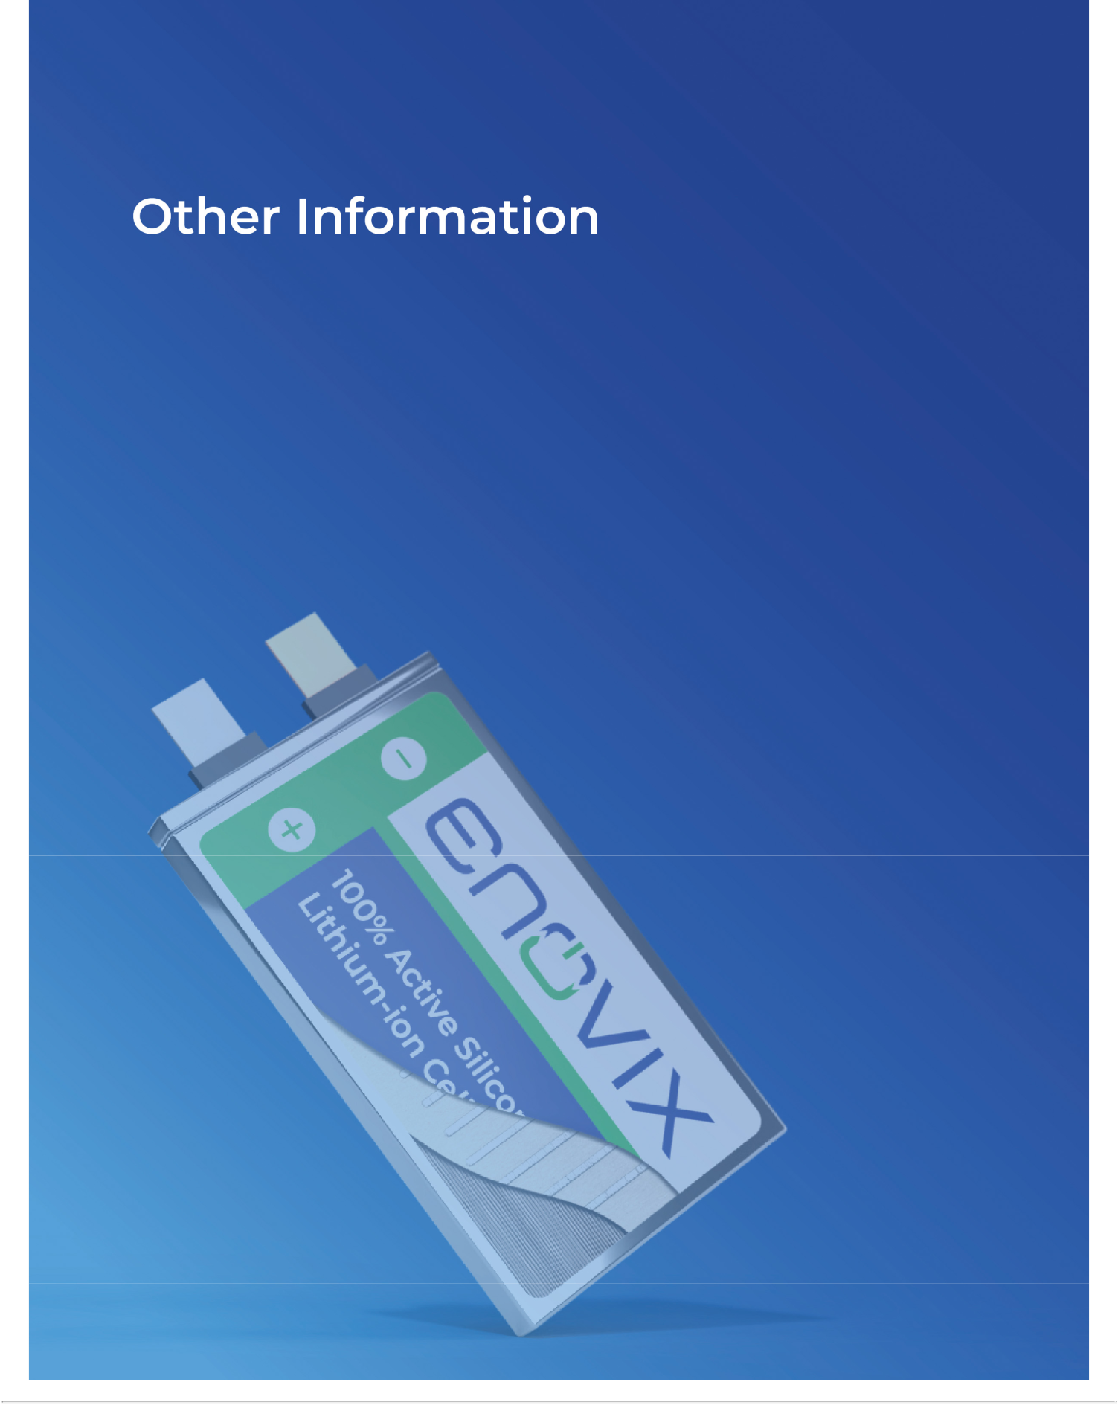

Table of Contents

Other Information

Equity Compensation Plan Information

The following table shows certain information with respect to all of our equity compensation plans in effect as of December 29, 2024.

 |  |  |  | Number of securities remaining
 | Number of securities to be |  | Weighted- average | available for issuance under equity
 | issued upon exercise of |  | exercise price of | compensation plans (excluding
 | outstanding options, warrants |  | outstanding options, | securities reflected in column (a))
Plan Category | and rights (a)(2) | warrants and rights (b)(3) |  | (c)(4)
Equity compensation plans approved by stockholders⁽¹⁾ | 14,923,219 | $ | 10.05 | 21,552,121
Equity compensation plans not approved by stockholders | — |  | — | —
Total | 14,923,219 | $ | 10.05 | 21,552,121

- Includes our 2006 Equity Incentive Plan (the “2006 Plan”), 2016 Plan, 2021 Plan, and 2021 Employee Stock Purchase Plan (the “2021 ESPP”). No additional equity awards may be granted under the 2006 Plan or 2016 Plan. These amounts reflect 1,751,118 outstanding stock options and 13,172,101 outstanding RSUs and PRSUs.

- Excludes future rights to purchase shares of common stock under our 2021 ESPP, which depend on a number of factors described in our 2021 ESPP and will not be determined until the end of the applicable purchase period.

- Represents the weighted-average exercise price of our outstanding stock options only. The weighted-average exercise price excludes any outstanding units subject to RSU awards, which have no exercise price.

- Consists of 11,865,775 shares of our common stock available for issuance under our 2021 Plan and 9,686,346 shares of our common stock available for issuance under our 2021 ESPP, which includes estimated Evergreen Increases (as defined below). The 2021 Plan provides that the total number of shares of our common stock reserved for issuance thereunder will automatically increase on January 1 of each year for a period of ten years commencing on January 1, 2022 and ending on January 1, 2031, in an amount equal to 4% of the total number of shares of common stock outstanding on December 31 of the preceding year, or such lesser number of shares of common stock as determined by our Board of Directors prior to January 1 of a given year (the “2021 Plan Evergreen Increase”). In addition, the 2021 ESPP provides that the total number of shares of our common stock reserved for issuance thereunder will automatically increase on January 1 of each year for a period of up ten years commencing on January 1, 2022 and ending on January 1, 2031, in an amount equal to the lesser of (i) 1% of the total number of shares of common stock outstanding on December 31 of the preceding calendar year, and (ii) 2,000,000 shares of common stock; or such lesser number of shares of common stock as determined by our Board of Directors prior to January 1 of a given calendar year (the “2021 ESPP Evergreen Increase” and together with the 2021 Plan Evergreen Increase, the “Evergreen Increases”). Accordingly, on January 1, 2025, the number of shares of common stock available for issuance under the 2021 Plan and the 2021 ESPP automatically increased pursuant to these provisions, as follows: the 2021 Plan Evergreen Increase was 7,622,538 shares, and the 2021 ESPP Evergreen Increase was 1,905,634.

Delinquent Section 16(a) Reports

Pursuant to Section 16 of the Exchange Act, executive officers, directors, and holders of more than 10% of the Company’s common stock are required to file reports of their trading in Company equity securities with the SEC. Based solely on a review of the copies of such reports filed with the SEC during with respect to the last fiscal year, and written representations from certain reporting persons that no other filings were required, the Company believes that all filings required to be made by its reporting persons complied with all applicable Section 16 filing requirements during fiscal year 2024, with the exception of one report filed in March 2024 on behalf of Mr. Rodgers for four transactions.

Enovix Corporation 63 2025 Proxy Statement

Table of Contents

2024 Annual Report

A copy of our Annual Report on Form 10-K for the fiscal year ended December 29, 2024 is available free of charge at the SEC’s web site at www.sec.gov. Stockholders can also access this Proxy Statement and our Annual Report on Form 10-K for the fiscal year ended December 29, 2024 at the investors section of our website at https://ir.enovix.com. A copy of our Annual Report on Form 10-K for the year ended December 29, 2024 is available without charge upon written request to Enovix Corporation, 3501 W. Warren Avenue, Fremont, California 94538, Attention: Investor Relations.

Other Matters

The Board of Directors does not know of any other matters that will be presented for consideration at the Annual Meeting. If any other matters are properly brought before the meeting, the persons named in the accompanying proxy will have discretion to vote the shares of our common stock they represent on such matters in accordance with their best judgment.

It is important that your shares be represented at the annual meeting, regardless of the number of shares that you hold. Therefore you are urged to vote as promptly as possible to ensure your vote is counted.

The Board of Directors

Fremont, California

April 24, 2025

Enovix Corporation 64 2025 Proxy Statement



