UNITED STATES
SECURITIES AND EXCHANGE COMMISSION
Washington, D.C. 20549
SCHEDULE 14A INFORMATION
Proxy Statement Pursuant to Section 14(a) of the
Securities Exchange Act of 1934
(Amendment No. )
Filed by the Registrant |  |  | ☒
Filed by a Party other than the Registrant |  |  | ☐
Check the appropriate box:
☐ |  |  | Preliminary Proxy Statement
☐ |  |  | Confidential, for Use of the Commission Only (as permitted by Rule 14a-6(e)(2))
☐ |  |  | Definitive Proxy Statement
☒ |  |  | Definitive Additional Materials
☐ |  |  | Soliciting Material Pursuant to § 240.14a-12

ENOVIX CORPORATION
(Name of Registrant as Specified In Its Charter)
(Name of Person(s) Filing Proxy Statement, if other than the Registrant)
Payment of Filing Fee (Check all boxes that apply):
☒ |  |  | No fee required
☐ |  |  | Fee paid previously with preliminary materials
☐ |  |  | Fee computed on table in exhibit required by Item 25(b) per Exchange Act Rules 14a-6(i)(1) and 0-11

On May 28, 2026, Enovix Corporation (“Enovix”) posted the following message on its LinkedIn, Facebook, X and Instagram accounts:

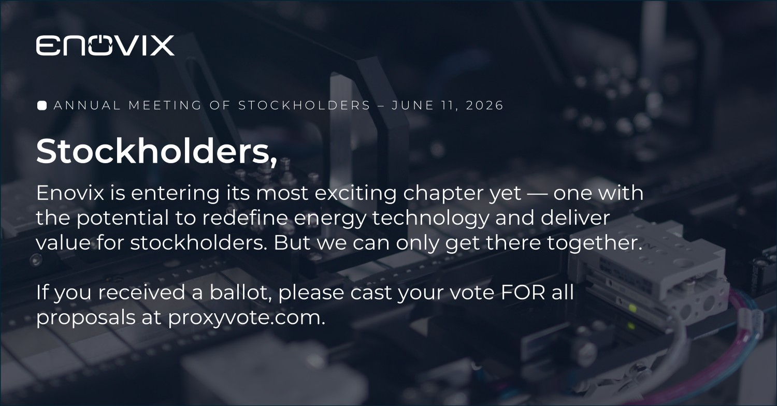

Important Information

Enovix has filed a definitive proxy statement with the SEC in connection with its 2026 Annual Meeting of Stockholders. Stockholders are encouraged to read the proxy statement and other relevant materials filed with the SEC because they contain important information. Investors may obtain these materials free of charge at www.sec.gov and through Enovix’s investor relations website at: ir.enovix.com.

Forward-Looking Statements

This communication contains “forward-looking statements” within the meaning of the Private Securities Litigation Reform Act of 1995. Enovix cautions readers that forward-looking statements are predictions based on Enovix’s current expectations about future events. All statements other than statements of historical or current facts, are forward-looking statements. These forward-looking statements, and the assumptions underlying such statements, involve a number of risks, uncertainties, some of which are beyond our control. It is not possible for us to predict all risks, nor can we assess the impact of all factors on our business or the extent to which any factor, or combination of factors, may cause actual results to differ materially from those contained in any forward-looking statements we may make. Accordingly, you should not rely on any of the forward-looking statements. For additional information on these risks and uncertainties and other potential factors that could cause actual results to differ from the results predicted, please refer to our filings with the SEC, including in the “Risk Factors” and “Management’s Discussion and Analysis of Financial Condition and Results of Operations” sections of our annual report on Form 10-K and quarterly reports on Form 10-Q and other documents that we have filed, or will file, with the SEC. Forward-looking statements speak only as of the date made, and we undertake no obligation to revise or update them, whether as a result of new information, future events or otherwise.

